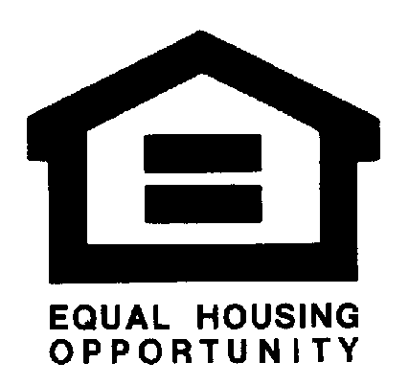
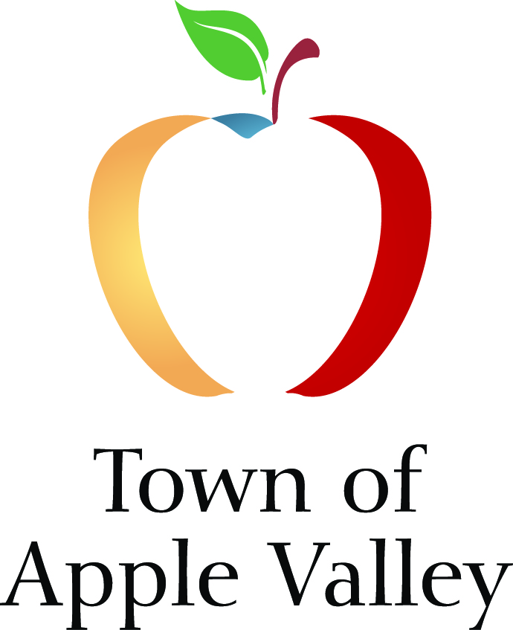
TOWN OF APPLE VALLEY
CDBG/HOME PROPOSAL APPLICATION
FY 2020-2021

FINAL DUE DATE: February 4, 2020 4:30 P.M.
NO EXCEPTIONS

FOR OFFICE USE ONLY...
Proposal ID: _________________ Amount Requested: $_________________

Date Received: _______________ Amount Recommended: $ ______________

Answer all questions which are applicable to your project as specifically as possible and attach the required and supporting documentation. Please use separate applications if applying for more than one (1) program/project.

Use tab key to move through fields/Shift + tab moves back to previous field

General Information
Amount Requested (rounded to nearest $1) $
(Minimum request/funding allocation $4,000):
CDBG/HOME Project Name:
Name of Organization:
Address (Administrative Office):
Mailing Address:
Zip Code: Facsimile Number:
Name and Title of Contact Person:

Telephone Number: E-mail Address:
DUNS Number: Federal Identification Number:
501 (C)(3) Number: Cage Code (www.sam.gov):

Organizational Structure:
Government or Public Agency Non-Profit Organization/Corporation
Other (Specify)
Town of Apple Valley Business License Number:
Location of Project (Site Address):
Legal Property Owner:
Project Title:
Program is: New for our agency An Ongoing Program
Is the program/project located within the Town’s CDBG Target Areas (see attached map)?
Yes No
Provide a brief description of the proposed activity. Describe 1) The client base to be served; 2) How and when the service will be provided; and 3) Who will provide the services, i.e., trained volunteers, licensed counselors, medical doctors, etc. 4) Describe in detail the specific service(s) to be provided to the Town of Apple Valley residents (limit to no more than half a page):

Experience

Is this agency currently funded by the Town of Apple Valley? Yes No
Has this agency previously administered CDBG Funds? Yes No

Please describe the agency’s experience with CDBG funds (limit to no more than half a page):

If the agency has not previously administered CDBG funds, describe the applicant’s grant management experience, or how administration of CDBG funds will be managed (limit to no more than half a page):

National Objective and Strategic Plan Priorities
- Please check the one (1) box next to HUD National Objective which most applies to this proposed program. You must meet at least one National Objective if your program/project is to be considered eligible for CDBG funding.

This program principally serves low and moderate-income persons;
This program aids in the prevention or elimination of slum and blight; or
This program addresses a recent and urgent community development need (as defined by HUD).

- If your program meets the National Objective of principally serving low and moderate-income persons, please check the box that best describes how your program meets this objective. (Select only one).

You receive income verification along with source documentation from each program participant;
Your program serves only a CDBG Target Area (attach CDBG Target Area Map showing area); or
Your program serves only the following clients (select only one):

Elderly persons (62+) Homeless persons Severely disabled adults
Illiterate persons Abused children Persons living with AIDS/HIV
Battered spouses Migrant farm workers

- Check the goals/needs below that this program will meet from the Town’s Consolidated Plan. Your activity must meet at least one (1) priority if the program/project is to be considered eligible for CDBG funding.

HOUSING
Increase the supply of transitional housing for homeless, victims of domestic violence, etc.
Increase the supply of affordable multi-family rental units
Rehabilitation of low income owner-occupied single-family residences
Increase the supply of affordable housing for low income veterans
Increase the availability of down payment assistance for low income homebuyers
Increase code enforcement activity in deteriorated areas to improve neighborhood esthetics/property values
Reduce overcrowding in occupied properties
Establish rent control for affordability
Encourage development of inclusive housing development - mixed income

HOMELESS SERVICES
Support development of ‘one stop’ resource centers to assist homeless/at-risk homeless by providing multiple reentry services at one location
Support the provision of food and nutrition services
Provide utility assistance to at risk homeless
Support the Homeless Outreach Proactive Enforcement (HOPE) program
Provide resource directories for available services
Encourage collaboration between stakeholders to unify services
Support efforts to increase volunteerism in human services programs

ECONOMIC DEVELOPMENT/EMPLOYMENT OPPORTUNITY
Increase job opportunity through education and job training programs
Encourage business development through business management education
Collaborate with agencies providing trade skills training
Encourage provision of education/training that meets the needs of local businesses
Support job creation with proactive business development policies

HUMAN SERVICES
Support programs that develop responsible, motivated and educated youth
Support development of arts, music and culture
Support programs that support a healthy lifestyle
Develop public facility amenities that facilitate community involvement and recreation
Disseminate fair housing information
Encourage programs to unite youth, seniors, veterans and disabled persons in mentoring and caregiving

ACCESSIBILITY AND MOBILITY
Support efforts to improve mobility in the community
Identify and remove barriers that impede accessibility
Support transit systems that improve access to employment, education, recreation, etc.
Support collaborative efforts to improve community and regional transit

Performance Measurements
All programs/projects are required to link goals and activities with objectives, outputs, and outcomes (goals vs actual). Please do not overestimate goals. Data received from funded activities will be directly transmitted to HUD.

- Describe briefly the overall mission of your agency and/or goal that this program/project plans to address (limit to no more than half a page).

- Using the table below, check the box that best describes the HUD defined outcome and objective that your proposed program/project will meet (select only one). Most public service agencies will select “Enhance suitable living environment through new/improved accessibility” and “Provide economic opportunity through new/improved accessibility.”

Outcomes→  Objectives↓ | Availability/  Accessibility |  | Affordability |  | Sustainability
Suitable Living  Environment |  | Enhance suitable living environment through new/improved availability/ accessibility |  | Enhance suitable living environment through new/improved affordability |  | Enhance suitable living environment through new/improved sustainability
Decent Housing |  | Create decent housing with new/improved availability/ accessibility |  | Create decent housing with new/improved affordability |  | Create decent housing with new/improved sustainability
Economic Opportunity |  | Provide economic opportunity through new/improved availability/ accessibility |  | Provide economic opportunity through new/improved affordability |  | Provide economic opportunity through new/improved sustainability

- Using the template below, please provide an outcome statement summarizing the outputs, outcomes, activities and objectives of your proposed program/project. For a complete outcome statement, be sure to include all four elements; Output + Outcome + Activity + objective.

Example: Output (50 low and moderate-income persons) + Outcome (were provided new/improved accessibility) Activity (to counseling services) + Objective (for the purpose of enhancing their living environment).

CDBG Regulation Citation

Select the eligibility category that pertains to your project:
(Most public service organizations will meet the Low/Mod Limited Clientele Benefit category)
Low/Mod Area Benefit 570.208(a)(1) | Low/Mod Housing Benefit 570.208(a)(3)
Low/Mod Jobs Benefit 570.208(a)(4) | Low/Mod Limited Clientele Benefit 570.208(a)(2)
Slums/Blight Area Benefit 570.208(b)(1) | Slums/Blight Spot Benefit 570.208(b)(2)
Slums/Blight Urban Renewal Benefit 570.208(b)(3) | Urgent Need 570.208(c)

Type of Accomplishment

Select the category type your program is designed to serve. Indicate the number of unduplicated Apple Valley clients or units of service you anticipate serving with the requested funds. Provide numbers next to the applicable category. Please do not over-estimate the number served. Choose one category only.

Type | Number Served | Type | Number Served
People (General) |  | Elderly Households
Youth |  | Businesses
Elderly |  | Organizations
Households (Housing) |  | Other

Past Performance (Capacity)

Indicate how many unduplicated clients were served or how many unduplicated units of service were delivered (accomplishments) for the benefit of Apple Valley residents/community during the most recent 12-month period:

Indicate the total number of unduplicated accomplishments (Clients or Units of Service) achieved for the benefit of all jurisdictions (including Apple Valley) during the most recent 12-month period:

Does your program have income eligibility requirements? Yes No

Does your program’s income eligibility requirements include source documentation? Yes No

If not, how do you determine eligibility for participation in project or program?

Purpose of this activity: (Please check yes only if your services directly benefits the groups indicated below)

- To help prevent homelessness? Yes No
- To help the homeless? Yes No
- To help those with HIV or AIDS? Yes No

Location Type

How will services be delivered? (Check one)

Address (specify):
Community-Wide:
Low Income Census Tract Area (specify, see map):

PROPOSED BUDGET

CONSTRUCTION & MAJOR EQUIPMENT PURCHASE ACTIVITIES
(To be completed if requesting Capital Project Funds only)

New Construction/Rehabilitation/Equipment Purchase

 | Anticipated Costs | CDBG  Amount  Requested | Committed  Funding Source | Committed Amount | Pending  Funding  Source | Pending Amount
Materials:
Labor:
Design &
Engineering:
Equipment:
Other:
Total:

Location:
Ownership of facility/location:
Occupancy Terms if not owned by applicant:
If facility/location is not owned by applicant, is owner willing to enter into binding agreement?
Description of Activity:

Scheduled Completion time?
What is the current zoning?
Is a Conditional Use Permit Required? If yes, please attach a copy of the permit. | Yes No
Age of existing building, if applicable:
Is the building listed on any local, state, or national historic registers?

Acquisition

Total Acquisition Costs: $

 | Anticipated  Costs | CDBG Amount Requested | Committed  Funding Source | Committed Amount | Pending  Funding  Source | Pending Amount
Acquisition:
Inspection:
Escrow:

Totals

Location:
Building Age:
Name of project/building:

Description:

Current owner:

Current owner’s address:

Owner phone number:

Broker name:

Broker phone number:

BUDGET FOR CDBG FUNDING
PUBLIC SERVICE ACTIVITIES
JULY 1, 2020 TO JUNE 30, 2021

Please provide budget justification regarding positions, hourly rates, number of hours budgeted; types and estimated yearly utility costs, types and quantities of equipment, supplies, insurance, and other miscellaneous categories, as appropriate.

FUNDING SOURCE: Apple Valley CDBG Funding

Category | CDBG | Other Funds | Line Item Description
Salaries/Fringe Benefits
(Position, hourly rate x number of hours per year)

Consultant & Contract Services (Position, hourly rate x number of hours per year)

Travel: (Specify purpose)
Mileage/Rate ______X current federal rate

Utilities (Specify type and estimate yearly expense)

Insurance (Specify type)

Equipment (Specify type and quantity)

Materials/Supplies (Specify type)

Miscellaneous
Sub Totals:
Total Budget (CDBG + Other):

The minimum funding amount request for CDBG activities is $4,000.

If requesting assistance for billing and/or acquisition, please include copies of Utility Bills/Supply Estimates/Office Equipment Costs, as applicable.

Proposed Budget Continued

Please indicate any additional funding sources budgeted, allocated or requested for the program or project. Provide documentation for each committed funding source.

Funding Source | Amount | Purpose | (Please check one)  Pending/Committed

Certification

The undersigned certifies that:

The information contained in the project proposal is complete and accurate;

The sponsor shall comply with all federal and Town policies and requirements affecting the CDBG program;

If the project is a facility, the sponsor shall maintain and operate the facility for its approved use throughout its economic life; and

Sufficient funds are available to complete the project as described, if CDBG funds are approved.

_________________________________________
Signature, Authorized Official

(Type Name and Title)

Date

APPLICANTS MUST SUBMIT ONE ORIGINAL OF THIS APPLICATION AND ALL REQUESTED DOCUMENTATION

THE FOLLOWING DOCUMENTS MUST BE INCLUDED AT THE TIME OF APPLICATION SUBMITTAL OR THE APPLICATION IS SUBJECT TO REJECTION:

- Completed Application Form with wet signature;

- Board Meeting Minutes Authorizing Request of Funds;

- Board Meeting Minutes of Authorized Official;

- Copy of Articles of Incorporation;

- By-Laws;

- List of Board of Directors (full names, titles, term of office and addresses of all members);

- Organizational Chart;

- Current Organizational Annual Financial Report (prepared by a qualified and independent entity);

- Copy of 501(c)(3);

- Current Fiscal Year Budget (Applicants must submit a proposed budget (page 6 for Construction and Major Equipment Purchase activities, page 7 for Acquisition, and pages 8 & 9 for Public Service activities. Applicants submitting for Construction and Major Equipment Purchase activities must have had prior discussions with the Town of Apple Valley CDBG Administrator.

- Agency’s Mission Statement;

- CDBG Target Area Map (If program is located within or will serve a target area);

- Optional - Please submit any additional information, such as newsletters, annual reports and fundraising literature that will assist the review committee in its evaluation of your application. Copy and size submittals to 8.5 x 11 format.

Instructions
Completed application packets must be received by this office by 4:30 p.m., Tuesday February 4, 2020. Completed packets should include: a signed original along with attachments. Applications must be unbound, one-sided and on 8 ½ X 11 paper. Do not include oversized or undersized pages. The application should not include any extraneous materials, unnecessary packaging, or a letter of transmittal, as they will be discarded. Please allow sufficient time if application is sent via mail or courier as applications received after the deadline will not be processed.

