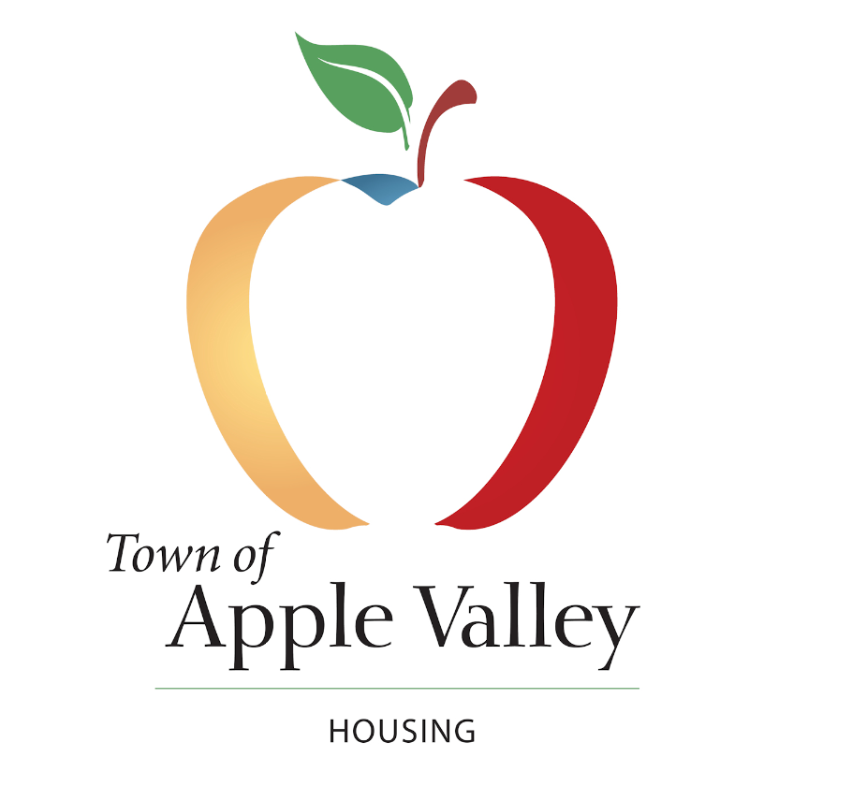

CITIZEN PARTICIPATION PLAN

Consolidated Plan and Affirmatively Furthering
Fair Housing (AFFH) Plan

Effective May 19, 2016

Amended 6/23/2020

TOWN OF APPLE VALLEY
Community Development Department
Citizen Participation Plan
CDBG, HOME, CDBG-CV ADDI, HOPWA and ESG Programs
& Affirmatively Furthering Fair Housing Plan (AFH)

Introduction

Federal regulations require that recipients of the Community Development Block Grant (CDBG), HOME Investment Partnerships (HOME), American Dream Downpayment Initiative (ADDI), Emergency Shelter Grants (ESG), and Housing Opportunities for Persons with AIDS (HOPWA) programs follow a Citizen Participation Plan in order to receive continued federal funding. To satisfy the federal requirements for receipt of CDBG and HOME funds, the Town of Apple Valley certifies that it will adhere to the following Citizen Participation Plan in providing for and encouraging public participation in the development and administration of its CDBG, HOME, and CDBG-CV programs as well as development of the Affirmatively Furthering Fair Housing Plan (AFH). The Town of Apple Valley does not currently receive ESG or HOPWA funds; however, if, in the future, the Town does receive ESG or HOPWA funds, the Citizen Participation Plan will be amended to include those programs.
Policy Statement

The purpose of the Citizen Participation Plan is to provide the method and process by which the Town of Apple Valley consolidated planning and AFH processes will comply with the citizen participation requirements promulgated by the U.S. Department of Housing and Urban Development (HUD) pursuant to Section 104(a)(3) of the Housing and Community Development Act of 1974, as amended, and as further augmented by program regulations under 24CFR Part 91.105 (rev.3/14/2016).Through implementation of this Citizen Participation Plan, citizens will be afforded the maximum feasible opportunity to provide input on housing and community development needs, issues and problems affecting very-low and low income persons; to learn about the Community Development Block Grant Program (CDBG), Home Investment Partnerships (HOME) Program, Section 108 Guaranteed Loan Funds, to provide input into the AFH and any other applicable programs that the Town may apply for and their expected amount of assistance to be received from each to develop local project proposals; to provide input to project selections and funding distributions; and to participate in the implementation of funded activities.

Primary Objectives

A summary of the primary objectives of the Participation Plan is provided below:

Ensure that citizens are informed of the amount of funds (including anticipated program income, as applicable) available under the Consolidated Plan (to include Section 108 Guaranteed Loan Funds, when applicable), the range of activities that may be undertaken, as well as the various program requirements.

Provide citizens with adequate opportunities to participate in the development of the Consolidated Plan and any required changes, revisions or amendments to the plan.

Provide citizens with adequate opportunities to participate in the development of the Affirmatively Furthering Fair Housing plan and any required changes, revisions or amendments to the plan.

Provide technical assistance to citizens in developing specific proposals for funding consideration.

Provide an ongoing process for citizens likely to be affected by program activities to articulate need, express preferences about proposed activities, assist in selecting priorities, and participate in the overall development of the Consolidated Plan and the AFH.

Provide a process through which citizens may participate in the monitoring and evaluation of community development and housing activities.

Provide a process whereby citizens may comment with respect to any aspect of the Town’s housing and community development performance and be assured that written comments will be considered and responded to in accordance with federal regulations.

Standards of Participation

All aspects of the Town’s citizen participation efforts shall be conducted in an open manner with freedom of access to all interested parties. The Town encourages the involvement of all groups including low and very low-income persons and protected classes, those living in slum/blighted areas, and in areas where CDBG and HOME funds are proposed to be used. These standards of participation extend to non-English speaking persons, as well as persons with mobility, visual or hearing impairments, members of minority groups, the elderly, the disabled, the business community, civic groups and the community at large.

While this plan describes a specific citizen organization (Community Development Citizen Advisory Committee), it is not intended to exclude any individual citizen input, but rather to enhance citizen participation in this process. All citizens of Apple Valley are encouraged to participate in every public meeting and to contact the Community Development Department with any questions concerning the process and the programs pertaining to the Consolidated Plan and AFH including the Community Development Block Grant Program, Home Investment Partnership (HOME) Program, Community Development Block Grant Program Covid-19 or any future programs.

Technical Assistance

To help facilitate citizen input, the Town will provide technical assistance through its staff to the Community Development Citizen Advisory Committee, as well as to groups representative of low, very low, extremely low income residents and protected classes which may require such assistance in developing proposals for federal funding as required by federal regulations. Technical assistance may be provided by telephone, meetings, U.S. mail, and workshops throughout the year.

Public Information

In order for citizens to become informed and involved in the Consolidated Plan and AFH processes, the Town will make available all relevant information, including the following:

Material concerning the amount of funds available for proposed community development and housing activities and the range of activities that may be taken including the amount that will benefit the persons of low and very low income and protected classes;

Applicable regulations and guidelines governing all aspects of the programs;

Prior applications, final statements and amendments, grant agreements, grantee performance reports, citizen participation plan and any other reports required by the U.S. Department of Housing and Urban Development (HUD);

Documents regarding other important program requirements such as contracting procedures, environmental policies, fair housing and other equal opportunity requirements and relocation provisions;

Mailings, notices and any other promotional materials;

Minutes of meetings and hearings;

Any other document the Town believes is necessary to the consolidated planning and AFH processes.

The summary of the proposed Consolidated Plan and AFH will be published in one or more newspapers of general circulation. The summary will provide the contents and the purpose of the Consolidated Plan and AFH and a list of locations where copies of the entire plans may be examined. Copies of the entire proposed plans will be available to the public at the Town Hall, Library, Development Services building and on the Town website. A period of not less than thirty (30) days will be provided to receive comments from citizens on the draft Consolidated Plan and AFH, as well as any proposal amendments to the Plan. A summary of comments regarding the proposed Consolidated Plan or AFH will be attached to the final Consolidated Plan or AFH.
Given the need to expedite actions to respond to COVID-19, the 30-day minimum for the required public comment period is waived for substantial amendments, provided that no less than 5 days are provided for public comments on each substantial amendment and a 10-day Notice of Public Hearing. The waiver is available through the end of the recipient’s 2020-2021 program year.

Scope of Public Participation in CDBG and HOME Programs

The Town of Apple Valley will provide for continuity of citizen participation throughout all stages of the application and administrative tasks of the CDBG and HOME Programs. Citizen involvement will be encouraged through the reasonable and timely access to local meetings, information and records relating to the following areas:
The Affirmatively Furthering Fair Housing Plan:

The combined Housing Element/Consolidated Plan and needs analyses;
The annual One Year Action Plan;
The Consolidated Annual Performance Evaluation Report (CAPER), including the CDBG Grantee Performance Report and the HOME Annual Performance Report;
Subsequent amendments and other changes to the above initiated by the U.S. Department of Housing and Urban Development or other federal agency.
Outreach

The Town will endeavor to achieve its level of public participation by organizations and the community through actively soliciting participation by these groups. When preparing the Consolidated Plan and AFH, the Town shall consult with other public and private agencies and jurisdictions that provide assisted housing, health services and social services during the preparation of the plans. One or more display ads/press releases/public notices designed to encourage citizens to participate and provide input into the development of the Consolidated Plan and AFH will be published in one (1) or more newspapers of general circulation.

Annual technical assistance workshops will be held in order to assist with the development of proposals for grant funding. Letters of invitation to attend the public hearing will be sent to community service organizations, business organizations, Chamber of Commerce, religious organizations and any other applicable groups and affected parties showing an interest in the Consolidated Plan and AFH.

Complaints

The Town will make every reasonable effort to provide written responses to complaints within fifteen (15) working days. A copy of each written citizen comment or complaint regarding the Consolidated Plan and AFH along with the Town’s assessment of the comment or complaint and a description of any action taken or written response made will be kept on file as a matter of public record.

Public Meetings and Public Hearings

The Town will conduct public meetings and public hearings during various phases of the Consolidated Plan/Action Plan and AFH processes. All public meetings and public hearings shall be open to the public. Meetings will be held at times and at locations in the Town that are convenient and acceptable to potential and actual beneficiaries. Special accommodations shall be made for persons with disabilities upon advance notice and as necessary. In cases where a significant number of non-English speaking residents are reasonably expected to participate, an interpreter will be provided by the Town upon advance notice and as necessary.

The Town Council shall conduct a minimum of two (2) public hearings during the fiscal program year for the Consolidated Plan/Action Plan. The first public hearing will be held to receive comments on assessing the needs of the community. The second public hearing will be held to obtain views on the proposed Consolidated Plan/Action Plan prior to its review and adoption by the Town Council.

The Town Council shall conduct a minimum of one (1) public hearing during the development of the AFH for the purpose of receiving community input regarding the proposed AFH. Prior to the public hearing, outreach meetings will be held with public agencies, stakeholders and the community to receive input regarding local and regional fair housing issues, their contributing factors and to develop goals to address these issues.

The Town Council shall conduct a public hearing for each substantial amendment to the Consolidated Plan or revision of the AFH.

Prior to each public hearing, a legal notice shall be published through Valleywide Newspaper with a minimum 10-day public noticing requirement. The legal notice shall contain the following information:

Date of hearing

Time of hearing

Place of hearing

Topic to be considered

Basic information about the program

At this time during the Covid-19 pandemic, the meetings are not open to public attendance; however members of the public may comment in one of two ways: 1) comments and contact information can be emailed to publiccomment@applevalley.org by 12:00 p.m. the day of the scheduled meeting to be included in the record; 2) a request to speak can be emailed to the same address as above and at the time of the requested agenda item, the Town Clerk will place a phone call to the commenter and allow them to speak to the council via speaker phone during the live meeting for up to three minutes.

Criteria for Substantial Amendments to the Consolidated Plan and AFH

The Town will substantially amend its approved Plan or AFH whenever it makes any of the following decisions:

To make a change in its priorities or a change in the method of distribution of funds

To revise an accepted AFH: due to a change in circumstances that affects the AFH to the extent that it no longer reflects actual circumstances; due to written notification by HUD specifying a material change that requires the revision (24 CFR 5.164).

To carry out a new activity, using funds from any program covered by the Consolidated Plan (including program income), not previously described in the Action Plan.

To substantially change the purpose, scope, location, or beneficiaries of an activity (Any activity whose funding allocation is increased by more than 50% will constitute a substantial amendment. Minor changes in scope and location which do not alter the intent of the previously approved project will not require a substantial amendment. For example, transfer of funds within a line item budget for a single activity may be administratively approved by the Assistant Town Manager, Community Development or designee, as long as the purpose and intent of the project is being met. For example, a capital improvement project, such as a street improvement project in a low-income eligible target area, may potentially broaden its scope by adding or extending additional street improvements within the same general location due to unforeseen circumstances.)

Any substantial changes to the Consolidated Plan or AFH are subject to the citizen participation process as described in the Citizen Participation Plan.

Community Development Citizen Advisory Committee (CDCAC)

Size and Appointment

The Community Development Citizen Advisory Committee shall consist of five (5) members. Each member of the Town Council shall appoint one (1) member, subject to approval by the Town Council.

Term of Office

Each member shall serve during the term of his/her appointer, subject to removal by a majority of the Town Council. The term of office shall automatically expire with the end of the appointing authority's service as a Town Council member.

The CDCAC shall have a chairperson and vice chairperson.

Meetings

The CDCAC will meet as often as required during the period set aside for reviewing proposals, plans and establishing needs and priorities, and as needed during the balance of the program year. All other regularly scheduled meetings are held on a quarterly basis and will be conducted in person, or by virtual meeting. All meetings are open to the public. Any member failing to attend (3) or more scheduled meetings per fiscal year, without being excused by the Committee, shall automatically cease to be a member of the Committee and the Council shall fill such vacancy immediately.

The following resolution was adopted by the CDCAC on September 23, 2010.

Resolution Authorizing Attendance of Meeting by Teleconference

WHEREAS, the Community Development Citizen’s Advisory Committee (CDCAC) is an advisory committee to the Town Council which, by state law, is the responsible legislative body governing matters related to the programs associated with the Consolidated Plan, AFH and the consolidated planning process.

WHEREAS, pursuant to the Citizen Participation Plan, the CDCAC will meet as often as required during the period set aside for reviewing proposals, plans and establishing needs and priorities, and as needed during the balance of the program year.

WHEREAS, in order to make it more convenient for committee members to attend meetings as necessary other than the meeting set aside for reviewing CDBG and HOME proposal applications, the CDCAC desires to authorize by resolution access to committee meetings by teleconference; and

WHEREAS, the CDCAC hereby finds that the approval of this Resolution at this time is in the best interest of the CDCAC and its members.

NOW, THEREFORE, BE IT RESOLVED by the CDCAC of the Town of Apple Valley as follows:

- Recitals. The above recitals are true and correct.

- Authorization of Attendance of Meetings by Teleconference. The CDCAC hereby authorizes the attendance of meetings by teleconference with the exception of the meeting set aside for the purpose of reviewing CDBG and HOME proposal applications.

- Effective Date. This Resolution shall take effect immediately upon its adoption.

Role and Responsibilities of the Community Development Citizen Advisory Committee (CDCAC)

The Community Development Citizen Advisory Committee (CDCAC) is an advisory committee to the Town Council which, by state law, is the responsible local legislative body governing matters relating to the programs associated with the Consolidated Plan and the consolidated planning process. The key responsibilities of the CDCAC are provided below:

Reviewing input and comments from public hearings and community development needs, fair housing and program performance meetings;

Assisting in the identification of community needs, priorities and strategies;

Reviewing citizen’s comments on housing, community development progress/ performance and fair housing issues;

Reviewing all housing and community development project proposals for specific funding to potentially include Community Development Block Grant (CDBG), Home Investment Partnerships Program (HOME), Emergency Shelter Grant Program, Section 108 Guarantee Loans, and CDBG Float Loans;

Making specific funding and program recommendations to the Town Council on the use of grant funds;

Making recommendations to the Town Council regarding AFH plans;

Monitoring and evaluating ongoing and potential housing and community development program activities through site visitations and interviews;

Reviewing staff recommendations to the Town Council on all proposed program amendments;

In addition to the responsibilities listed above, the CDCAC will act as liaison between the community and the Town. The Committee will also be available for meeting with citizen groups that represent residents impacted by community development, housing activities and fair housing issues.

