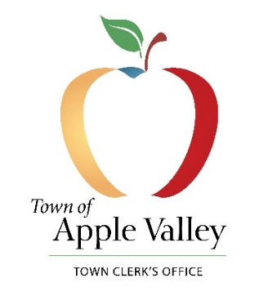

**NOTICE OF PUBLIC HEARING**

***NOTICE IS HEREBY GIVEN*** that a Public Hearing will be held before the Apple Valley Town Council in the Town of Apple Valley, California on the following date:

***DATE OF HEARING:*** Tuesday, February 8, 2022

***TIME OF MEETING:*** 6:30 p.m.

***TIME OF HEARING:* 7:30 p.m.**

***PLACE OF HEARING:*** Town of Apple Valley, Town Council Chambers  
 14955 Dale Evans Parkway  
 Apple Valley, CA 92307

As required by Assembly Bill 849, the Town Council will hold its first public hearing at which the public is invited to provide input regarding the redistricting process and composition of districts.

Any person affected or concerned by these proposals may submit written comments to the Town Clerk's office before the public hearing or appear and be heard in support of or in opposition to the proposals at the time of the public hearing. If you challenge these proposals in court, you may be limited to raising only those issues you, or someone else raised at the public hearing described in this Public Hearing Notice, or in written correspondence delivered to the Town Clerk at, or prior to the public hearing.

Any person interested in the proposals may contact the Town Clerk’s Office at 14955 Dale Evans Parkway, Apple Valley, CA 92307 or by calling 760-240-7000, ext. 7800 during normal business hours. Any information available for public inspection will be available for review at the above address.

I, La Vonda M-Pearson, Town Clerk for the Town of Apple Valley, do hereby certify that I caused to be posted the foregoing Notice of Public Hearing on Tuesday, January 31, 2022, at 12:00 p.m.

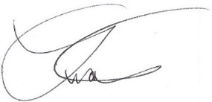

____________________________  
 La Vonda M-Pearson  
 Town Clerk