NOTICE OF PUBLIC HEARING

THE TOWN OF APPLE VALLEY PLANNING COMMISSION WILL MEET ON WEDNESDAY, JUNE 15, 2022 AT 6:00 P.M.

14955 DALE EVANS PARKWAY
APPLE VALLEY, CA 92307

A HEARING HAS BEEN SCHEDULED BEFORE THE TOWN OF APPLE VALLEY PLANNING COMMISSION TO CONSIDER THE FOLLOWING:

CASE NUMBER: General Plan Amendment No. 2021-002; Zone Change No. 2021-001; Specific Plan No. 2021-001

APPLICANT: Town of Apple Valley and the Village Property and Business Improvement District (PBID)

PROPOSAL: The Village Specific Plan guides the long-term development and redevelopment of the Planning Area. It revises the current land use plan by establishing five (5) planning districts, each with its own land uses, development standards, and guidelines that are tailored to the district’s existing uses, development potential, and community vision. The Specific Plan is intended to enhance the Village’s identity as a downtown shopping and dining destination, guide future development of vacant parcels and redevelopment of underutilized parcels, and protect residential neighborhoods with guidelines that scale down development at the periphery of the Village. It expands the mix of land uses to serve local and sub-regional markets while also preserving small-scale and locally owned businesses. It coordinates various aspects of infrastructure planning, infill development, and lot consolidation, where appropriate. Its transportation concept improves the functioning of Highway 18 in the Planning Area by minimizing traffic conflicts, integrating multimodal features, and improving access to provide an efficient and safe circulation system. Its vision and development standards and guidelines are consistent with General Plan goals and policies.

ENVIRONMENTAL
DETERMINATION: The potential impacts of the Project were determined to be less than significant for the following topics: energy, hazards and hazardous materials, hydrology and water quality, land use and planning, public services, and utilities. The potential impacts of the Project were determined to be less than significant with mitigation measures identified in the Draft EIR for the following topics: Aesthetics, Air Quality, Biological Resources, Cultural Resources, Energy, Geology and Soils, Hazards and Hazardous Materials, Hydrology and Water Quality, Land Use and Planning, Noise, Population and Housing, Public Services, Recreation, Transportation, Tribal Cultural Resources, and Utilities/Service Systems. The potential impacts of the Project were determined to be significant and unavoidable for Greenhouse Gas Emissions.

LOCATION: The planning area includes 651± acres north and south of the State Highway 18 corridor generally between Navajo Road and Central Road. The planning area is in the east central portion of Apple Valley in southwestern San Bernardino County.
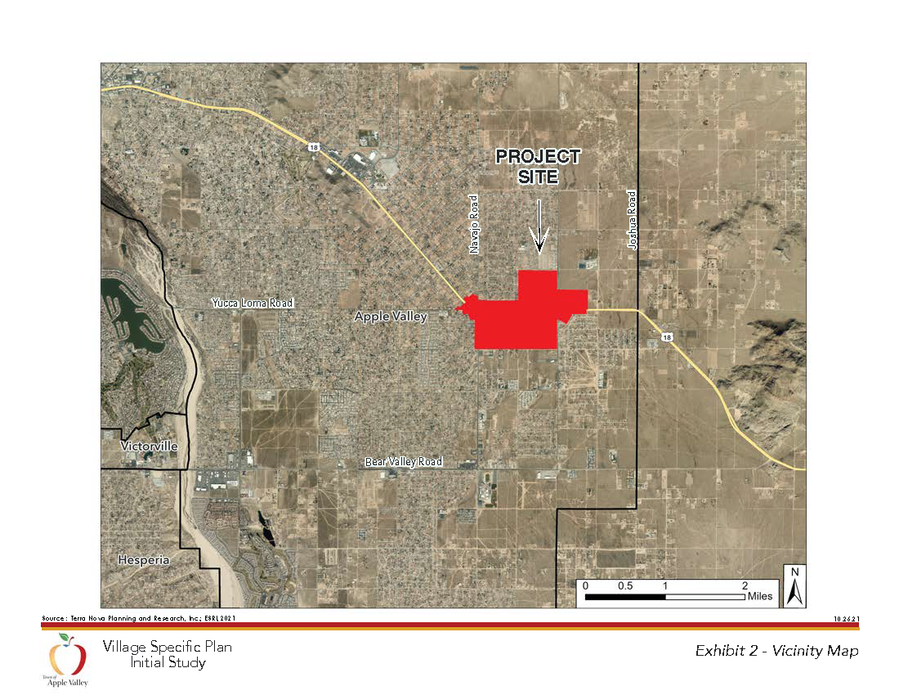

IMPORTANT NOTICE

THE MEETING IS BROADCAST LIVE AND VIEWABLE ON FRONTIER CHANNEL 29 OR CHARTER SPECTRUM CHANNEL 186 AND LIVE STREAMED ONLINE AT APPLEVALLEY.ORG.
FOR INDIVIDUALS NOT PHYSICALLY PRESENT AND STILL WISHING TO MAKE PUBLIC COMMENTS, YOU MAY COMMENT IN ONE OF TWO WAYS: 1) COMMENTS AND CONTACT INFORMATION CAN BE EMAILED TO PUBLICCOMMENT@APPLEVALLEY.ORG BY 12 P.M. WEDNESDAY, JUNE 15, 2022, TO BE INCLUDED IN THE RECORD; 2) A REQUEST TO SPEAK CAN BE EMAILED TO THE SAME ADDRESS AS ABOVE AND AT THE TIME OF THE REQUESTED AGENDA ITEM, THE PLANNING COMMISSION SECRETARY WILL PLACE A PHONE CALL TO THE COMMENTER AND ALLOW THEM TO SPEAK TO THE PLANNING COMMISSION VIA SPEAKER PHONE DURING THE LIVE MEETING FOR UP TO THREE MINUTES.

The proposed project application and environmental finding(s) may be viewed at the Town of Apple Valley Planning Division, located at 14955 Dale Evans Parkway, Apple Valley, CA, Monday through Thursday between 7:30 a.m. and 5:30 p.m., and alternating Fridays between 7:30 a.m. and 4:30 p.m. (closed the subsequent Fridays). Should you have any questions concerning this project, please contact Daniel Alcayaga, Planning Manager at (760) 240-7000, ext. 7205 or email dalcayaga@applevalley.org. A full copy of the analysis of this proposal will be available on the Town’s website at “www.applevalley.org” roughly three days prior to the meeting.

The Planning Commission in its deliberation may recommend approval, denial or recommend modifying the project.

If you challenge the project in court, you may be limited to raising only those issues you or someone else raised at the Public Hearing described in this notice, or in written correspondence delivered to the Town Planning Division at, or prior to, the Public Hearing.

