**TOWN OF APPLE VALLEY**

**NOTICE OF PREPARATION**

**PROJECT TITLE:**

**THE DEVELOPMENT AT DALE EVANS AND LAFAYETTE**

**CONTACT PERSON:** Daniel Alcayaga, Planning Manager

Email: [dalcayaga@applevalley.org](mailto:dalcayaga@applevalley.org) Phone: (760) 240-7000 x7200

**PROJECT LOCATION:**

Southeast corner of Lafayette Street and Dale Evans Parkway in the Town of Apple Valley.

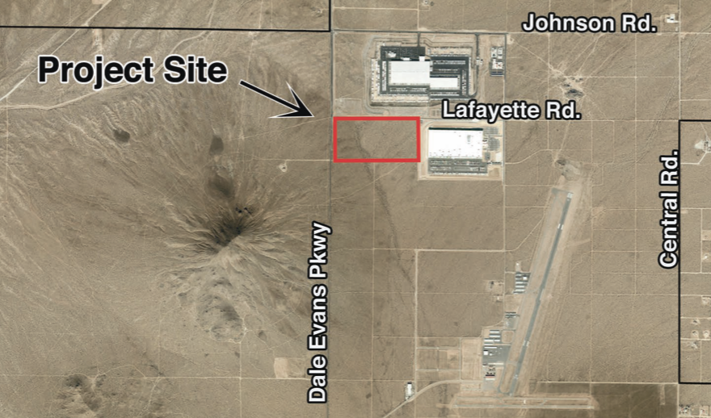**PROJECT DESCRIPTION:** The project proposes to develop a 1,207,544 square foot warehouse distribution center on a 77± acre parcel of land in north Apple Valley. The project site is bounded by Lafayette Street to the north, Dachshund Avenue to the east, Burbank Avenue to the south, and Dale Evans Parkway to the west. The project site is within the boundary of the North Apple Valley Industrial Specific Plan (NAVISP), which aims to accelerate the Town’s future economic growth by attracting high quality industrial facilities. The project site is subject to the standards and restrictions codified in the NAVISP. Under the NAVISP, the project site is designated as Industrial – Specific Plan (SPI). Manufacturing facilities, regional warehousing facilities, and support services are all land-uses that are appropriate for the SPI designation. The project will require a Design Review application approval.

**FINDINGS/DETERMINATION:** The Town has reviewed and considered the proposed Project and has determined that potentially significant impacts could result from the proposed Project. Therefore, an Environmental Impact Report should be prepared. Based on the location and characteristics of the proposed Project, the EIR will include analysis of potentially significant effects on the environment related to the following topics: Aesthetics, Air Quality, Biological Resources, Cultural Resources, Energy, Geology and Soils, Greenhouse Gas Emissions, Hazards and Hazardous Materials, Hydrology and Water Quality, Land Use and Planning, Noise, Population and Housing, Public Services, Recreation, Transportation, Tribal Cultural Resources, and Utilities/Service Systems.

**PUBLIC REVIEW PERIOD:** A 30-day public review period for the Notice of Preparation will commence on December 16, 2022 and end on January 16 2023 for interested individuals and public agencies to submit written comments on the document. Any written comments on the Notice of Preparation must be received at the Town address (14955 Dale Evans Parkway) or via email to Daniel Alcayaga at [dalcayaga@applevalley.org](mailto:dalcayaga@applevalley.org) within the public review period. Copies of the Notice of Preparation and Initial Study are available for review on the Town’s website at www.applevalley.org.