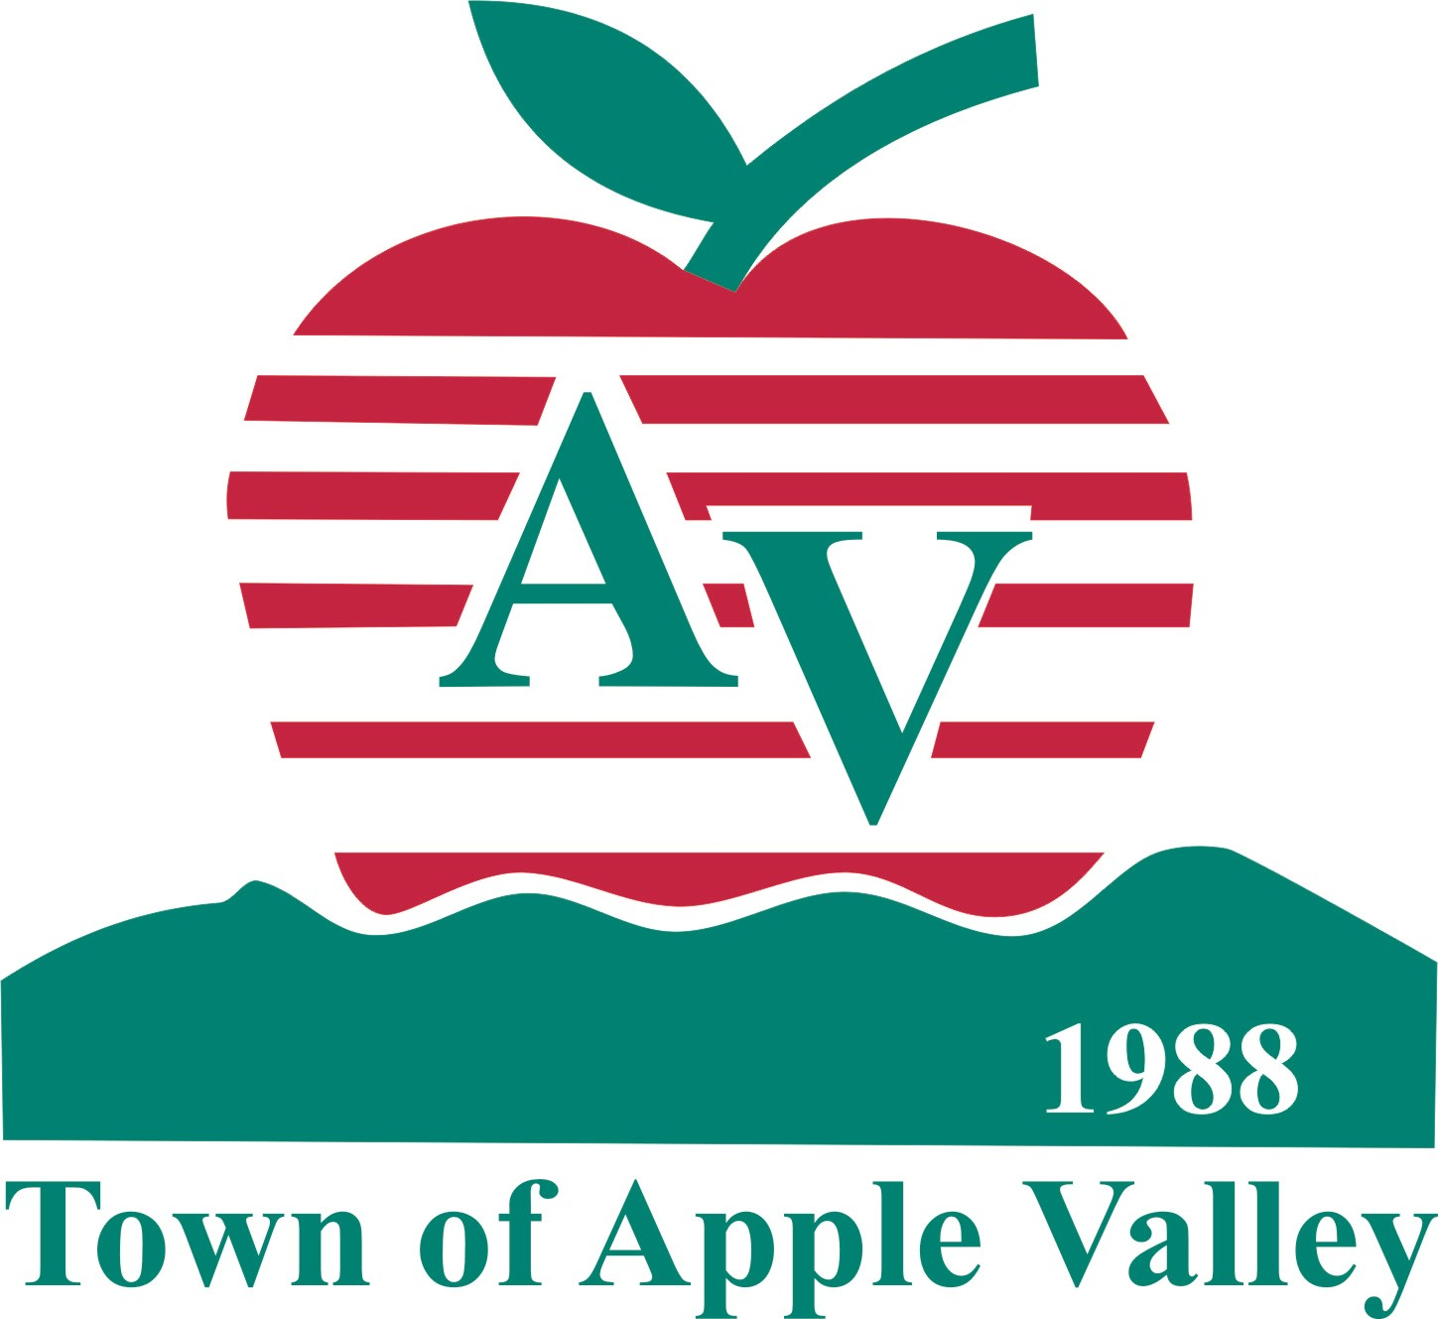

TOWN OF APPLE VALLEY
NEIGHBORHOOD STABILIZATION PROGRAM/DOWNPAYMENT ASSISTANCE PROGRAM (NSP/DAP)
INSPECTION RESULTS

Date:

Property:

Buyers:

During a recent inspection of the above referenced property, the following items were identified as requiring corrections:

- (List the defects . . . of the property)

