Town of Apple Valley
NSP/DAP WIRING INSTRUCTIONS

Bank
From Prelim Title Wiring Instructions
Name
Address
City, State, Zip

ABA(Routing #)
Account Number
Reference (Title Order #)

Account Holder

Name (Title Co)
Contact (Title Co)
Order No. (Title Order #)
Address
City, State, Zip
Phone
Fax
Email
In Trust For Buyer
Reference File # (TOAV Finance Code)

Amount: $

Approval:

Kenneth J. Henderson, Assistant Town Manager- Economic and Community Development Date

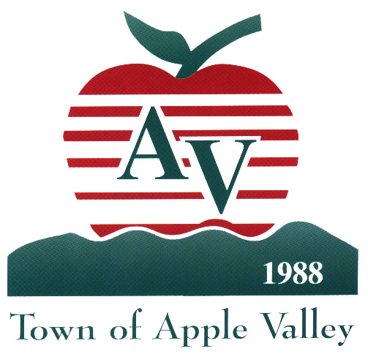

TOWN OF APPLE VALLEY

M E M O R A N D U M

DATE: July 28, 2026

TO: Bill Pattison

Assistant Town Manager, Finance and Administration

FROM: Christopher Moore
Housing and Community Development Specialist

RE: Neighborhood Stabilization Program/Downpayment Assistance Program (NSP/DAP)
Request for Wiring of Funds

COPIES: Cindy Amagrande, Housing & Community Development Specialist II
Kaye Reynolds, Assistant Director of Finance

The Town of Apple Valley anticipates closing a Neighborhood Stabilization Program/Downpayment Assistance Program (NSP/DAP) Loan. The Town has received the executed loan closing documents; please wire the funds as indicated below.
This loan is to be funded by HERA funds through the U.S. Department of Housing and Urban Development (HUD).

Applicant Information

NSP/DAP Applicant Title Order Number :

Applicant Name(s):

Address:
Apple Valley, CA 9230

DAP Loan Amount: $

NSP/DAP Account Finance Code

Attached are the wire instructions for the afore-mentioned loan. The estimated closing date for this loan is . Please reference title order number, name and address. Should you need additional information or clarification, please call me at extension 7921.

Town of Apple Valley

Wire Transfer Request Form

Today’s date:

Requested by:

Make Wire Transfer Payable to (name and mailing address):

Amount: $

Coding:

Description:

Department Approval:

Special Handling Instructions:

Finance Only:

Vendor Number:

Revised 09/09/09

