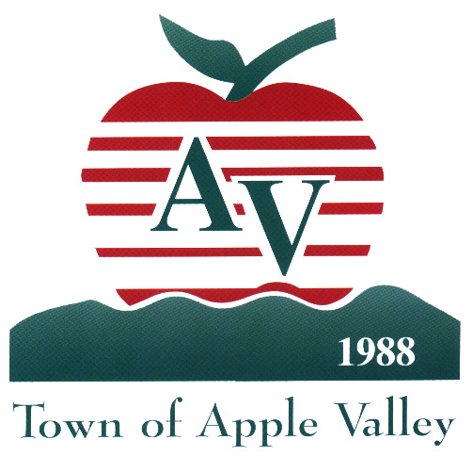

Town of Apple Valley

14955 Dale Evans Parkway, Apple Valley, California 92307

July 31, 2026

Re: Town of Apple Valley Neighborhood Stabilization

Program/Downpayment Assistance Program (NSP/DAP)

Dear Lender:

Thank you for attending the Town of Apple Valley Lender’s Training for the (NSP/DAP). If you are interested in becoming a participating lender, please complete and submit your Lender Application today prior to leaving the training. Also, complete and return the Participating Lender Agreement along with the required documentation at your earliest convenience.

As mentioned at the lender training, all eligible lenders are required to complete a Lender Participation Agreement. Enclosed is an original Agreement for review and execution. Please have three (3) copies of the Agreement signed by the authorized signatory for your company and promptly return the three (3) signed originals to our office. Once the signed application and Agreements are received and executed by the Town, a copy will be returned to your office. Receipt of the Agreement is proof that your company has been approved as a participating lender. Your company will be added to the Town’s Participating Lender’s List that will be displayed in marketing material and on the Town’s website.

Additional notes regarding submitted Lender’s Participation Agreement:
-Provide a corporate resolution authorizing the signer to bind the corporation.
-An acknowledgment notarizing his or her signature is required and must be attached to the signature page of all agreements.
-Affix the corporate seal to all signature pages of all agreements.

In addition to a copy of the executed Agreement, you will receive access to the required NSP/DAP forms. All forms and procedures information should be managed by the designated ‘responsible contact person’ for each office. The ‘responsible contact person’ is also designated to review and approve all NSP/DAP loan packages prior to submission to the Town.

Again, thank you for your interest and we look forward to a productive working relationship. Should you need additional information, an application or clarification, please call me at (760) 240-7000 extension 7921

Sincerely,
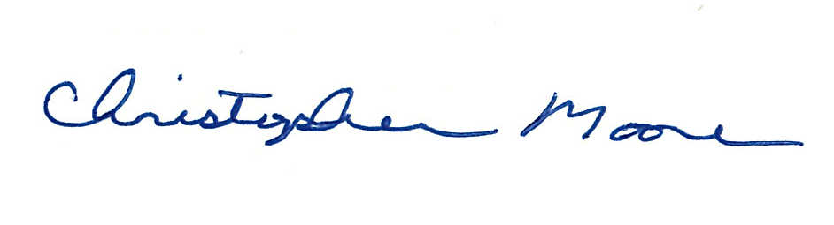

Christopher Moore

Housing and Community Development Specialist

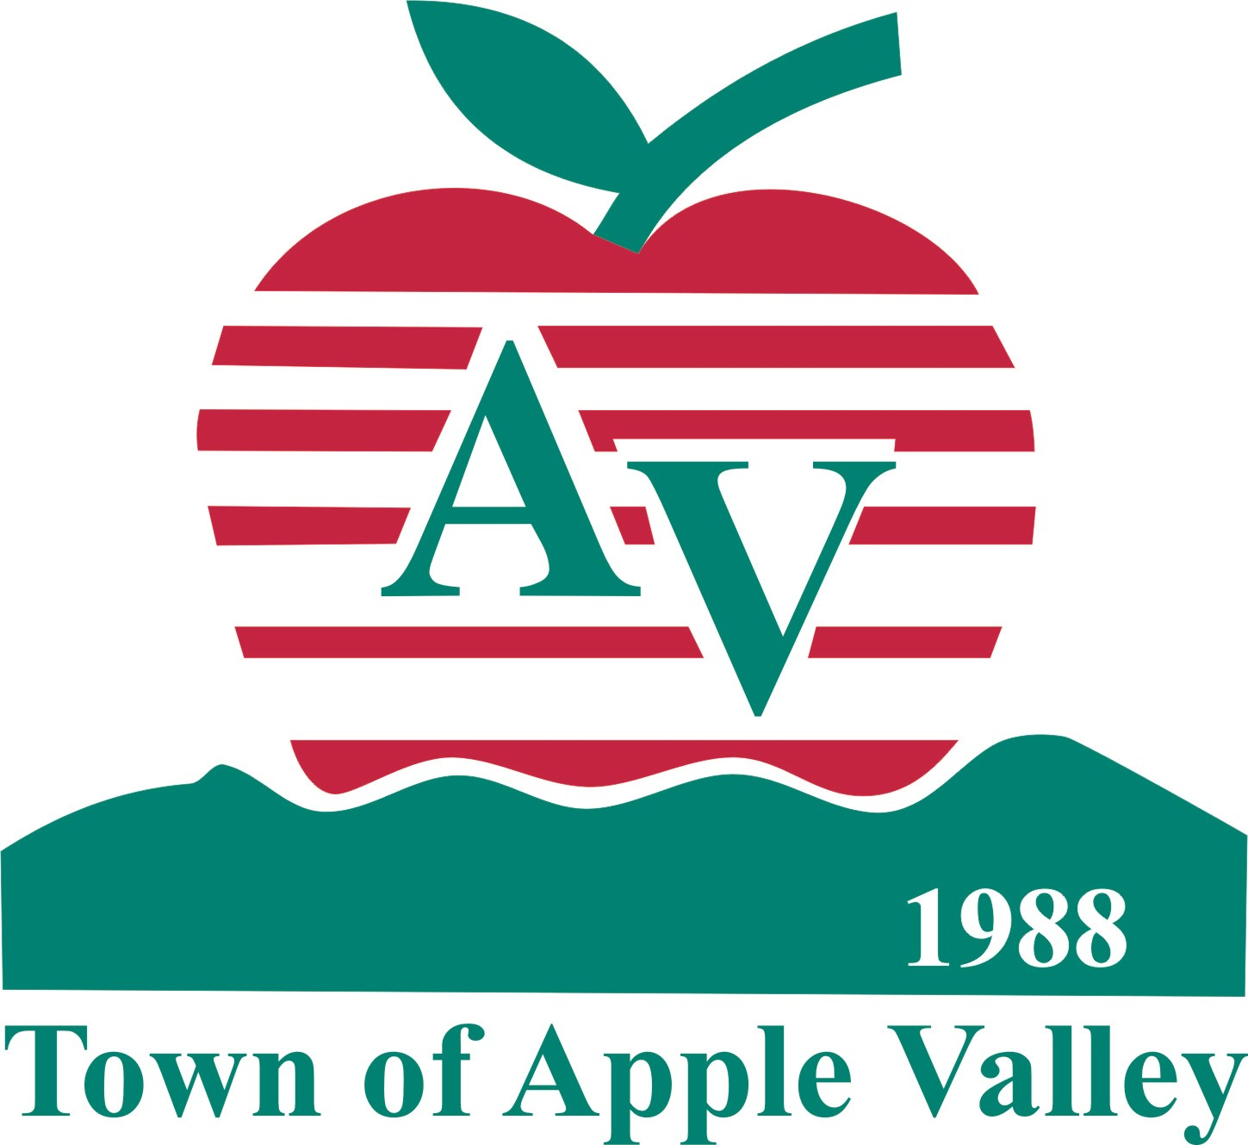
Town of Apple Valley
Economic Development Department
LENDER PARTICIPATION AGREEMENT
Neighborhood Stabilization Program/Downpayment Assistance Program NSP/DAP

This Lender Participation Agreement (the “Participation Agreement”) is made and entered into as of the day of ,2010, by and between the Town of Apple Valley, (hereinafter referred to as “Town”) and (hereinafter referred to as the “Lender”).

WHEREAS, the Lender wishes to participate in the Program administered by the Town in connection with NSP/DAP loans it will make available for the acquisition of single-family housing.

NOW, THEREFORE, the Town and the Lender mutually agree as follows:

Section 1. REPRESENTATIONS AND WARRANTIES

The Lender hereby covenants and represents to the Town as follows:

a) The Lender is a duly organized and existing corporation currently in good standing under the laws under which it was formed.

b) The Lender has attended a training session provided by the Town for the NSP/DAP and is familiar with the general Program description as contained in the NSP/DAP Policies and Procedures Manual and is familiar with the unique underwriting requirements of the Program as outlined in the “Lender's Certification of Applicant Eligibility”.

c) The Lender acknowledges that a NSP/DAP loan can only be used in conjunction with a fully amortized, level-pay, fixed rate thirty (30) year first mortgage for a home which is to be occupied by the buyer as his or her primary residence and that NSP/DAP applicants must accept the highest-ratio fixed-rate loan for which they qualify.

d) The Lender agrees that prior to requesting a reservation of Program funds, sufficient due diligence investigation shall be performed to determine the preliminary eligibility of the applicant to participate in the Program and the eligibility of the home to be acquired.

- The Lender acknowledges that the Certification of Applicant Eligibility, signed by the Lender and the applicant(s), must be submitted in conjunction with the NSP/DAP Reservation and is aware that a reservation of funds does not ensure loan approval, but merely reserves funds while the loan application is being processed (see Exhibit B).
f) The Lender acknowledges that a true and correct copy of the Fannie Mae Transmittal Summary Form 1008 or a true and correct copy of the FHA Mortgage Credit Analysis Worksheet, Form 92900-WS, in addition to a complete copy of the loan file utilized by Lender for underwriting purposes, must be submitted to the Town along with the “Lender’s Certification of Applicant Eligibility” before the Town will take action on any loan. Approval or denial of the NSP/DAP loan is at the sole discretion of the Town.

g) The Lender agrees that once funds are reserved for an applicant, the Lender shall immediately notify the Town in the event the applicant is found to be ineligible for participation in the Program or fails to qualify for a first mortgage loan.

h) The Lender agrees that no person shall be excluded from employment in the performance of this Participation Agreement on grounds of race, creed, color, sex, age, marital status, or place of national origin. In this connection, the Lender agrees to comply with all county, state and federal laws relating to equal employment opportunity rights.

i) The Lender agrees that there shall be no discrimination against, or segregation of, any person, or group of persons on account of sex, marital status, race, color, religion, creed, national origin or ancestry for participation in the NSP/DAP.

j) The Lender agrees that if the Lender is not a direct lender, with an underwriter on staff, that the Lender shall originate loans through a direct lender approved by the Town NSP/DAP. The Lender agrees to have the Fannie Mae Transmittal Summary Form 1008 or the FHA Mortgage Credit Analysis Worksheet Form 92900-WS prepared and executed by an approved lender for the Town’s NSP/DAP.

Section 2. The Lender agrees to indemnify and hold harmless the Town and the Agency and their officers, employees, and agents, against any and all losses, claims, damages, liabilities and expenses, including attorney’s fees arising from any act or omission of the Lender or any of its agents, employees or licensees due to failure on the part of the Lender to abide by the requirements of the NSP/DAP or the provisions of this Participation Agreement. In the event that any action or proceeding is brought against the Town or Agency, with respect to which indemnity may be sought hereunder, the Lender upon written notice from the indemnified party, shall assume the investigation and defense thereof, including the employment of counsel satisfactory to the indemnified party and the payment of all expenses related thereto; provided, however, that the Town and/or the Agency shall have the right to review and approve or disapprove any compromise or settlement in connection with any such claim brought against it or proceeding to which it is a party. The requirements contained in this Section 2 shall survive any expiration or termination of this Participation Agreement.

Section 3. The Lender acknowledges that the Town will not reserve exclusively for the Lender any portion of the Town’s funding appropriated for the Program. Neither the Town nor the Agency shall have any liability or responsibility for any expenses incurred by the Lender in connection with the Lender’s participation in the NSP/DAP.

Section 4. The Participation Agreement shall be governed by the laws of the State of California. Venue shall be in San Bernardino County.

Section 5. The Participation Agreement constitutes the entire agreement and supersedes any prior agreements and understandings, both written and oral, with the Lender with respect to the NSP/DAP.

Section 6. The Participation Agreement may not be assigned by the Lender without the prior written consent of the Town.

Section 7. The Participation Agreement may be executed in several counterparts, each of which shall be an original and all of which shall constitute but one and the same instrument.

Section 8. Any notice required or desired to be served by either party upon the other shall be addressed to the respective parties as set forth below.

AS TO TOWN: | AS TO LENDER:
KENNETH J. HENDERSON
Assistant Town Manager, Economic & Community Development
Town of Apple Valley
14955 Dale Evans Parkway
Apple Valley, CA 92307
Tel. (760) 240-7000 Ext. 7900
Fax (760) 240-7910

Section 9. The undersigned certifies that he or she is authorized to sign this Participation Agreement on behalf of the Lender.

Section 10. The parties further agree as follows:

- The Town hereby designates the Lender as its agent for receipt and processing of applications for NSP/DAP under the Program.

- The Lender agrees to prepare its representatives to work on NSP/DAP by providing them with training and materials, including NSP/DAP Procedures Manual and NSP/DAP forms and processes.

- The Lender shall make information regarding NSP/DAP available to potential borrowers. The Lender shall process and review the application for any potential borrower in order to determine eligibility for the Program.

- The Lender shall perform all investigation and verification that it would normally perform for underwriting a mortgage to provide in connection with NSP/DAP. The Lender shall notify the borrower and the Town in writing of any decision to cancel processing for NSP/DAP.

- The Lender shall conduct such reasonable investigation as is necessary to certify that the applicant has satisfied all requirements for NSP/DAP eligibility.

- The Lender warrants that it is familiar with the NSP/DAP guidelines established by the Town. The Lender hereby agrees to comply with all provisions of applicable federal, state and local laws, and said regulations and guidelines.

- The Lender agrees to comply with the terms of the Town’s NSP/DAP Quality Commitment Policy, the terms of which are incorporated into this Participation Agreement by reference. See Appendix ‘A’.

Section 11. The Lender shall charge a potential borrower applying for NSP/DAP only those reasonable fees, as would be charged to any other potential borrower applying for a first mortgage.

Section 12. The Lender hereby agrees that it shall make a reasonable effort to forward to the Town any information which it may receive during the life of the mortgage loan which tends to indicate that a misrepresentation was made in applying for NSP/DAP, that may affect the applicant’s continued eligibility for NSP/DAP.

Section 13. This Participation Agreement shall remain in full force and effect until terminated. The Lender and the TOWN may terminate this Participation Agreement, without cause, upon sixty (60) days written notice. The Town may immediately terminate this Participation Agreement and prohibit the Lender from participation in the NSP/DAP upon the Lender’s failure to comply with the terms and conditions of this Participation Agreement and upon written notice by the Town. No amendment to this Participation Agreement shall be effective unless in writing and signed by both parties hereto.

THIS PARTICIPATION AGREEMENT is entered into as of the first day and year written above.

Lender: Office Location:

By: Email Address:

Title:

Responsible Contact Person: Date:

Funding Lender Date:

Approved as to content:
Town of Apple Valley

By: _____________________________
Kenneth J. Henderson
Assistant Town Manager, Economic & Community Development

ACKNOWLEDGMENT
State of California
County of San Bernardino

On before me, , a notary public,

personally appeared , who proved to me on the basis of satisfactory evidence to be the person(s) whose name(s) is/are subscribed to the within instrument and acknowledged to me that he/she/they executed the same in his/her/their authorized capacity(ies), and that by his/her/their signature(s) on the instrument the person(s), or the entity upon behalf of which the person(s) acted, executed the instrument.

I certify under PENALTY OF PERJURY under the laws of the State of California that the foregoing paragraph is true and correct.

WITNESS my hand and official seal.

Signature ______________________________ (Seal)
Appendix ‘A’

NSP/DAP

QUALITY COMMITMENT POLICY

Town of Apple Valley Economic Development and Housing Department invites the mortgage lending community to participate in the Neighborhood Stabilization Program/Downpayment Assistance Program (NSP/DAP). I, _______________________________________ (“Lender”) agree to uphold the Town’s NSP/DAP Quality Commitment Policy as set forth herein.

Participation will continue to be open to approved mortgage lenders who uphold the following work standards in processing the NSP/DAP Loan for the Town of Apple Valley.

- Each Lender enrolled in the Program designates a NSP/DAP Responsible Contact Person for each participating branch. The Contact’ s responsibilities include (1) Preparing Lender Update letters (including attachments) available to all NSP/DAP-related personnel in a timely manner; (2) attending at least one NSP/DAP training session per year; (3) notifying the Economic Development Department of any re-assignment regarding their role as contact person (4) assist in the training of staff involved in NSP/DAP loan packaging.
- Lending company personnel receive training in the NSP/DAP Loan before being assigned to prepare NSP/DAP packages. This training includes: NSP/DAP training sessions conducted by Lender and/or Responsible Contact Person; NSP/DAP Procedures Manual, forms and other training materials; NSP/DAP Lender Update letters including attachments and revised forms.
- Lenders are required to ensure the submission of NSP/DAP packages contain accurate information. All submissions must be typewritten.
- Additionally, the lender’s Contact person will be responsible for reviewing and approving loan applications prior to submission to the Town. The responsible Contact person will review for completeness, accuracy and eligibility in accordance with NSP/DAP guidelines.
- A Notice of expiration of the Commitment without the required paperwork having been submitted is to be responded to by the Lender in a timely manner, with the submittal of the necessary documentation to bring the delinquent file current or to close it out.
- The Lender obtains the Town of Apple Valley Commitment to issue the NSP/DAP loan before funding the loan.
- Each funding lender ensures that the closing or funding department of their company is aware of their obligations under the NSP/DAP Loan and is prepared to submit all necessary closing documentation in a timely manner.
- Buyers are treated fairly, receiving full and accurate explanation about the NSP/DAP Loan. For questions that the Lender cannot answer, the buyer is referred to the Economic and Community Development Department.

I, ________________________________, am responsible for the review and approval of NSP/DAP loan packages prior to submission to the Town of Apple Valley. I will ensure completeness, accuracy and eligibility and compliance with the Town of Apple Valley’s Neighborhood Stabilization Program/Downpayment Assistance Program NSP/DAP guidelines and procedures.

Lender signature Phone # Date

Responsible Contact Person Signature Phone # Date

EXHIBIT B (Sample)

TOWN OF APPLE VALLEY
14955 Dale Evans Parkway
Apple Valley, CA. 92307
(760) 240-7000, Ext. 7900

LENDER’S CERTIFICATION OF APPLICANT ELIGIBILITY

1. (“LENDER”) hereby states the following:

The Lender has accepted and reviewed the Neighborhood Stabilization Program / Downpayment Assistance Program (NSP/DAP) Application for:

Name(s):

Address:

Who shall be referred to as Applicant(s).

- This application was made in conjunction with an application for a first mortgage loan for the purchase of a single-family residence (the “Residence”) located at:

3. The Lender hereby certifies that the above-referenced property is an eligible property according to the Procedures Manual for the NSP/DAP.

4. The purchase price for the Residence is $

Current market analysis (CMA)/ Broker Price Opinion(BPO) value of property is $

Discount of purchase price relative to current market value %.
100% less (purchase price / current market value)
Minimum required is 1%. Provide copy of (CMA/ BPO).

5. The Lender is considering a first mortgage loan to the Applicant in the amount of $ which includes $ ___________for MIP/PMI. The lender certifies this is the maximum loan for which Applicant will qualify. The proposed total monthly payment (PITI and MIP/PMI premium) will be $ .

6. $ Amount of Buyer Contribution (Minimum 50% of required down payment.

7. The totals gross annual household income is $ for a household of , which is within the NSP/DAP income limits.

AMI Income Group- <50% , <80%, <120%

% Maximum assistance ( sales price + closing costs)

Maximum assist 30% of sales price + closing costs: Income < than 120% of AMI
45% “ “ “ “ 80% “
60% “ “ “ “ 50% “
8. $ Amount of assistance requested. (sales price less first mortgage less buyer contribution)

$ Amount of closing cost assistance requested.

$ Total Amount of assistance requested. (Not to exceed maximum assistance limits stated in NSP/DAP Procedure Manual; depending on income)

9. The Applicants will have $ in reserve after close of escrow.

10. Total gross annual income, as adjusted for family size, is less than 120% of the area median income in the San Bernardino County Area AND the total monthly payment (PITI & PMI) for the first mortgage loan cannot exceed 30% of total household gross monthly income. It is %. The applicant’s top ratio is and the back end ratio is . The back end ratio cannot exceed 45%.

11. Lender hereby certifies that upon review of Household’s income tax returns, the applicant(s) has had no present ownership interest in a principal residence at any time during the past three (3) years* prior to (date of application).

12. The Lender has charged the Applicant(s) only those reasonable fees as would be charged to a potential borrower applying for a mortgage loan, which is NOT in conjunction with the NSP/DAP. (Submit copy of Good Faith Estimate.)

13. Based upon a reasonable investigation, the Lender has no reason to believe that the Applicant(s) has made any negligent or fraudulent statements, nor any material misstatements in connection with this application for downpayment and closing cost assistance.

14. Lender certifies that all files and records pertaining to any NSP/DAP application will be retained by Lender for a period of five years and made available for random audits by the Town of Apple Valley and/or its successors and/or Assigns.

15. In the event that Lender’s first mortgage loan will be sold to the Federal National Mortgage Association (“FNMA”), Lender certifies that a valid contract is in existence between Lender and FNMA allowing for the sale of mortgage loans pursuant to FNMA’s Community Partnership Program.

16. Eligible NSP-DAP target area – property located on Target Area map, within eligibility area. See Realtor’s Certification NSP-DAP 229 submitted with accepted purchase contract.

17. A complete copy of the loan package is provided herewith.

By:

Printed Name:

Title:

Date:

