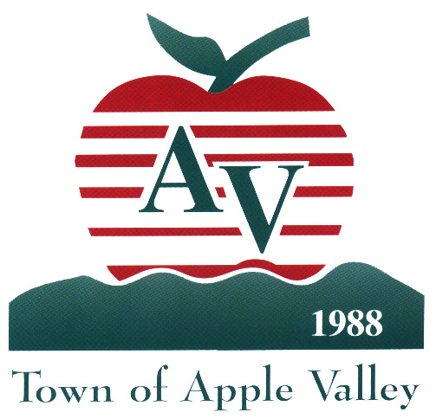

Town of Apple Valley

14955 Dale Evans Parkway, Apple Valley, California 92307

June 23, 2009

Town of Apple Valley Neighborhood Stabilization Program/Downpayment
Assistance Program (NSP/DAP)

PROGRAM UPDATES: 1% Purchase Discount; Qualifying First Time Homebuyers- Manufactured
Home Owners on Leased Land; 50% Maximum towards Down Payment; Maximum Assistance inclusive of Loan Gap, Down Payment and Closing Costs.

Dear Participating Lenders:

As the NSP/DAP program progresses, some guidelines may be updated or clarified. Occasionally, letters will be sent to update the Participating Lenders regarding these changes. Please respond as needed and update your program files and procedures.

1% Minimum Purchase Discount
Effective immediately HUD has reduced the required purchase discount to a minimum one percent (1%). This discount must be shown as a reduction from the current market value, not list price.

Qualifying First Time Homebuyers- Manufactured Home Owners on Lease Land
Owners of Manufactured Homes in parks on leased land will be considered as first time homebuyers for the NSP/DAP program.

HUD Limitation on NSP/DAP Down Payment Assistance
HUD clarified permissible uses for down payment assistance. NSP/DAP monies can be used for gap financing of a soft second, buyer’s closing costs and up to 50% of required down payment.

Maximum Assistance Provided by Town Inclusive of Loan Gap, Down Payment and Closing Costs
The maximum NSP/DAP Loan to be provided by the Town of Apple Valley will be determined based on the category of Income Group (50%, 80%, 120% of Area Median Income). The maximum loan assistance (30%, 45%, 60%) is inclusive of loan gap financing, down payment and closing costs.

Again, thank you for your interest and we look forward to a productive working relationship. Should you need additional information or clarification, please call me at (760) 240-7000 extension 7921

Sincerely,
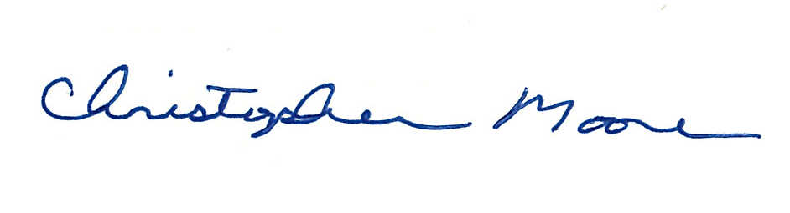
Christopher Moore

Housing and Community Development Specialist

