Chapter 9.37 Commercial and Office Districts Design Standards (Amended Ord. 236, 239, 251, 265, 272, 290, 291, 313)
Sections:
9.37.010 Purpose and General Plan Consistency 1
9.37.015 Applicability (Amended Ord. 236, 265, 291) 1
9.37.020 Site Planning (Amended Ord. 272) 2
9.37.030 Grading 3
9.37.040 Access and Circulation 4
9.37.050 Landscaping 8
9.37.060 Buffering and Screening 11
9.37.070 Walls and Fences 13
9.37.080 Architecture (Amended Ord. 239, 313) 14
9.37.090 Lighting (Amended Ord. 251, 290) 16

9.37.010 Purpose and General Plan Consistency
A. Purpose. The purpose of this Chapter is to implement the Town General Plan and Comprehensive Economic Development Plan goals, objectives, and policies and to complement the development standards for the various types of development found in Chapters 9.35 and 9.36 and the Performance Standards, Chapter 9.70, of this Development Code with respect to the design features of a given project. In addition, the purpose of these standards is to assist the developer in understanding the Town's goals and objectives for high quality commercial development, as described in the General Plan. The design standards that follow are therefore provided to:
1. Improve the site planning and appearance of Office, Commercial and Mixed Use districts through the application of modern and creative solutions to common and repeated design problems found throughout the Town;
2. Provide a clear and consistent set of design standards to assist the development community in comprehending the Town's intent in regulating design quality and ensuring that the long-term goals of the Town are met;
3. Create an identifiable community image through urban design and planning excellence that will create a visually unified and coherent community resulting in consistent recognition and association of a certain quality of place with the name 'Apple Valley';
4. Promote office and commercial development capable of strengthening the local economy and enhancing the quality of life for Apple Valley residents;
5. Protect the property values of existing business areas from inappropriately designed or scaled projects and enhance the investment of residents and business owners;
6. Encourage and promote designs which related to and are compatible with the region's desert environment.
B. Intent. The overall intent of these standards is to provide a framework that defines the type of built environment desired by the Town that can be used by developers, Town staff, the Planning Commission and the Town Council to design and evaluate development proposals. These standards are also intended to be used as minimums to evaluate standards proposed as a part of future specific plans and Planned Commercial Developments.

9.37.015 Applicability (Amended Ord. 236, 265, 291)
A Development Permit allows for the architectural/aesthetic review of structures permitted by this Code for the various zoning districts. A Development Permit is not required if a Conditional Use Permit has been submitted and approved where the Commission has addressed the aesthetics and site design issues required under a Development Permit.
A Development Permit approved by the Planning Commission shall be required for all residential tract maps (except single family residential homes built upon individual lots), parcel maps where conditioned by the Commission at time of tentative approval, commercial, office and industrial development, and Mixed Use projects within the Town of Apple Valley. Additionally, any addition, reconstruction or relocation totaling more than 50% of the existing floor area, or 2,500 square feet, or exterior remodeling or construction altering the exterior appearance of the structure requiring a building permit or discretionary review within any residential (except single family residential homes built upon individual lots), commercial, office or industrial district shall be subject to Planning Commission approval of a Development Permit.
Approval of a Conditional Use Permit shall be required for any new structure of 230,000 square feet or larger within any Commercial Zoning District or 750,000 square feet or larger within any Industrial Zoning District as provided in Chapter 9.16 “Conditional and Special Use Permits”. Said Conditional Use Permit requirement shall also apply to additions or alterations that result in an existing building being enlarged beyond the thresholds noted above.

9.37.020 Site Planning (Amended Ord. 272)
A. General
1. Significant site features such as Joshua trees, topography, and natural rock outcroppings shall be preserved.
2. Buildings shall be sited to complement existing buildings and landscape, the shape of the parcel, and natural conditions such as topography and rock outcroppings and significant vegetation.
Figure 9.37.020-A

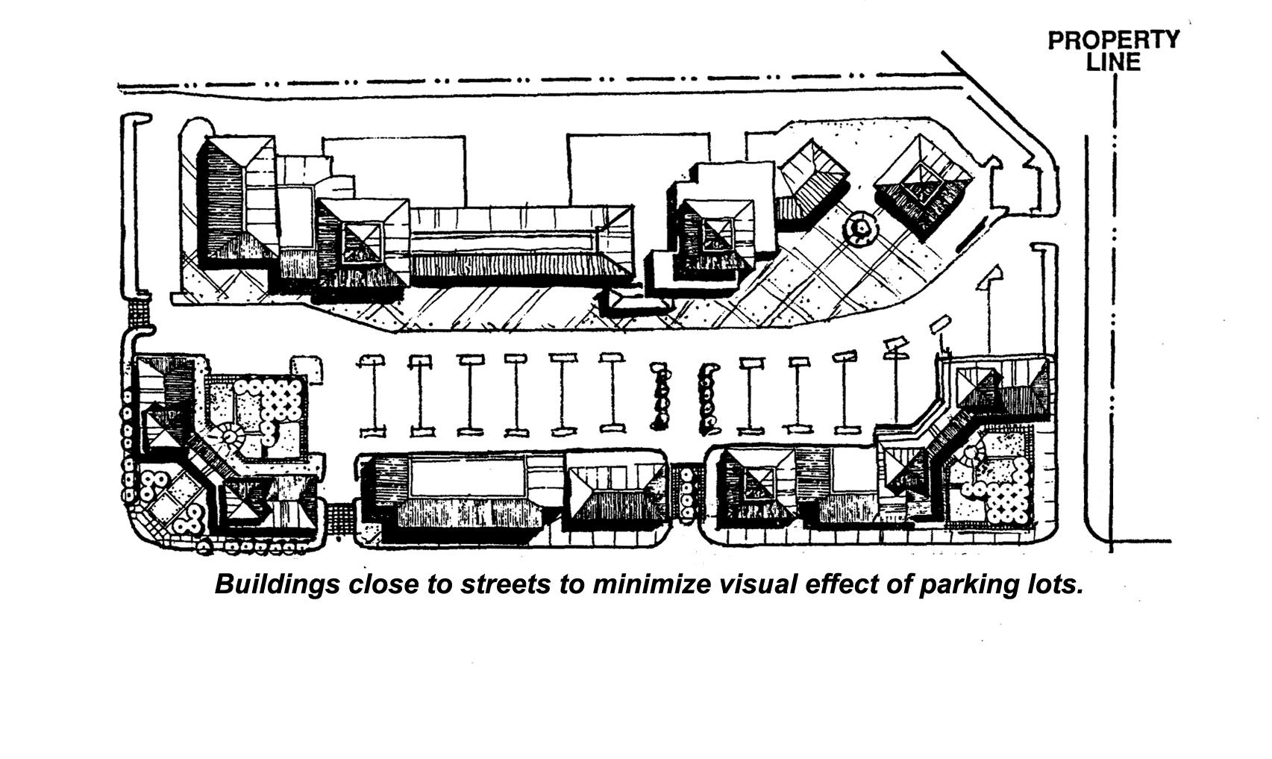

- Building footprints should be varied throughout a site plan. Repetitious or continuous expanses of rectangular buildings shall always be avoided in favor of varied and articulated footprints.
- Wherever possible, buildings shall be placed close to the street to create a more attractive streetscape, insure privacy of adjacent uses, and minimize the visual impact of large areas of pavement or parking from public streets (Figure 9.37.020-A).
- Building placement on adjoining parcels along a street shall be varied to avoid creating a monotonous blockface type streetscape.
- Buildings shall be clustered to optimize on-site open space and create opportunities for plazas and pedestrian circulation (Figure 9.37.020-B).
- Office and/or commercial uses shall be clustered with shared facilities, rather than developed in strips with separate facilities for each site.
- Arrangement of structures, landscaping and hardscape shall create view corridors into projects while still establishing a sense of arrival and place.
- Buildings shall be sited so that main entrances are generally oriented toward the driveways (parking circulation area).
- Encroachment onto utility or other public or private easement is prohibited. Buildings shall be sited or arranged so as not to encroach on any utility, public, or private easements.
- The orientation of buildings and activities on a site shall be compatible with the existing layout of the adjacent property.
- Curb cuts shall be kept to a minimum and driveways between parcels shall be shared whenever possible.
- Coordinated site design (including shared parking, driveways and circulation, sign facilities, landscaped areas and garbage collection areas) shall be encouraged on adjacent parcels with similar uses. Such coordination will typically involve (mutual access) rights-of-way over both properties or reciprocal easements and mutual access agreements.
- Adjacent parking lots shall be connected whenever possible to minimize conflicts along streets.
- All trash, loading and service areas shall be screened from public rights-of-way and adjacent residential uses or districts. Loading areas shall be located to the rear of the site and service bays shall be oriented away from public rights-of-way and adjacent residential uses or districts.
- Physical barriers (e.g. fences, walls, curbs) between adjacent parcels with similar uses shall be avoided unless necessary for security purposes.
- Solar Access. Buildings shall be designed and sited so that solar access for the buildable lot area of adjacent vacant properties are protected to the maximum extent feasible.
- Street Address. Street addresses shall be conspicuously displayed along the street frontage, and visible from the street, of any new construction or any development which is subject to a review and approval by the Planning Commission under a Development Permit as specified under Development Code Section 9.17.020 “Applicability”. Street addresses for structures of 50,000 square feet or less in size shall be electronically illuminated during the hours of darkness, with numbering a minimum of six (6) inches in height with a minimum three-quarter (3/4) inch stroke. Street addresses for structures over 50,000 square feet in size shall be electronically illuminated during the hours of darkness, with numbering a minimum of twelve (12) inches in height with a minimum one and one-half (1 1/2) inch stroke.
Where any such structure is located more than two-hundred (200) feet from the front property line, additional non-illuminated contrasting twelve (12) inch numbers shall be displayed at the property entrance.

9.37.030 Grading
A. General
1. Site grading and disturbance shall be minimized.
2. The site plan shall be designed to integrate the development into existing topography and natural vegetation as much as possible.
3. Grading for developable pads shall follow the contours of the existing landform. Mass grading, which can alter the integrity of the natural landform shall be avoided.
4. Terraces shall be used if more than six (6) feet of height is required in front or street side setback areas.
5. Transitions at top and toe of manufactured or cut and fill slopes shall be rounded.
6. Individual parcels shall be graded in such a way as to direct runoff away from buildings and into drainage facilities.
7. Grading and the use of berming within the streetscape shall be coordinated with development pad location and landscaping to screen parking or loading areas.
8. Detention/Retention and other drainage facilities shall be no larger than required to fulfill their function.

9.37.040 Access and Circulation
A. General
1. Separate vehicular and pedestrian circulation systems shall be provided. Pedestrian linkages between uses in commercial developments shall be emphasized, including distinct pedestrian access from parking areas in large commercial developments, such as shopping centers.
2. Clear Sight Triangle. Adequate visibility for vehicular and pedestrian traffic shall be provided by clear sight triangles at all ninety (90) degree angle intersections of public rights-of-way and private driveways. The Clear Sight Triangle is defined as the area within the triangle formed by connecting the points thirty (30) feet (10 feet at driveways) from the intersection of the two right-of-way lines. Trees within the Clear Sight Triangle shall be trimmed (to the trunk) to a line at least six (6) feet above the nearest street elevation (Figure 9.35.060-A).
3. Site access from major roads shall be minimized. Where no alternatives exist, turning lanes shall be provided. Stacking distances shall be determined by the Town Engineer who may require the applicant to prepare a traffic study (see Figure 9.37.040-A).
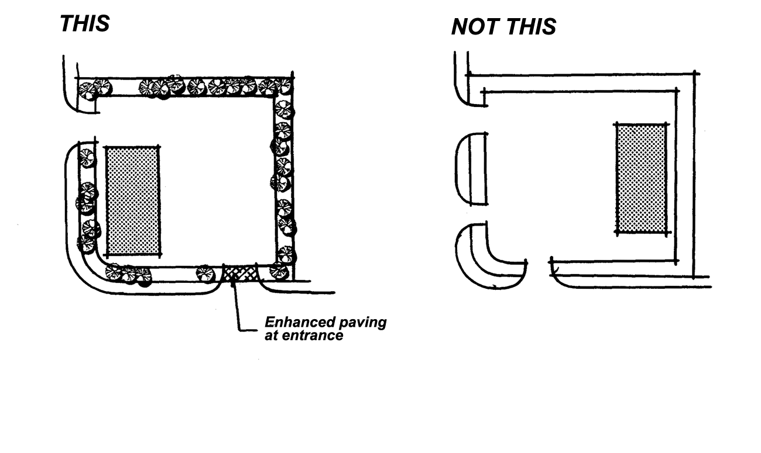

Figure 9.37.040-A Site Access

4. Corner lots with frontage on both major and secondary or local streets shall concentrate access on the secondary or local street wherever possible.
5. Driveway access to parking lots or garages shall be perpendicular to the right-of-way.
6. Driveway access shall be adequate to accommodate all emergency and delivery vehicles.
7. One-way driveways shall be limited to drive-in facilities or to where a two-way driveway is not possible.
8. Vehicular stacking distance at project entries and exits shall be provided as approved by the Town Engineering Division.
9. Directional arrows for one way entrances and exits shall be clearly defined on the pavement.
10. The location of curb cuts shall be reviewed and approved by the Town Engineer.
11. Access and parking reciprocity between parcels shall be accomplished whenever feasible to reduce the number of curb cuts and potential conflict points along streets.
12. On-site directional signs shall be used selectively to avoid cluttering the site with unnecessary signage or confusing directions.
13. Bricks, pavers or decorative stamped concrete should be used to accent and highlight street entries, corners, pedestrian walkways in parking areas and plaza or focal areas.
B. Parking Areas
1. Off-street parking areas shall be adequate to meet all of the parking and loading demands generated by the use as required by Chapter 9.72, Off-Street Parking and Loading Regulations, of this Code.
2. Parking areas shall be designed so that all vehicles shall enter and exist public streets in a forward movement only.
3. Parking areas shall be designed so that pedestrians walk parallel to moving cars. The need for pedestrians to cross parking aisles shall be minimized (Figure 9.37.040-B).
4. All parking spaces shall be clearly outlined on the surface of the parking facility with painted white lines or stone, brick, textured or smooth concrete banding.
5. Parking aisles shall be separated from vehicle circulation routes wherever possible.
- Where parking areas are connected across adjacent lots, interior circulation shall allow for a similar direction of travel and orientation of parking bays to reduce potential conflict at points of connection.
7. Parking within structures, including basement and roof parking, shall be considered whenever possible in order to minimize asphalt pavement and maximize open areas.

Figure 9.37.040-B Pedestrian Circulation in Parking Areas

C. Pedestrian Circulation
1. Pedestrian walkways shall be provided on both sides of Major, Secondary and local commercial streets and shall connect developments to one another as well as to adjacent lands uses.
2. On-site pedestrian walkways shall be provided for customers to walk safely from parking and street sidewalk areas to the central use area. Pedestrian walkways or crosswalks shall be provided for each major entrance of a building or center and each public entrance to a major tenant of a larger center or mall.
3. Pedestrian walkways shall be delineated through the use of textured paving and/or concrete pavers, landscaping, trellises and other hardscape features (Figure 9.37.040-C).
4. Pedestrian circulation areas shall include architectural and hardscape treatments that are at human scale and which create a pleasant environment which invites people to linger in commercial areas.
5. Pedestrian walkways shall connect developments through open space areas whenever possible.
6. The minimum planting areas between pedestrian walkways and sidewalks or the nearest curb shall be six (6) feet wherever possible.
7. Separations between bicycle and pedestrian circulation shall be provided whenever possible.

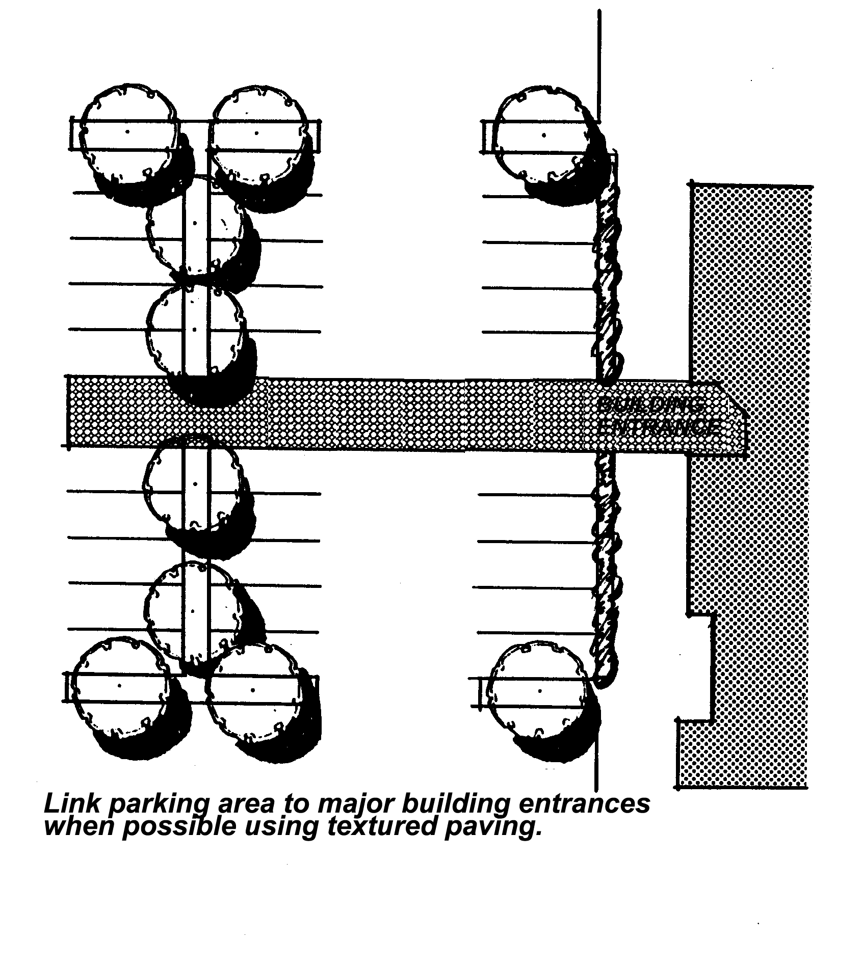

Figure 9.37.040-C Pedestrian Links

D. Transit Facilities. Recommendations of the local transit district shall be considered to ensure the provisions of adequate opportunities for transit services and facilities such as turnouts and bus shelters.
E. Visitor Serving Development. New recreation and visitor serving development is required to support special visitor serving recreation transit service where appropriate, including but not limited to construction of bus turnouts and shelters, parking spaces for buses and shuttle service, and bus passes for employees. Transit and bus parking facilities are required at all major hotel, motel, convention and other tourist serving areas.
F. Equestrian, Pedestrian and Bicycle Trails
1. Trails shall be provided and located as required by the General Plan; and
2. Trails shall be designed and constructed to meet the minimum standards provided by the Planning Division.

9.37.050 Landscaping
A. General
1. Landscaping, earth berms, decorative walls and other buffers shall be used to define project boundaries and to reduce impacts on adjacent properties.
2. Plant materials protected by Chapter 9.76, Plant Protection and Management, of this Code, shall be undisturbed or retained wherever possible during site development and shall be maintained with proper irrigation and regular pruning and clearing. Land disturbance shall be limited to thirty (30) feet surrounding the building, landscaping, circulation and parking areas.
3. Landscaping shall be provided around the entire base of structures to soften the edge between the parking lot and the structure, except at entrances, exits, loading and service areas, and zero (0) foot side or rear setbacks. Landscaping shall be accented at the building entrance.
4. Individual developments shall integrate on-site landscaping with the streetscape landscaping in the project vicinity.
5. Landscaping shall consist of native or drought-tolerant plants capable of surviving the desert environment and climate with a minimum of maintenance and supplemental watering. A list of plants determined capable of meeting this criterion is contained in Section 9.75.070 of this Code, Approved Plant List. Other plants may be considered on their merits in meeting this criterion. Determinations of plant species suitability will be made by the Director upon submission of project plans.
6. Landscaping shall be used to break up uninterrupted building mass, expanses of paved surfaces, frame views, and connect development on adjacent pads.
7. All landscaping shall utilize xeriscape practices in recognition of the Town's desert climate. Concrete mow strips shall separate turf from shrub areas.
8. Landscaping shall be provided in sufficient size and quantity to adequately screen and soften the effect of new building planes within the first year (typically a mix of 24" box and 15 gal. trees, and 5 gal. shrubs). Tree clusters shall be used to reduce the linear appearance of building planes and to soften the otherwise harsh appearance of the building height and mass.
9. A minimum of one tree planting shall be provided for every thirty (30) linear feet of street and access drive frontage with trees informally clustered and grouped. Gaps between plantings should not exceed fifty (50) feet.
B. Parking Areas
1. The visual impact of parking areas shall be reduced by landscaping, hedges, berming, planted islands and fingers.
2. Low walls, berms or landscaping, thirty-six to forty-two (36 to 42) inches in height shall be used to screen automobile headlights in parking areas along major roads and across from residential areas. Such landscape walls shall also be used as edge treatments to define private space and act as a border between the natural desert landscape or public domain and intense use areas (Figure 9.37.050-A).

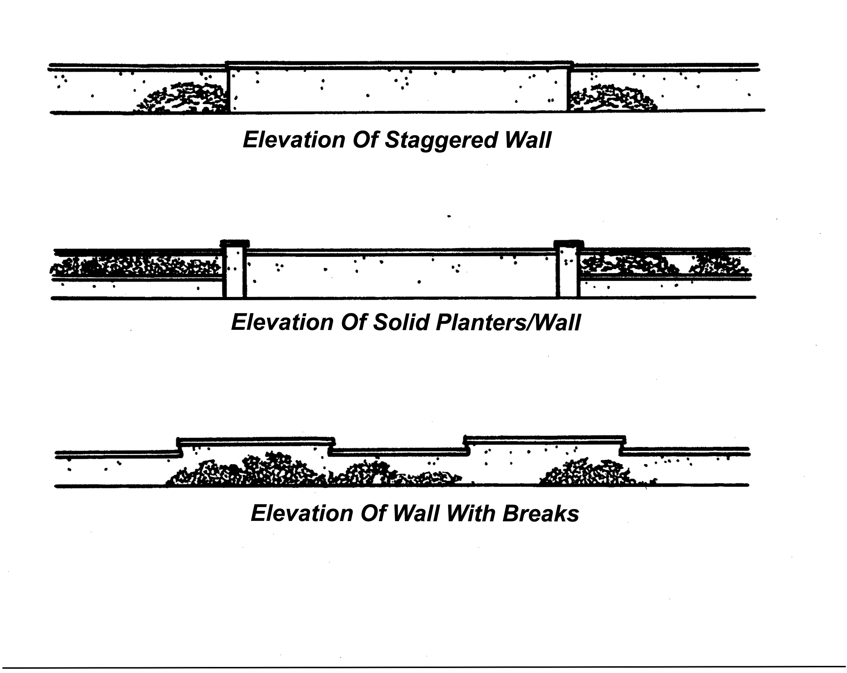

Figure 9.37.050-A Recommended Design Features and Materials

3. Landscaping trees shall be distributed throughout parking areas in islands and fingers between parking spaces to shade parking areas and reduce the accumulation and radiation of heat from large paved areas. A minimum of one landscape island or finger containing a tree or trees per seven (7) parking spaces shall be provided.
4. Concrete curbs shall be provided in parking areas to keep vehicles from disturbing landscape areas.
5. Driveways perpendicular to streets shall have triangular shaped extended landscape areas, with one side running along the driveway and one side running along the street right-of-way, each measuring thirty (30) feet (Clear Sight Triangle). This will create areas for enhanced landscaping and monument signs; however, the Clear Sight Triangle provisions of Section 9.37.040.A.2 shall be observed (Figure 9.37.050-B).

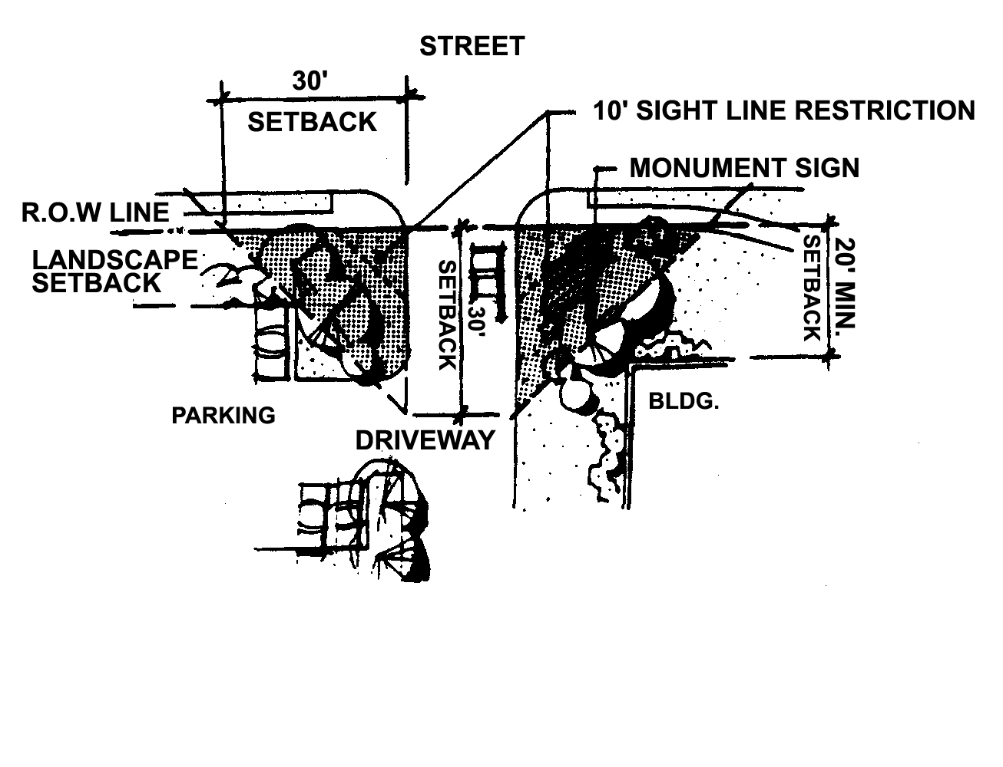

Figure 9.37.050-B Corner Landscaping

C. Project Entries
1. Entries into development areas shall reinforce the design layout of adjoining development by feature paving materials, accent trees and shrubs.
2. Accent trees and vegetation shall be used as identity plantings at major entries and intersections and shall be used to highlight key features such as entry monument signs or hardscape elements.
3. Project entry crosswalks shall be highlighted by a band of interlocking brick pavers a minimum of fifteen (15) feet in width. Near buildings, paving materials should reflect major intersection treatments.
4. A continuation of streetscape grading, berms and other landscape treatments used by adjacent development to screen parking shall be provided by new development with similar site conditions.
D. Hardscape Elements
1. Project Entry statements consisting of hardscape elements shall be provided with all commercial developments. The entry statement may include but shall not be limited to:
a. Enhanced landscaping treatment
b. Enhanced monument signage
c. Boulder groupings
d. Decorative entryway
e. Exposed aggregate or stamped concrete
f. Berming/low decorative wall
2. Commercial projects larger than five (5) acres in size shall include a hardscape element which creates a focus for the development and creates a usable public open space amenity such as a plaza or arbor facility. Appropriate hardscape elements shall include but not be limited to plaza areas, arbor or patio facilities, courtyards, atriums and outdoor gathering and eating areas.
3. Hardscape elements shall be used in coordination with the architecture and landscaping to provide a connection between the street edge and individual developments. Hardscape may be used as an accent to site architecture.
4. Hardscape shall relate individual buildings to an overall theme or style. Materials used in the construction of street furniture shall complement architectural materials used on adjacent buildings and shall be of a common design. Trash receptacles and other minor details shall also relate to the architectural style of the buildings.
5. Enhanced paving treatments shall be used for major entries into the site and intersections to highlight key areas of the streetscape. Such treatments shall be located at building entryways, plaza areas and courtyards, pedestrian approaches to buildings, and on-site crosswalks, driveways, and passenger drop off areas.
6. Water features, such as fountains or ponds, sculptures, or enhanced landscaping shall be used at plazas and courtyards to create focal points along pedestrian areas and to enhance views from building windows.
7. Materials used in the construction of street furniture shall complement architectural materials used on adjacent buildings. Plastic and materials such as fiberglass are not allowed.
E. Major Intersection Landscaping
1. Special landscaping shall be required adjacent to intersections of designated major streets to reinforce the Town image.
2. Accent vegetation shall be provided as identity plantings.
3. Native and desert appropriate trees shall be massed to enhance these landscaping areas.
4. Enriched paving treatments, such as interlocking brick pavers shall be used to visually denote crosswalks. These crosswalks shall be a minimum of fifteen (15) feet in width.
5. Other hardscape elements, such as bollards, shall be strategically placed behind the sidewalks edge to reinforce the community theme.

9.37.060 Buffering and Screening
A. General
1. Buffers such as landscaping, earth berms, and decorative-architecturally treated walls, shall be used to define project boundaries and minimize impacts on adjacent properties.
2. Where screening is required, a combination of elements shall be used, including solid masonry wall, berms and landscaping (Figure 9.37.060-A).
3. Ancillary structures and service areas such as trash enclosures or loading areas shall be screened from public streets and adjacent properties through a combination of landscaping and walls (Figure 9.37.060-A).

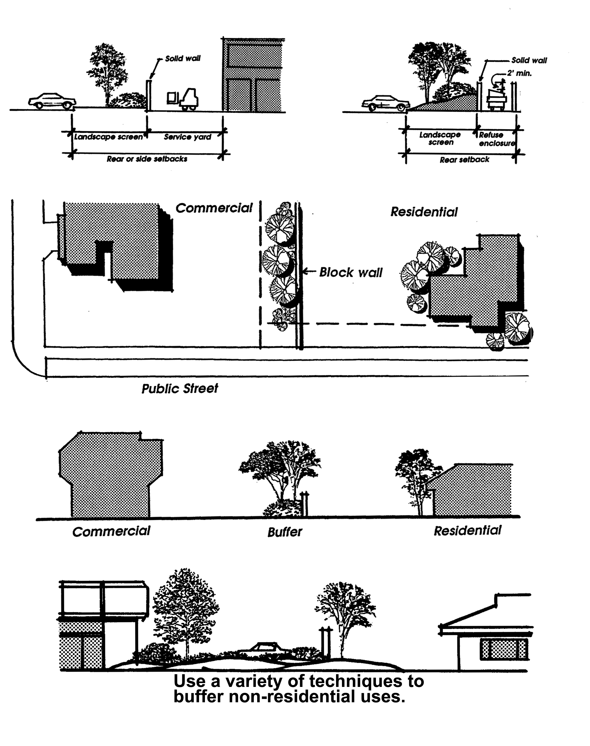

Figure 9.37.060-A Buffering and Screening

4. Screening for outdoor storage shall be a minimum of six (6) feet and a maximum of ten (10) feet in height. Chain link fencing with redwood or neutral colored slats is acceptable screening material for areas of a lot not visible from any public right-of-way or from any residential use or district.
5. The edges of larger development projects which border open space areas shall be informally landscaped using native species found outside the project boundaries in order to provide a transition to open space vegetation.
6. All outdoor mechanical and electrical equipment, whether rooftop, side of structure, or on the ground, shall be hidden from view by architectural elements designed to be an integral part of the building. Plans submitted shall include the locations and elevations of all outdoor equipment. Plumbing, vents and ducts should be grouped together whenever possible to minimize roof penetration.
7. Roof equipment shall be located below the tallest vertical architectural element of the roof.
8. Acoustical buffering shall be provided to protect adjacent sensitive uses such as schools, hospitals, and residences. Noise levels leaving the project site at the property line of such uses shall not exceed sixty (60) Ldn or CNEL.

9.37.070 Walls and Fences
A. General
1. Unless required for a specific screening or security purpose, walls should not be used within commercial areas. Walls shall be kept as low as possible while still performing their screening or security function (Figure 9.37.070-A).
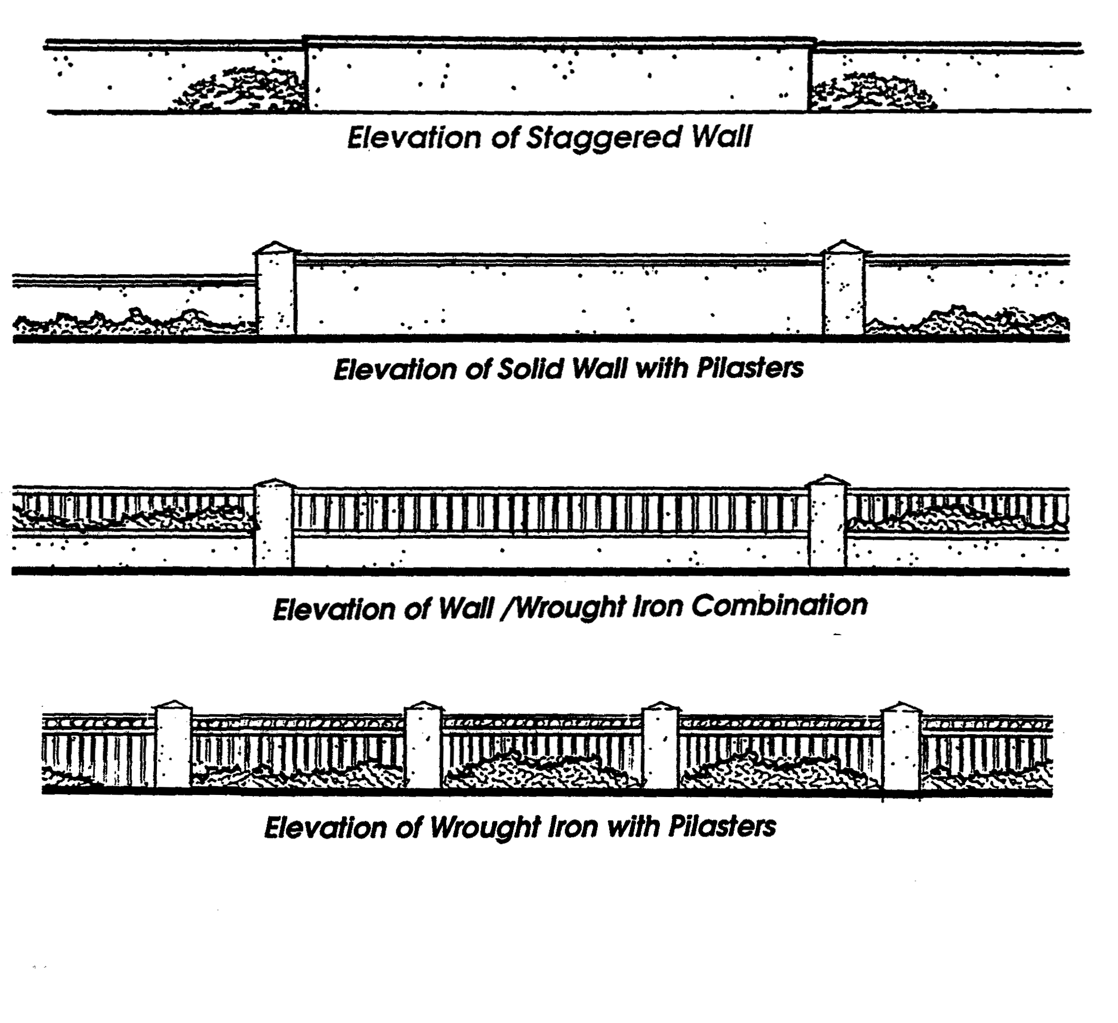

Figure 9.37.070-A Recommended Design Features and Materials

2. The design and architecture of all walls, retaining walls, and fences shall reinforce the Town's desert character by the use of natural looking materials which can be expected to withstand the extremes of the high desert climate.
3. Walls design shall be compatible with the architectural character of the primary structures and the surrounding area.
4. Long expanses of wall surface or fence surface shall be offset and architecturally designed to avoid monotony. Pilasters shall be provided at regular intervals consistent with the length and scale of the wall but at a minimum of every fifty (50) feet and landscape pockets shall be provided.
5. Construction materials and colors shall be consistent with the project architecture and provide an element of continuity throughout the project.
6. Wall shall be designed to blend with the architecture of the site, both sides of all walls shall be finished.
7. Retaining walls of more than one hundred twenty (120) square feet shall be constructed of finished decorative material which is compatible with the primary material used on the main building.
8. When on-site barriers are necessary for security, open view fencing shall be used. Open view fencing shall have pilasters of a materials which complements the building architecture. Metal rails and pickets shall be sufficiently spaced to restrict trespassing. Spires or spikes or other detailing may be used to impede trespassing.
B. Location and Height. On all other lots, and corner lots outside of the Clear Sight Triangle, a maximum six (6) foot high solid wall or fence may be located anywhere except in the required front or street side setback, unless greater height is required to screen an outdoor use in accordance with Section 9.06.0305. A Wall Height Permit shall be required for a wall or fence above six (6) feet in height, up to a maximum of eight (8) feet in height, as measured from the lowest grade adjacent to either side of the wall, and may be approved by the Planning Division, where such wall or fence separates a commercial or industrial use from an existing residential use or residentially zoned property. The Wall Height Permit shall not be approved or issued until the Planning Division has received written acceptance of the proposed wall or fence from all adjacent property owners. Further, the fence or wall shall be architecturally and aesthetically consistent with the primary commercial or industrial structure built on site. Within the required front or street side setback, solid walls or fences are limited to forty-two (42) inches in height; open fences constructed of wrought iron incorporating decorative features, such as pilasters and spires or other embellishments, may be six (6) feet in height.

9.37.080 Architecture (Amended Ord. 239, 313)
A. General
1. Architecture should reflect the Town's desert setting and long term traditional values. Building design options should be compatible with existing development to the greatest extent possible.
2. A variety of building designs and a mixture of one and two story profiles are encouraged in office and commercial areas. Mixed Use projects should include varied building heights including one, two, three and/or four stories, throughout the project. Long expanses of a single height building are discouraged.
3. Rooftop mechanical and electrical equipment shall be screened as an integral part of the architecture.
4. Similar architectural treatments shall be used to create a theme or sense of unity among buildings in a development.
5. Plazas and courtyards shall be sited to best take advantage of sun angles, wind protection, and vistas.
6. Building design and interior layout shall incorporate noise buffering sufficient to meet the Community Noise Exposure standards contained in Table N-1 of the Town General Plan.
B. Entries. Building entries shall be identified through the use of various architectural elements to avoid box-like structures.
C. Height
1. The height of structures shall relate to adjacent open space and shall preserve views of adjacent mountains, knolls, and other adjacent natural features from public roads and adjacent structures to the extent practical.
2. The scale of new development shall provide a transition from the height of existing adjacent development to the maximum height of the new development.
D. Scale
1. The scale of buildings shall be generally consistent throughout a development, except where anchor or major tenants require larger building areas.
2. The different parts of a building's facade shall be articulated through the use of color, arrangement of facade elements, or a change in materials.
3. Recesses that provide shade and create an interplay of light and shadow, such as building pop-outs, covered walkways, colonnades, arcades, and other human scale openings shall be provided to reduce the impact of building mass and create visual interest.
4. All visible elevations of structures shall be architecturally treated and conform to these standards.
5. Commercial development shall consider the scale of adjacent residential areas and provide an appropriate transition using landscaping, setbacks, building height and/or other architectural or site design elements (Figure 9.37.080-A).

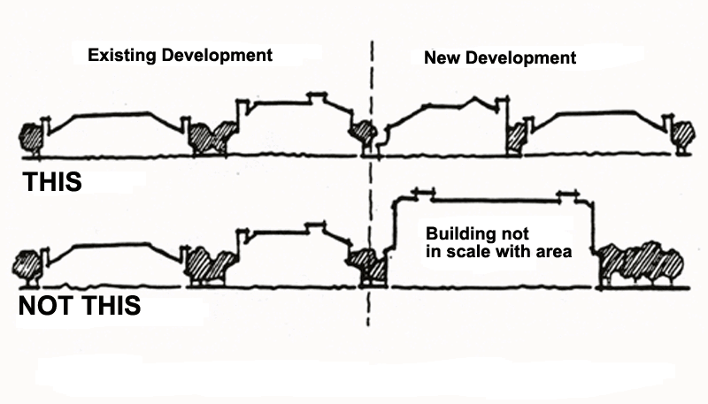

Figure 9.37.080-A Scale of Commercial Development

E. Windows and Doors
1. The size and placement of windows and doors should relate to the overall form of the building.
2. Awnings shall be compatible with the architectural design of the structure and shall not dominate the building facade.
3. Windows, doors, wall vents, stairways, and other architectural features shall be highlighted and treated in a decorative manner to break up flat surfaces that otherwise appear massive and bulky. Exceptions may be made for pueblo and adobe architecture. Techniques such as building cutouts, overhangs, and staggered buildings shall be utilized to reduce the appearance of mass and bulk.
F. Building Materials
1. Building materials shall provide architectural aesthetic quality, durability and ease of maintenance and shall be compatible with the architectural style of the building.
2. New development shall be encouraged to utilize adobe, stucco, smooth plasters, earthen color block, natural stone, wood and terra cotta tile as the dominant building materials in response to the Town's desert environment. The use of metal on the exterior of any portion of a structure constructed on site, or structures assembled from modular or similar units on site, or structures assembled off site and moved on site as one unit, may use metal exteriors when the Planning Commission determines, during a project’s Development Permit or Conditional Use Permit review, that the proposed structure shall have an appearance emulating and simulating the color, texture and appearance of other structures within the surrounding area or where it can be clearly demonstrated that the proposed structure shall be an enhancement to the surrounding area. Said metal exterior must provide the same texture depth and other physical characteristics as the exterior of the main structure on the surrounding properties

9.37.090 Lighting (Amended Ord. 251, 290)
A. General
1. Lighting shall be used only for the functional requirements of safety, security, and identification. Unnecessary lighting is prohibited in the interest of energy.
2. All glare shall be directed onto the site and away from adjacent properties (Figure 9.37.090-A).
3. Light standards shall blend architecturally with buildings, pedestrian areas, and other hardscape elements.
4. Lighting fixtures in the vicinity of the airport shall be compatible with airport operations.
5. All lighting used in parking lots for security purposes or safety-related uses shall be scheduled so light rays emitted by the fixture are projected below the imaginary horizontal plane passing through the lowest point of the fixture and in such a manner that the light is directed away from streets and adjoining properties.
6. If lighting is used or is necessary for color rendition, the primary lighting system shall be supplemented with a secondary lighting system which shall serve as security-level lighting and shall be the sole source of lighting during the nonoperating hours of each business.
7. Lighting standards and fixtures shall be of a design compatible with the architecture of on-site buildings.
8. Flashing lights are prohibited.
9. The intensity of light at the boundary of any multi-family, commercial, or industrial zoning district shall not exceed seventy-five (75) foot lamberts from a source of reflected light.
10. Flag poles displaying official flags of the United States, the State of California, and other states of the nation, counties, municipalities, and official flags of foreign nations are accessory structures that may be allowed up to thirty-five feet (35’) in height anywhere upon a property, except within the required front-yard or street side-yard setback area. Said flag poles, when a flag is flown, may be illuminated provided any such lighting is shielded in a manner so that all glare shall be directed onto the site and away from adjacent properties and that such lighting standards shall blend architecturally with buildings, pedestrian areas, and other hardscape elements on the site. A maximum of three (3) flag poles shall be allowed per recorded lot.

A. General
1. Lighting shall be used only for the functional requirements of safety, security, and identification. Unnecessary lighting is prohibited in the interest of energy.
2. All glare shall be directed onto the site and away from adjacent properties (Figure 9.37.090-A).
3. Light standards shall blend architecturally with buildings, pedestrian areas, and other hardscape elements.
4. Lighting fixtures in the vicinity of the airport shall be compatible with airport operations.
5. All lighting used in parking lots for security purposes or safety-related uses shall be scheduled so light rays emitted by the fixture are projected below the imaginary horizontal plane passing through the lowest point of the fixture and in such a manner that the light is directed away from streets and adjoining properties.
6. If lighting is used or is necessary for color rendition, the primary lighting system shall be supplemented with a secondary lighting system which shall serve as security-level lighting and shall be the sole source of lighting during the nonoperating hours of each business.
7. Lighting standards and fixtures shall be of a design compatible with the architecture of on-site buildings.
8. Flashing lights are prohibited.
9. The intensity of light at the boundary of any multi-family, commercial, or industrial zoning district shall not exceed seventy-five (75) foot lamberts from a source of reflected light.

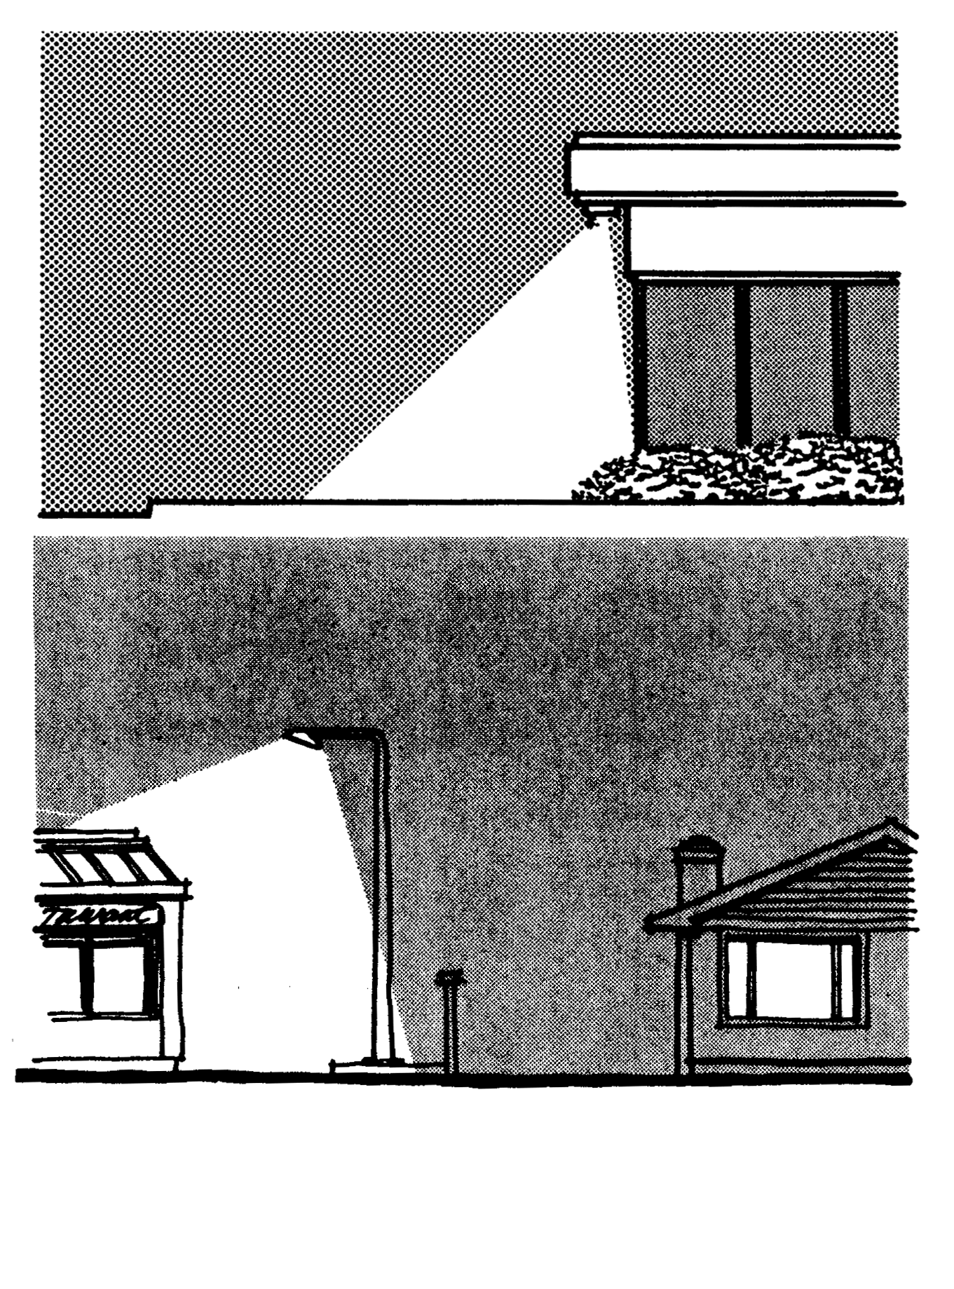

9.37.090 Creative/Sustainable Design Incentives for Commercial and/or Industrial Development
Design incentives are included for new commercial or industrial development that integrates creative and sustainable site design principles, as described below and/or that involves the incorporation of innovative and creative architectural design as well as sustainable building materials and practices and energy-conservation measures for both exterior and interior spaces.

Incentives are also considered for existing commercial or industrial development and involve rehabilitation, remodeling and/or retrofitting to improve and enhance aesthetics and to improve energy efficiency.

Suggested Concessions and Incentives for Qualifying Residential Developments
1. For the purposes development under Development Code Section 9.35 the Town shall utilize the following incentives and concessions for qualifying commercial and/or industrial projects:
- Reduction in commercial or industrial site development standards or a modification of zoning code requirements or architectural design requirements that exceed the minimum building standards approved by the California Building Standards Commission as provided in Part 2.5 of Division 13 of the Health and Safety Code, including but not limited to:
- A reduction of up to 10% in setback requirements;
- An increase of up to 10% in maximum building coverage requirements;
- A reduction of up to 10% in the ratio of vehicular parking spaces;
- Other regulatory incentives or concessions proposed by the developer or the Town that result in identifiable, financially sufficient and actual reductions in energy or water use.

b. A range of financial incentives for qualifying business owners or commercial an/or industrial project developers:

1. Plan check fee reduction of 10% for new or expanding commercial and/or industrial development projects incorporating two or more of the following:
- alternative energy systems on-site;
- design parameters that allow for frequent, reliable and convenient public transit;
- site design that utilizes appropriate site orientation to assure solar access and the use of shade and windbreak trees to enhance the use of alternative energy systems;
- site design that utilizes a minimum of 50% sustainable and energy efficient interior and exterior building materials;
- landscape plans that exceed Town water efficient landscape requirements by at least 15% through the use of landscape materials and efficient irrigation systems;
- installation of energy-efficient indoor and outdoor lighting that reduces energy use at least 25% over traditional or existing lighting fixtures;
For an additional 10%:
- certification as LEED Gold or Platinum.
2. Rebates and low interest loan programs for energy saving improvements that may include any combination of the following (rebate/loan program will be adopted annually by the Economic Development Department):
      - Rebate of up to a specified amount to cover the cost and installation of energy-saving devices and improvements that demonstrably increase energy efficiency by at least 25%, based on specified criteria and timelines as approved by the Town.
      - Rebates or deferred/low interest loans of up to a specified amount to cover the cost and installation of solar photovoltaic systems in existing commercial or industrial establishments or sites, based on specified criteria and timelines as approved by the Town.
      - Rebates offered via a system of points tied to financial incentives such as tax credits for demonstrated energy savings of at least 25% for existing commercial or industrial establishments.
        - Tax credits or other incentives for new commercial or industrial development projects that provide incentives for transit and/or alternative programs for employee transit.
Figure 9.37.090-A Confine Light To Within The Site Boundaries

