Chapter 9.46 Specific Use Regulations for Industrial Districts (Amended Ord. 313)
Sections:
9.46.010 Purpose and General Plan Consistency 1
9.46.020 Planned Industrial District Standards 1
9.46.025 High Desert Corridor Near Industrial Districts 2
9.46.040 Accessory Uses and Structures 2
9.46.050 Outdoor Uses 3
9.46.060 Intensity Bonus 5
9.46.070 Pre-fabricated Structures (Amended Ord. 313) 6
9.46.080 Trash Enclosures 7

9.46.010 Purpose and General Plan Consistency
A. Purpose and General Plan Consistency. The purpose of this Chapter is to:
1. Protect and enhance the quality of the natural and built environment and to promote the public health, safety and welfare by minimizing public exposure to potential emissions and hazards generated by industrial operations and to encourage future development that is compatible with adjacent uses and surrounding neighborhoods;
2. Implement the goals, objectives, strategies and action plans of the General Plan, and the Town's Comprehensive Economic Development Plan through industrial development featuring design and planning excellence;
3. Support measures which buffer both new and established residences and businesses from potential adverse impacts caused by adjacent commercial, industrial and agricultural uses in order to ensure that land use conflicts are minimized and that long-term interests for industrial projects are maintained;
4. Promote commercial and industrial developments that are capable of strengthening the local economy and enhancing the quality of life of Town residents;
5. Achieve design and planning excellence in both public and private development projects;
6. Expand the industrial base and encourages both large and small-scale industrial development to locate within the Town;
7. Encourage long-term investment in the community;
8. Promote an area's long-term economic viability by not allowing unnecessary visual nuisances to degrade the appearance of a site.

9.46.020 Planned Industrial District Standards
A. Purpose. The purpose of the Planned Industrial District is to provide flexibility in the standards for industrial development in exchange for higher quality development than is possible through the implementation of the standards contained in this Development Code.
B. Performance Standards. The processes and equipment employed and the goods processed shall be limited to those that are low in emissions consisting of odors, dust, smoke, cinders, gas, fumes, noise, vibrations, refuse matter, water carried waste, or other emissions in accordance with the provisions of Chapter 9.70 of this Development Code.
C. Access. All uses shall have direct access to a major or secondary street, such access may be through the interior local industrial street network of the industrial park. In no case shall any access be permitted onto local residential streets (street types are defined in Figures C-3A and C-3B of the Circulation Element of the General Plan).
D. Lot Size. The area included within a planned industrial district shall be a minimum of ten (10) acres. The minimum lot size within the district shall be 20,000 square feet.
E. Buffering and Screening
1. Buffering and Screening. Buffering and screening shall be provided in accordance with the provisions of Section 9.37.070, of this Code.
2. Street Frontages Across from Residential Districts. Along all street frontages situated across from residentially zoned property, a three-foot high landscaped earthen berm shall be constructed.
3. All Other Lot Lines Adjacent to Residential Districts. Along all other lot lines adjacent to residential districts, a maximum eight-foot high decorative masonry wall or fence and a minimum ten (10) foot wide landscape planter shall be constructed. Such planter shall contain the following minimum sizes of plant material at the initial planting:
a. 24-inch box trees;
b. 15-gallon plants;
c. other approved dense screening material.
The number and placement of the plant material shall be approved by the Director and shall be in accordance with Chapter 9.75, Water Conservation/Landscaping Regulations, of this Code.

9.46.030 High Desert Corridor Near Industrial Districts
A. Applicability. The following regulations shall apply to all industrial Districts adjacent to or abutting the High Desert Corridor right of way, as depicted on the General Plan Land Use Map, or established by the California Department of Transportation.
B. General Provisions. Any proposed industrial development occurring adjacent to the High Desert Corridor shall submit a request letter to the California Department of Transportation (Caltrans) in order to ascertain Caltrans requirements for development occurring in proximity to the High Desert Corridor. Current contact information for the High Desert Corridor design/construction team shall be available in the Planning and Engineering Divisions at the Town offices.

9.46.040 Accessory Uses and Structures
A. Purpose. The purpose of this Section is to mitigate the potential adverse health, safety and aesthetic impacts of accessory uses in all of the industrial districts, consistent with the goals, objectives and policies of the General Plan.
B. Accessory Uses in Office or Industrial Buildings. Barber shops, beauty shops, coffee shops, cafeterias and newsstands may be located in an office or industrial building provided that:
1. There are no entrances directly from the street to such businesses.
2. There are no signs or other evidence indicating the existence of such businesses visible from the outside.
3. Patronage of such businesses may be expected to be furnished substantially or wholly by tenants of the office or industrial building.
C. Accessory Retailing. Industrial establishments may include accessory retailing. For purposes of this Chapter, accessory retailing is defined as retailing not to exceed twenty-five (25) percent of the gross floor area of the building.
D. Accessory Uses for Service Stations
1. Vehicle washing and lubricating services;
2. The sale and servicing of tires, batteries, replacement items and other automotive accessories;
3. Minor automotive repair;
4. Towing service limited to two (2) tow trucks.
E. Accessory Structures. The following provisions for accessory structures shall apply to all industrial districts:
1. Accessory structures shall not be located in the front or street side setback or in front of the primary structure.
2. Accessory structures shall meet all of the setback requirements of the applicable zoning district.
3. Accessory structures may not exceed the height of the primary structure.
4. Accessory structures shall be architecturally compatible with the primary structure, i.e., similar building materials, architectural style, color, etc.
5. Pre-fabricated accessory structures shall comply with Section 9.46.070, of this Chapter.

9.46.050 Outdoor Uses
A. Enclosed Building Requirement. All uses within the industrial districts shall be conducted within a completely enclosed building unless the use is specifically permitted in Section 9.45.030, Permitted Uses, of this Code, as an outdoor use or is specifically approved through a Conditional Use Permit.
B. Outdoor Manufacturing
1. Permit Required. Applications for proposed outdoor manufacturing uses are subject to approval of a Conditional Use Permit in the I-RE district. Outdoor manufacturing is not permitted in the I-P district.
2.
3. Location
a. Outdoor manufacturing uses shall be located a minimum of one thousand (1,000) feet from a residential use or district or public facility.
b. Outdoor manufacturing uses shall be located a minimum of two hundred (200) feet from restaurant, office or retail uses or a commercial district.
4. Screening. Outdoor manufacturing uses shall be appropriately screened on all sides. Screening shall consist of all of the following:
a. A minimum twenty-five (25) foot wide landscaped area shall be provided and maintained along each street which abuts the property used for outdoor manufacturing. Within the landscaped area a blend of desert appropriate trees, shrubs and groundcover shall be planted;
b. A minimum eight (8) foot high solid masonry wall shall be erected at the rear of the landscaped area adjacent to all streets. Walls shall also have offsets, indentations or pilasters to break up long, flat planar sections of wall. The wall may be reduced to six (6) feet in height where such height will fully screen all materials and operations;
c. Property lines not adjacent to a street shall be fenced with chain link fencing with appropriate opaque inserts (plastic or redwood slats); and
d. Gates for vehicular access into the site shall be solid metal gates the same height as the wall and of the sliding/rolling type rather than the swinging type. Such gates shall be closed except during periods of entry and exit of vehicles.
5. Paving of Work Areas. Work areas within the site shall be paved with a minimum of two (2) inches of asphaltic concrete or equivalent. Storage areas and other areas shall also be paved or may be treated in some non-paved manner such as gravel base over six (6) millimeter plastic film, to control dust and erosion.
6. Plan of Operation. Each applicant for an outdoor manufacturing use shall submit a plan of operation which describes all aspects of the business, including, but not limited to:
a. Number of employees;
b. Hours and days of operation;
c. Type of machinery, equipment and materials to be used and noise, vibration, glare, odor and possible air pollution and other impacts which can be expected;
d. Quantities and types of materials which will be stored on the site and used in the manufacturing process;
e. Size of trucks, and the time and frequency of delivery of materials to the site;
f. Size of trucks, and the time and frequency of removal of materials from the site;
g. Description of the quantities and properties of hazardous materials which will be used on the site;
h. Description of any possible health and safety hazards that may exist due to materials, equipment and processes involved in the proposed outdoor manufacturing use; and
i. Methods proposed to mitigate impacts from the proposed use.
7. Permanent Buildings. Outdoor manufacturing and assembly uses shall only be allowed in conjunction with a permanent building for office, restroom, and eating areas.
8. Performance Standards. All performance standards relating to noise, vibration, air quality, glare, heat, electrical disturbances, fire hazards and waste disposal contained in Chapter 9.70 of this Development Code, shall apply to all outdoor uses in this district.
9. Utilities. Electrical and telephone lines shall be placed underground as required by the Town's Underground Utilities Ordinance.
10. Lighting. Lighting fixtures shall be shielded so that no light is directed above the horizontal plane of the fixture. Lighting not necessary for security shall be on timers set to turn off at the close of business.
C. Outdoor Storage. Outdoor storage of materials and equipment is permitted in the I-P District. Such storage shall be located in the rear one-half of the site and screened completely from view from any adjoining property or roadway by a solid wall or fence at least six (6) feet in height, but not to exceed ten (10) feet in height. Said fence or wall shall be constructed of or finished with materials that match those of the primary building on the site. Items that are being stored outdoors shall not be stacked to a height exceeding the height of the required wall or fence.
D. Visible Storage. Except as may be otherwise permitted in this Chapter, there shall be no visible storage of motor vehicles (except display areas for sales or rentals), trailers, airplanes, boats, recreational vehicles, or their composite parts; loose rubbish, garbage, junk, or their receptacles; building materials; or any other items on any portion of a lot or parcel. No storage shall occur on a vacant parcel.
E. Permitted Storage of Building Materials. Building materials for use on the same parcel or building site may be stored on the parcel or building site during the time that a valid building permit is in effect.
F. Other Outdoor Storage Standards
1. Storage shall not be permitted in the required setback areas.
2. Storage shall not be permitted in required parking spaces or driveways and shall not at any time impede the use of any required parking space or driveway.
3. The limits of the outdoor storage area shall be clearly delineated on the approved site plan.

9.46.060 Intensity Bonus
A. Purpose. The purpose of this Section is to encourage the addition of enhanced site amenities and increased flexibility in design for new developments in the industrial districts through the granting of additional floor space (increased floor area ratio, F.A.R.), additional building height, or other differences from Site Development Standards, Section 9.45.040, of this Code. Such differences are subject to the approval of a Conditional Use Permit.
B. Types of Amenities
1. Employee trip reduction incentives
2. Public spaces, plazas
3. Public art, sculptures
4. Enhanced landscaping
5. Other amenities as approved by the Planning Commission.
C. Exceptions. Exceptions from the provisions of Section 9.45.040, Site Development Standards, of this Code, may be granted by the Planning Commission through the approval of a Conditional Use Permit when enhanced site amenities described in subsection B of this Section are provided. Such exceptions are limited to:
1. Fifteen (15) foot increase in height, except within 100 feet of a residential use or district; or
2. Ten (10) percent decrease in required landscape coverage, e.g., 10% to 9%, 15% to 13.5%; or
3. Ten (10) percent decrease in required setbacks, except when adjacent to residential uses or districts.

9.46.070 Pre-fabricated Structures (Amended Ord. 313)
A. Pre-fabricated Structures.
The following standards shall apply to the use of pre-fabricated structures in industrial districts:
1. The design of pre-fabricated structures shall be compatible with surrounding uses.
2. The design and finish of the pre-fabricated structures shall be compatible with and complementary to existing structures on the site.
3. Pre-fabricated structures shall conform to all standards, goals and objectives of this Chapter and the General Plan.
4. Adequate screening from adjacent residential uses and public streets shall be provided.
5. A permanent foundation system shall be provided.
6. Access for the handicapped and adequate sanitary facilities shall be provided.
7. Prefabricated structures are prohibited in the industrial districts shall also be compatible with, and complementary to surrounding development.
B. Metal Buildings
1. Buildings constructed on site, or structures assembled from modular or similar units on site, or structures assembled off site and moved on site as one unit, may use metal exteriors when the Planning Commission determines, during a project’s Development Permit or Conditional Use Permit review, that the proposed structure shall have an appearance emulating and simulating the color, texture and appearance of other structures within the surrounding area or where it can be clearly demonstrated that the proposed structure shall be an enhancement to the surrounding area. Said metal exterior must provide the same texture depth and other physical characteristics as the exterior of the main structure on the surrounding properties.
2. All other sides shall have a factory processed color finish such as baked enamel.
3. Where large wall or roof areas are adjacent to public parking areas, such areas shall be designed with architectural relief through the use of various materials, varying setbacks, accent colors and landscaping.
4. Landscaping shall be used to soften the building lines.
5. Main entryways shall be clearly defined and smoothly integrated with building and landscape designs. They shall be designed as focal points and pleasant invitations to visitors.
6. Material of less than 26-guage shall not be used.

9.46.080 Trash Enclosures
Garbage containers or trash bins shall not be kept, placed or maintained so as to be visible from any public street or alley, except on days designated for trash collection, in accordance with Section 6.20.130 of the Town Municipal Code. In addition, the standards cited below shall apply.
A. Size of Trash Enclosures. Trash receptacles for industrial district uses shall be of sufficient size to accommodate the trash generated by the uses being served, consistent with the Town trash enclosure standards (see Figures 9.45.080-A and B), providing a minimum of:
1. One (1) trash bin per each three (3) industrial uses or units (or fraction thereof) where the units contain 5,000 square feet or less.
2. One (1) trash bin per industrial use or unit where such use or unit contains between 5,001 and 15,000 square feet in size.
3. Two (2) trash bins per industrial use or unit where such use or unit contains greater than 15,000 square feet.
B. Screening of Trash Storage Areas. All outdoor storage of trash, garbage, refuse, and other items or material intended for discarding or collection shall be screened from public view on three sides by a six (6) foot high wall of eight (8) inch block construction. The fourth side shall be an opaque gate six (6) feet in height made of wood or metal. Gates of trash enclosures shall remain closed at all times except when the enclosure is being accessed for refuse disposal or pick up.
A covered storage area at least three (3) feet by six (6) feet in size, or other size enclosure depending on the nature and quantity of recyclable materials generated, and accessible for truck loading, shall be incorporated into each trash enclosure for collection of recyclable materials.
C. Architectural Treatment. All trash enclosures visible from streets or public parking areas shall be constructed and finished to match the architectural details and decor of the primary structure.
D. Location. Trash enclosures shall not be located in the required front or street side setbacks and shall be located near a driveway that allows access by the trash pick up vehicles.
- Variations. Any variation from these standards shall be approved by the Director.

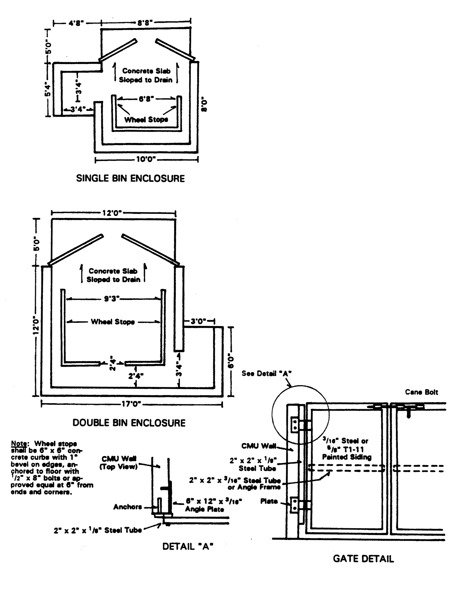
MATERIALS: Six (6) foot high, eight (8) inch block construction per Trash Enclosure Wall Detail (figure 9.45.080-B) with wood or metal opaque gates; set on four (4) inch P.C.C. pad; pad to be at ground level; all hardware to be corrosive resistant.

FINISH: The decorative block or stucco used shall be finished to be compatible with surrounding architectural features.

NUMBER REQUIRED:

Residential: One (1) - 8' x 14' enclosure per eight (8) dwelling units

Commercial/Industrial:
One (1) trash bin per each three (3) units where the units are 5,000 sq. ft. or less
One (1) trash bin per unit where the units are between 5,001 and 15,000 sq. ft.
Two (2) trash bins per unit where the units are larger than 15,000 sq. ft.

Note: Any variations from these standards shall be approved by the Director.

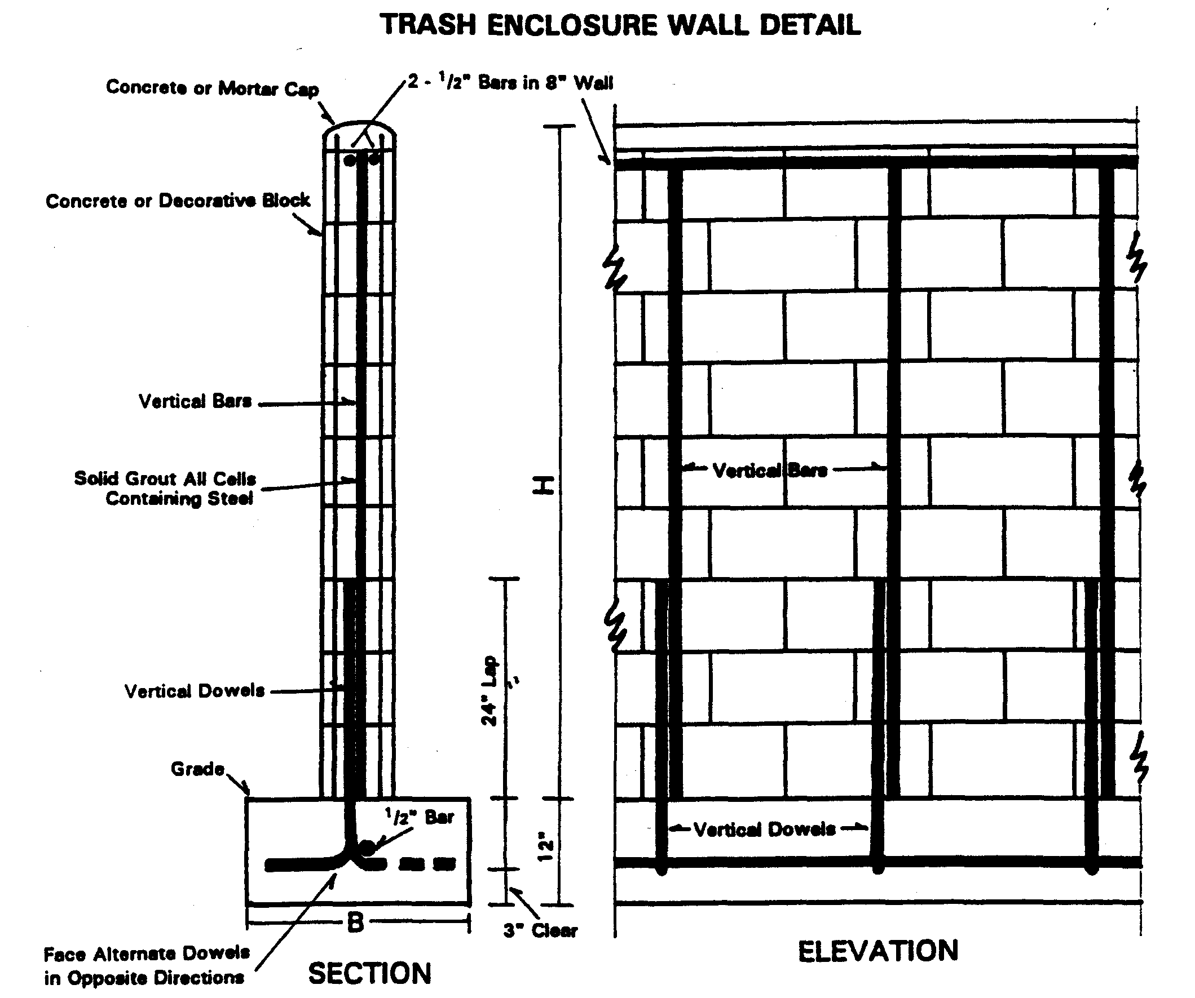

Figure 9.45.050-A Trash Enclosure Specification
WALL SPECIFICATION:

Height (H) Base (B) Vertical Reinforcing
6'0" 24" 1/2" @ 32" O.C.
5'0" 20" 1/2" @ 32" O.C.
4'0" 18" 3/8" @ 48" O.C.
3'0" 12" 3/8" @ 48" O.C.

Notes: 1. Trash enclosure walls shall be constructed of eight (8) inch concrete or decorative block.
2. All vertical cells containing reinforcing steel shall be filled with grout.
3. Two 1/2 inch diameter vertical bars are required at each side of each opening, foundation dowels of same number, size and spacing required.
Figure 9.45.080-B Trash Enclosure Wall Specification

