Chapter 9.35 Commercial and Office Districts (Amended Ord. 239, 289, 291, 309, 313, 316, 347, 366, 383)
Sections:
9.35.010 Purpose and General Plan Consistency 172
9.35.020 Commercial and Office Districts (Amended Ord. No. 347) 173
9.35.030 Permitted Uses (Amended Ord. 289, 309, 316, 347, 383) 173
9.35.040 Site Development Standards(Amended Ord. 289, 291) 177
9.35.050 Projections into Yards 182
9.35.060 Projections Above Height Limits 182
9.35.070 Accessory Structures 183
9.35.080 Outdoor Storage and Use (Amended Ord. 289, 366) 184
9.35.090 Trash Enclosures (Amended Ord. 313) 185
9.35.100 Intensity Bonus 187
9.35.100 Intensity Bonus 188
9.35.110 Maintenance of Uses 188
9.35.120 Pre-Fabricated Structures (Amended Ord. 239, 313) 189
9.35.130 Residential Structure Conversion/Relocation 189
9.35.140 Abandoned or Converted Service Stations 190

9.35.010 Purpose and General Plan Consistency
A. The purpose of this Chapter is to guide the growth and development of the Town in an orderly manner consistent with the goals, policies and action plans of the General Plan and the Comprehensive Economic Development Plan; to protect and enhance the quality of the natural and improved environment; and to promote the public health, safety and welfare by achieving the following:
1. Providing appropriately located areas for office uses, retail stores and service establishments to meet the needs of the Town.
2. Promoting office and commercial locations and site designs which are conveniently accessible by equestrian, bicycle and foot traffic, as well as autos.
3. Supporting development that is compatible with surrounding uses and neighborhoods while suggesting uniqueness and character.
4. Providing for open spaces and areas for landscaping through the use of Site Development Standards to protect the property values of existing business developments from inappropriately located uses and to enhance the investment of residents and business owners.
5. Encouraging office and commercial uses to be grouped for the safety of the public and to avoid nuisance impacts from incompatible land uses.
6. Clustering commercial activities in selected locations adjacent to major roads and in the vicinity of the Apple Valley Airport.
7. Allowing for the development of projects that include residential and retail and office commercial development in an integrated, master planned project in the Mixed Use zone.
8. Supporting sound destination attractions/commercial recreation projects that can uniquely occur in Apple Valley.
9. To establish zoning for lands surrounding the Town, both within and outside its sphere of influence, which establishes Town zoning districts for these lands, if they are annexed to the Town in the future.

9.35.020 Commercial and Office Districts (Amended Ord. No. 347)
A. Office Professional District (O-P). The O-P district is intended as a buffer to general commercial uses and is primarily for the development of professional and administrative offices and ancillary retail uses. Setbacks, landscaping and architectural requirements designed to make such uses sensitive to surrounding land uses, especially residential uses, are required, consistent with the Office Professional (O-P) land use designation of the General Plan. A maximum floor area ratio (F.A.R.) of 1.0 is permitted in the O-P District.
B. General Commercial District (C-G). The C-G district is intended for the development of a full range of retail stores, offices and personal and business services, including shopping centers along major roadways, consistent with the General Commercial (C-G) land use designation of the General Plan. A maximum floor area ratio (F.A.R.) of 0.5 is permitted in the C-G District.
C. Service Commercial District (C-S). The C-S district is intended to provide an area in which certain light industrial uses may be combined with those commercial activities which are frequently not compatible with conventional retail, service and office uses. This district implements the Service Commercial (S-C) land use designation of the General Plan. A maximum floor area ratio (F.A.R.) of 0.5 is permitted in the C-S District.
D. Regional Commercial District (C-R). The C-R district is intended for the development of a full range of retail stores, offices and personal and business services on a scale to serve the needs of the Town and the surrounding region, to be located in proximity to interstate and state highways and arterial roadways. This district implements the Regional Commercial (C-R) land use designation of the General Plan. A maximum floor area ratio (F.A.R.) of 1.0 is permitted in the C-R District.
E. Village Commercial District (C-V). The C-V district is intended as a vehicle for the revitalization of a specific area of the Town commonly known as the "Village". A variety of uses including, but not limited to, food service, office, auto, truck and recreation vehicle sales and service, lumber yards, home repair and building supplies, discount and wholesale sales and light manufacturing are permitted, consistent with the goals, policies and objectives of the General Plan. A maximum floor area ratio (F.A.R.) of 0.5 is permitted in the C-V District.
F. Mixed Use District (M-U). The M-U District is intended to allow for the development of projects that include residential, retail and office commercial development in an integrated, master planned project. The M-U District is consistent with the Mixed Use land use designation of the General Plan A full range of retail stores, offices and personal and business services, including shopping centers are permitted. A wide range of specifically designated commercial uses are permitted, including retail stores, offices, personal and business services. Residential development should occur over commercial development, or within a commercial complex (i.e. residential building abutting a commercial building). A maximum floor area ratio (F.A.R.) of 0.5 is permitted for commercial development in the Mixed Use District. In addition to the commercial floor area, a density of 4 to 30 units per acre is permitted for residential development.

9.35.030 Permitted Uses (Amended Ord. 289, 309, 316, 347, 383)
If a proposed use is not listed in this Section, the Director shall, upon written request and in accordance with Section 9.05.070, Similar Uses, of this Code, review the proposed unlisted use. Based on the characteristics of the proposed use, the "Standard Industrial Classification Manual" and other available resource material, the Director may determine that the proposed unlisted use is equivalent in nature and intensity to a listed use. The proposed use shall then be treated in the same manner as the equivalent listed use in determining where it can be located, what permits are required and what standards affect its establishment if the findings required in Section 9.05.070, Similar Uses, of this Code, can be made.

ABBREVIATIONS
O-P Office Professional
C-G General Commercial
C-S Service Commercial
C-R Regional Commercial
C-V Village Commercial
M-U Mixed Use

The uses listed in Table 9.35.030-A shall be allowed in the Commercial, Office and Mixed Use districts as indicated in the column beneath each district and as defined below and explained in Section 9.11.020, Table 9.11.020-A.
CUP: Conditional uses, subject to Conditional Use Permit process, Planning Commission
review.
SUP: Special Use Permit required.

P: Permitted uses
"-": Denotes those uses that are prohibited
The Conditional Use Permit process is detailed in Chapter 9.16 and the Development Permit process is detailed in Chapter 9.17 of this Code.
The uses listed in Table 9.35.030-A of this Chapter, below, apply to applications for expansion, tenant improvements, change of occupancy, or new development.

Table 9.35.030-A Permitted Uses

 | DISTRICT⁽²⁾
TYPE OF USE⁽¹⁾ | O-P | C-G | C-S | C-R | C-V | M-U
A. Residential Uses
1. Caretakers residence | SUP | SUP | SUP | SUP | SUP | SUP
2. Congregate care facilities (Senior Housing)  Up to 19 persons  20 or more persons | CUP  CUP | CUP  CUP | CUP  CUP | CUP  CUP | CUP  CUP | CUP  CUP
3. Emergency shelters/transitional housing⁽³⁾ | - | - | SUP | - | - | -
4. Multi-family housing | - | - | - | - | - | P
5. Small family day care homes (8 or fewer children) | - | - | - | - | - | P
6. Large family day care homes (9 to 14 children) | - | - | - | - | - | -
B. Office and Related Uses
1. Administration and professional office | P | P | P | P | P | P
2. Administration and professional office within a shopping center:  a. More than ten (10) percent of the overall gfa of the ground floor of the shopping center  b. Located on the second floor of the shopping center | -  - | CUP  P | CUP  P | CUP  P | CUP  P | CUP  P
C. Commercial Uses
1. Commercial retail uses such as clothing,  food, gifts, studios, services and other  similar uses. | - | P | P | P | P | P
2. Adult businesses | - | CUP | - | - | - | -
3. Alcoholic Beverage Sales
a. Liquor stores, no on-site consumption | - | P | P | P | P | CUP
b. Convenience stores, no on-site consumption | SUP | P | P | P | P | CUP
c. Grocery Stores, no on-site consumption | - | P | P | P | P | P
d. Restaurants, on-site consumption | SUP | P | P | P | P | P
e. Taverns, bars, on-site consumption | - | CUP | CUP | CUP | CUP | CUP
4. Animal care facility, including animal hospital veterinarian, commercial kennel, grooming
a. Excluding exterior kennel, pens or runs | - | P | P | - | P | P
b. Including exterior kennel, pens or runs | - | CUP | CUP | CUP | CUP | -
5. Arcades | - | SUP | SUP | SUP | SUP | SUP
6. Automotive services, including motorcycles, boats, motorhomes, trailers, and campers
a. Gasoline stations and/or Carwash | - | SUP | SUP | SUP | SUP | SUP
b. Major repairs, including engine work, painting, body work, and upholstery | - | - | CUP | - | CUP | -
c. Minor repairs including such as smog check, tune-ups, tires, brakes, batteries, mufflers | - | CUP | CUP | CUP | CUP | CUP
7. Carpenter or cabinet shop | - | - | P | - | P | CUP
8. Catering establishments | - | P | P | P | P | P
9. Mortuary | - | CUP | CUP | - | CUP | CUP
9a. Cremation service | - | CUP | CUP | - | CUP | -
10. Child day care center | SUP | SUP | SUP | SUP | SUP | SUP
11. Commercial recreation facilities including:
a. Health clubs | SUP | P | P | P | P | P
b. Indoor uses such as bowling, billiards, or theaters | - | P | P | P | P | P
c. Outdoor uses such as golf, tennis, basketball, baseball, family amusement centers, | - | CUP | CUP | CUP | CUP | CUP
12. Communications and cable television facilities. | CUP | CUP | CUP | - | CUP | CUP
13. Concessionaire, small kiosks not located in  a parking lot. | - | P | - | P | P | P
14. Convenience stores | SUP | P | P | P | P | P
15. Drive-thru/drive up | SUP | SUP | SUP | SUP | SUP | SUP
16. Feed and tack, including the incidental exterior storage of hay, packaged feed and related bulk feed products on site⁽⁴⁾ | - | P | P | P | P | SUP
17. Hotels and motels | - | P | P | P | P | P
18. Kiosks for key shops, film drops in parking lots | SUP | SUP | SUP | SUP | SUP | SUP
19. Nurseries | - | P | P | P | P | P
20. Parking lots/structures | P | P | P | P | P | P
21. Pawn shops | - | P | P | - | P | -
22. Recycling facilities for reusable domestic materials
a. Reverse vending machines | - | P | P | P | P | P
b. Recycling Collection Point less than 500 sq ft | - | P | P | P | P | P
c. Recycling Collection Point over 500 sq ft | - | SUP | SUP | SUP | SUP | SUP
d. Recycling Center | - | - | CUP | - | - | -
23. Restaurants (not drive thru or drive in) | P | P | P | P | P | P
24. Services, such as barber/beauty, repair, laundry | - | P | P | P | P | P
25. Spiritualist readings or astrological forecasting | - | P | P | - | P | P
26. Storage yard/facilities, including limited to boats, RV’s, trucks, mini storage and equipment/supplies | - | CUP | CUP | - | CUP | CUP
27. Studios, such as dance and photo | P | P | P | P | P | P
28. Swap Meets  Indoor –  Outdoor - | -  - | P  CUP | P  CUP | -  - | P  CUP | P  -
29. Thrift or second hand stores | - | P | P | - | P | P
30. Transportation facilities, train, bus and taxi depots, not including office only uses | - | CUP | CUP | CUP | CUP | SUP
31. Trucking facilities such as:
a. Truck terminals | - | - | CUP | CUP | - | -
b. Truck yards | - | - | CUP | - | - | -
c. Truck repair | - | - | CUP | - | - | -
32. Registered vehicle sales/rental including boats, trailers and Campers | - | CUP | CUP | CUP | CUP | CUP
33. Outdoor sale/rental of farm and large construction equipment and small equipment | - | SUP | SUP | SUP | SUP | SUP
34. New construction of outdoor storage. | - | SUP | SUP | SUP | SUP | SUP
35. Vocational and business trade schools
a. Shop related | - | - | SUP | - | - | -
b. All other | P | P | P | P | P | P
D. Public and Semi-Public Uses
1. Religious institutions  Under five (5) acres  Five (5) or more acres | CUP  CUP | - | - | - | - | -
2. Convalescent facilities and hospitals | SUP | SUP | SUP | SUP | SUP | SUP
3. Educational institutions | SUP | SUP | SUP | SUP | SUP | SUP
4. Libraries and museums, public or private | P | P | P | P | P | P
5. Private and public clubs and lodges, including  YMCA, YWCA and similar youth groups | CUP | - | - | - | - | CUP
6. Government Facilities | CUP | CUP | CUP | CUP | CUP | CUP
7. Public utility installations, other than offices | CUP | CUP | CUP | CUP | CUP | CUP
8. Places of Assembly | CUP | - | - | - | - | -
E. Accessory Uses
1. Antennas (Telecommunications facilities shall be subject to Chapter 9.77 of this Code.)
a. Commercial Antennas | CUP | CUP | CUP | CUP | CUP | CUP
b. Non-Commercial Antennas under 35’ in height | P | P | P | P | P | P
c. Non-Commercial Antennas over 35’ in height | SUP | SUP | SUP | SUP | SUP | SUP
d. Ham radio | P | P | P | P | P | P
2. Water Storage tanks less than 5,000 gallons | P | P | P | P | P | P
more than 5,000 gallons | SUP | SUP | SUP | SUP | SUP | -
3. Liquid, petroleum or Gas (LPG) Tanks not  exceeding 200 gallons | P | P | P | P | P | P
4. Liquid, petroleum or Gas (LPG) Tanks greater  than 200 gallons or flammable tanks up to 2,500  gallons | CUP | CUP | CUP | CUP | CUP | CUP
5. Overnight commercial vehicle parking for  vehicles not related to the on-site use and which  does not reduce available parking spaces during  business hours | - | - | SUP | - | - | -
F. Manufacturing/Production/Wholesale Uses
1. All uses in Table 9.45.030-A (Sections A-G)  where conducted within a completely enclosed  building, except for accessory outdoor storage | - | - | P | - | - | -

(1) All uses shall be conducted within a completely enclosed building unless the use is specifically permitted in this Chapter as an outdoor use or the outdoor use is specifically approved through a Conditional Use Permit or Special Use Permit.
- CUP: Major Conditional Use Permit
CUP: Conditional Use Permit
P: Permitted Uses
SUP: Special Use Permit
“-“ Denotes uses are prohibited
- Fees Waived
(4) The incidental exterior storage of hay, packaged feed and related bulk feed products when associated with a Feed and Tack business is permitted and may be located anywhere on site to the rear of the leading edge of the building on said site or behind the required street side-yard setback area. Said stored hay, packaged feed and related bulk feed products need not be screened from view and may be stacked to a height not to exceed ten (10) feet.
(5) Regulations for Churches and Places of Assembly in Sebsection 9.29.050 shall apply.

9.35.040 Site Development Standards(Amended Ord. 289, 291)
The site development standards in Table 9.35.040-A are intended to provide standards for the development and use of land within the Commercial and Office districts. (summarized in Table 9.35.040-B and Figure 9.35.040-C). These standards apply in conjunction with the applicable specific use regulations in Chapter 9.36, the design standards in Chapter 9.37, and the performance standards in Chapter 9.70 of this Development Code. All submissions to the Town of Apple Valley for a development or other permit, whether for Planning Commission, Town Council, or Plan Check and Building Permit review, may be required to provide public right-of-way or other appropriate dedication(s) and off-site and/or street and other related public improvement(s) consistent with the Circulation Element of the adopted General Plan and/or applicable standards established by the Town Engineer, as determined by the Town of Apple Valley Town Engineer, to mitigate and/or contribute toward mitigation of impacts, to promote the public health, safety and welfare, and as not otherwise restricted by law.

The setbacks specified in Table 9.35.040-A shall be the setback Standards unless approved otherwise by a different setback is required, as delineated on all Final Maps, Parcel Maps and Records of Survey Maps recorded in San Bernardino County between March 1, 1948, and January 1, 1987, or on Composite Development Plans on file in Town offices.; then these setbacks shall be the street and yard setback distances required on the property within said Final Map, Parcel Map, Records of Survey or Composite Development Plan. Notwithstanding any other provision of this Development Code, any request to modify or deviate from a building setback line designated on a recorded map or final map shall be made in accordance with the provisions of Chapter 9.24, Variances, of this Code.

Approval of a Conditional Use Permit shall be required for any new structure of 230,000 square feet or larger within any Commercial Zoning District or 750,000 square feet or larger within any Industrial Zoning District as provided in Chapter 9.16 “Conditional and Special Use Permits”. Said Conditional Use Permit requirement shall also apply to additions or alterations that result in an existing building being enlarged beyond the thresholds noted above.

Table 9.35.040-A Site Development Standards( Amended Ord. 313)
 | DISTRICT
STANDARDS(1) | O-P | C-G | C-S | C-R | C-V | M-U
1. Minimum lot area | 7.5K sf | 10K sf | 10K sf | 8.1 ac(2) | 10K sf | 1 ac.
2. Minimum lot width (feet) | 75 | 75 | 75 | N/A | 75 | 75
3. Minimum lot depth (feet) | 90 | 100 | 100 | N/A | 100 | 100
4. Minimum front setback (feet)  a. From local streets  b. From major or secondary  streets | 35  45 | 35  45 | 35  45 | 35  45 | 10  10 | 35  10
5. Minimum rear setback(3) (feet) | 0 | 0 | 0 | 30(4) | 0 | 0
6. Minimum side setback(3) (feet) | 0 | 0 | 0 | 30(4) | 0 | 0
a. If adjacent to residential use | 25 | 25 | 25 | 30 | 25 | 25
7. Minimum street side and rear setback(3) (feet) | 25 | 25 | 25 | 30 | 10 | 10
8. Height limitations (feet)
a. Within 100' of a residential use or district | 25 | 25 | 25 | 25 | 25 | 25
b. All other locations | 48⁽⁵⁾ | 35 | 35 | 100 | 35 | 50
9. Accessory Structures⁽⁶⁾ | allowed | allowed | allowed | allowed | allowed | allowed
10. Walls or Fences Maximum Height
a. Within Clear site triangle | 30 in. | 30 in. | 30 in. | 30 in. | 30 in. | 30 in.
b. Solid walls or fences within  front or street side setback⁽⁷⁾ | 42 in. | 42 in. | 42 in. | 42 in. | 42 in. | 42 in.
c. Open fences within front or  street side setback⁽⁷⁾ | 72 in | 72 in. | 72 in. | 72 in. | 72 in. | 72 in.
d. All other locations on site⁽⁸⁾ | 72 in. | 72 in. | 72 in. | 72 in. | 72 in. | 72 in.
11. Outdoor Storage⁽⁹⁾ ⁽¹²⁾ | --- | allowed | allowed | allowed | allowed | allowed
12. Storage on Undeveloped Lots⁽¹⁰⁾ | --- | --- | --- | --- | --- | ---
13. Storage of Building Materials | allowed | allowed | allowed | allowed | allowed | allowed
14. Minimum total landscape area⁽¹¹⁾ | 10% | 10% | 10% | 10% | 5% | 10%
15. Maximum floor area ratio (F.A.R.) | 1.0 | 0.5 | 0.5 | 1.0 | 0.5 | 0.5⁽¹³⁾

(1) In the case of existing substandard lots, setbacks may be reduced proportionately.
(2) Unless part of an approved Development Permit.
(3) Setbacks for buildings located adjacent to a residential use or district shall be twenty-five (25) feet and rear and street side setbacks shall be as specified for that district, where applicable.
(4) From the perimeter of the development.
(5) Up to one hundred (100) feet with a Conditional Use Permit
(6) Accessory Structures shall meet all of the setback requirements of the zoning district in which they are located.
(7) Open fencing constructed of wrought iron or other decorative metal and incorporating decorative features may be constructed either in conjunction with a solid wall(s) or fence(s) where the solid portion of the wall or fence is not more than two (2) feet in height, with the wrought iron or other decorative fencing extending not more than four (4) feet about the solid wall or fence (where the maximum overall height of the combined materials does not exceed six (6) feet) FROM THE HIGHEST ADJOINING GRADE.
(8) Walls over a height of 72 inches are not allowed in any Office Professional District.
(9) Outdoor storage of materials and equipment shall not be permitted within the O-P, Office Professional, District. Outdoor storage of materials and equipment shall not be permitted in the Commercial Districts except when it is clearly incidental to the permitted use on the site and in compliance with the provisions of this chapter. Such storage shall be located in the rear of the site and shall be completely screened from view from any roadway by a solid wall or opaque fence at least six (6) feet in height but not to exceed ten (10) feet in height. Said opaque fence or solid wall shall be constructed of or finished with materials that are similar to or compatible with those of the primary building on the site. Items that are being stored outdoors shall not be stacked to a height exceeding the height of the required wall or opaque fence. When on-site barriers are necessary for security, open fencing shall be used. High voltage electrification is not permitted.
(10) Building materials for use on the same or adjacent parcel or building site may be stored on the parcel building site during the time that a valid building permit is in effect.
(11) Areas not utilized for structures, walkways, parking and driveways shall be landscaped. A minimum ten (10) foot landscape strip is required along street frontages. This may include landscaping within the right-of-way. In the Mixed Use district, 10% landscaping requirement applies for parking and project perimeter only. Additional landscaped open space is required for residential component of the project (see Section 9.36 for open space requirements).
(12) The incidental exterior storage of hay, packaged feed and related bulk feed products when associated with a Feed and Tack business is permitted and may be located anywhere on site to the rear of the leading edge of the building on said site or behind the required street side-yard setback area. Said stored hay, packaged feed and related bulk feed products need not be screened from view and may be stacked to a height not to exceed ten (10) feet.
(13) Floor Area Ration applies to commercial component only. In addition, residential development in a Mixed Use Project shall include:
a) A minimum of 4 dwelling units per acre; and
b) A minimum of 1 dwelling unit (only for existing lots of record of less than one acre as of the date of adoption of this Ordinance).

A. Access and Circulation
1. Opposing driveways and intersections along major streets shall be spaced a minimum of one hundred fifty (150) feet apart. , two hundred (200) feet is preferred.
2. Driveway access to a site shall be located as far as possible (minimum of 150 feet) from a street intersection. The number of access points shall be limited to the minimum to provide adequate circulation.
B. Utilities
1. Utility and service lines shall be installed under-ground.
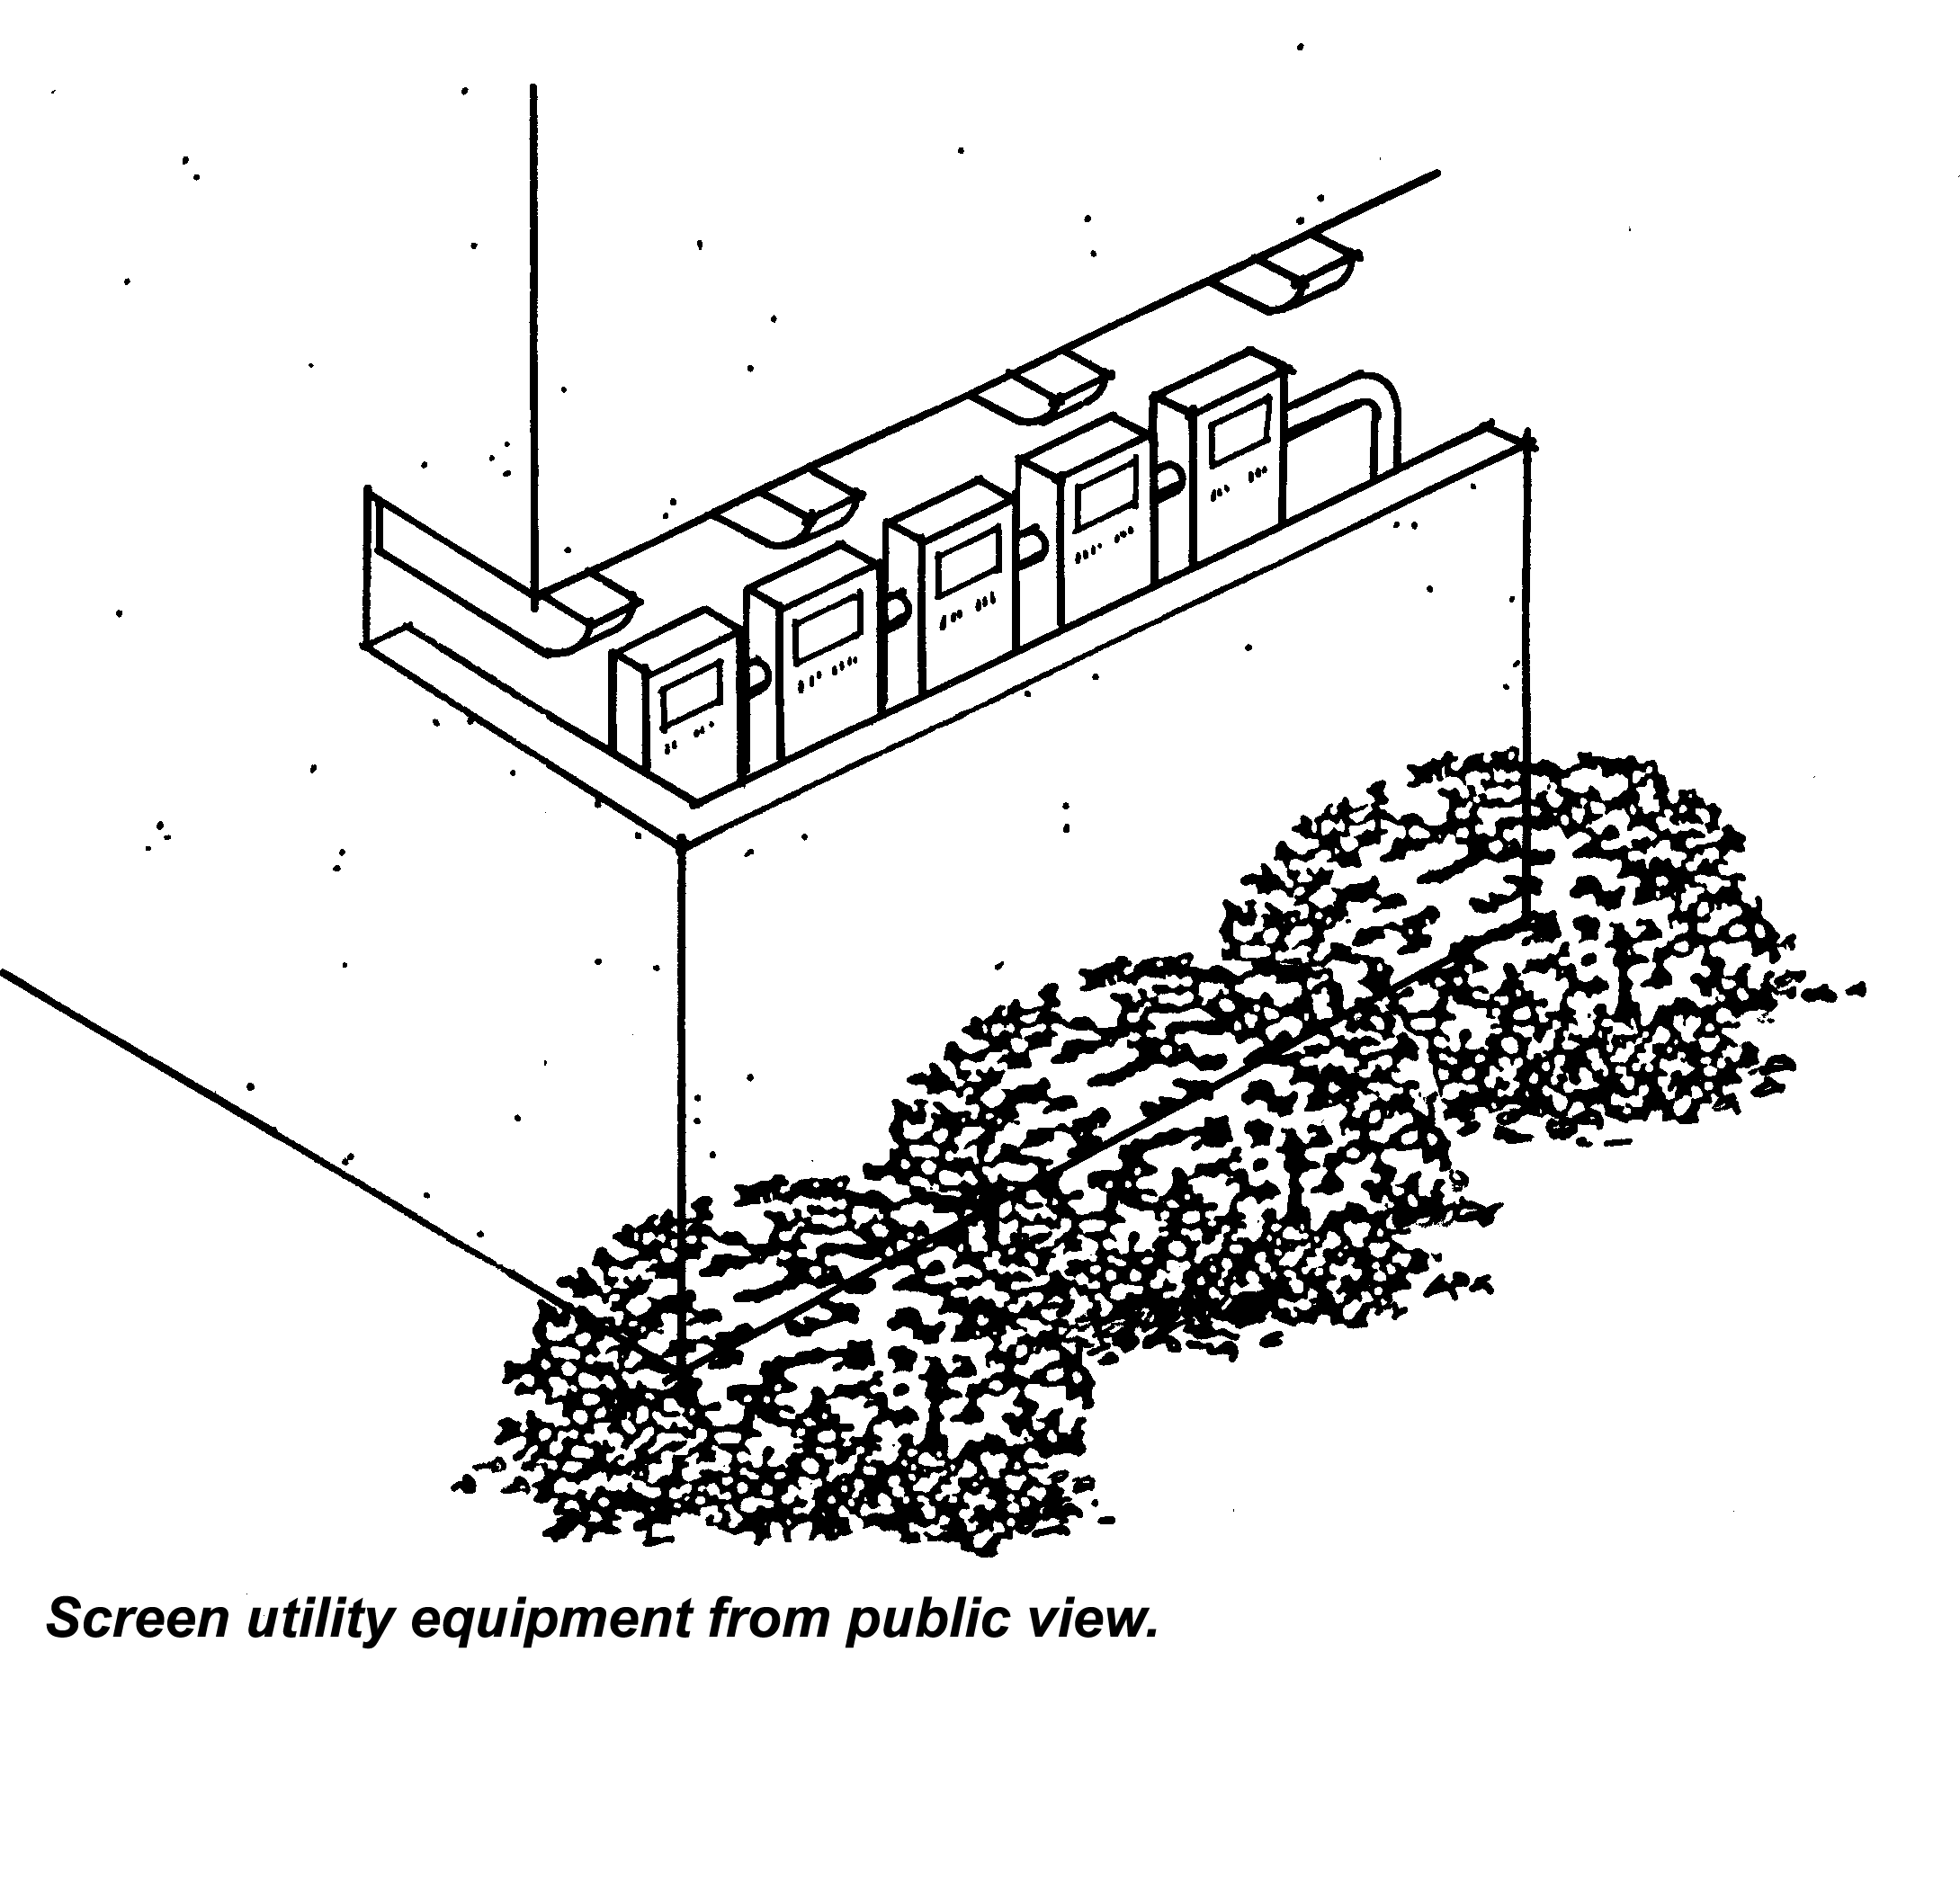
2. All utility connections shall be designed to coordinate with the architectural elements of the site so as not to be exposed except where necessary. Padmounted transformers and/ or meter box locations shall be included in the site plan with any appropriate screening treatment (Figures 9.35.040-A and B).
Figure 9.35.040-A Screen Utility Equipment

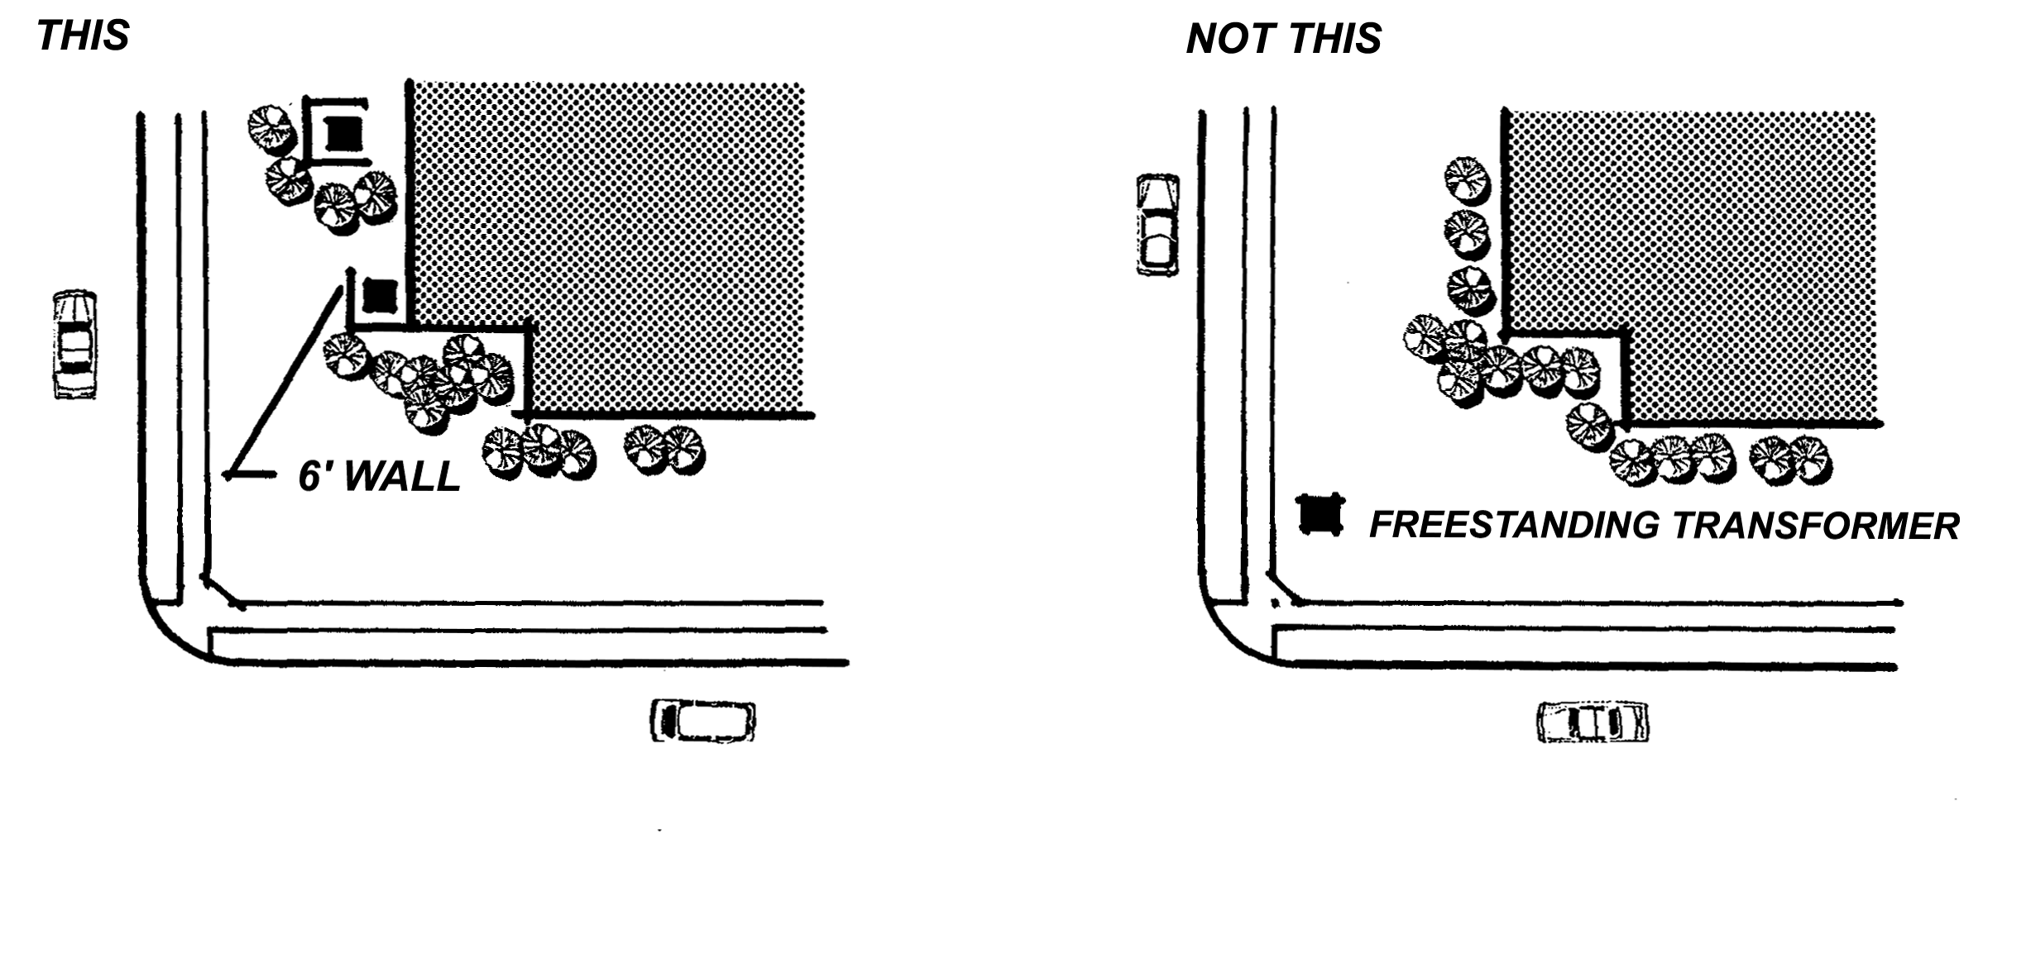

Figure 9.35-040-B Screen Utility Equipment

Table 9.35.040-B Summary of Site Development Standards
for Commercial and Office Districts
Table 9.35.040-B summarizes minimum site development standards for commercial and office zoning districts
 | A | B | C | D | E | F | G
ZONING DISTRICT | MINIMUM LOT  WIDTH | MINIMUM LOT DEPTH | MINIMUM FRONT SETBACK LOCAL/ MAJOR OR SECONDARY | MINIMUM REAR SETBACK | MINIMUM STREET SIDE SETBACK | MINIMUM SIDE SETBACK | MAXIMUM HEIGHT(1)
O-P | 75 | 90 | 35/45 | 0 | 25 | 0 | 48(2)
C-G | 75 | 100 | 35/45 | 0 | 25 | 0 | 35
C-S | 75 | 100 | 35/45 | 0 | 25 | 0 | 35
C-R | N/A | N/A | 35/45 | 30 | 30 | 30 | 100
C-V | 75 | 100 | 10/10 | 0 | 10 | 0 | 35
M-U | 75 | 100 | 35/10 | 0 | 10 | 0 | 50
(1) Maximum height in all commercial, office and mixed use districts is twenty-five (25) feet within one hundred (100) feet of a residential use or district.
(2) Maximum height may be extended to one-hundred (100) feet with a Conditional Use Permit.
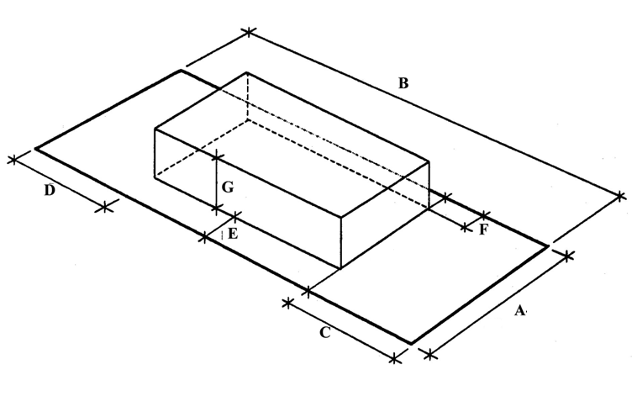

Figure 9.35.040-C Building Envelope

9.35.050 Projections into Yards
A. Table 9.35.050-A summarizes the various projections that are permitted into the required setbacks in the Commercial and Office Districts.

Table 9.35.050-A Projections Into Yards
 |  | Permitted Projections into Setbacks
PROJECTION |  | Front  Setback | Street  Side  Setback | Interior  Side  Setback |  | Rear  Setback
Eaves, cantilevered roofs, butt-resses and wing walls | 3ft |  | 3ft |  | 3ft |  | 3ft
Rain conductors, spouts, utility  service risers, shut-off valves  and architectural accents | 1ft |  | 1ft |  | 1ft |  | 1ft
Raised structures, less than 30  inches in height, including por-  ches, landings, decks, and stairs  thereto | 3ft |  | 3ft |  | 3ft |  | 3ft
Outside stairways, balconies, ex-  terior corridors, fire escapes,  and other exterior access facili-  ties(1) | not  permitted |  | not  permitted |  | 3ft |  | 3ft
Awnings and canopies | 3ft |  | 3ft |  | 3ft |  | 3ft
Wall and window mounted air  conditioners, coolers and/or fans | not  permitted |  | not  permitted |  | not  permitted |  | 1ft

B. Projections into required yards shall be subject to the following limitations:
1. No portion of eaves or cantilevered roofs shall be less than eight (8) feet above grade, and no related vertical supports or members shall be located within the required yard.
2. Raised structures, less than thirty inches in height, including porches, landings, decks, balconies and stairs thereto shall be open and un-enclosed.
3. Awnings and canopies shall have no vertical support located in the required yard.
C. Use of Required Yards. Required yards may be used for landscaping, walkways, and driveways from the street to the interior of the lot. Required yards may be used for parking when all other requirements, such as landscaping, have been satisfied, except that no parking shall be allowed in the minimum required front and street side setbacks, as established in Table 9.35.040-A.

9.35.060 Projections Above Height Limits
A. Antennas. Telecommunications facilities shall be subject to Chapter 9.77 of this Code.
B. Structures. Architectural features such as cupolas, belltowers, and steeples may exceed the height limits by a maximum of fifteen (15) feet when approved by the Planning Commission. The Planning Commission must find that any such projection which exceeds the height limits is an integral part of the building and will enhance the overall design of the building(s).
C. Walls, Fences and Hedges
1. On corner lots, no man-made visual obstructions may be erected, placed, planted or allowed to grow within the Clear Sight Triangle to a height in excess of thirty (30) inches above the nearest street elevation. The Clear Sight Triangle is defined as the area within the triangle formed by connecting the points thirty (30) feet (10 feet at driveways) from the intersection of the two right-of-way lines. Trees within the Clear Sight Triangle shall be trimmed (to the trunk) to a line at least six (6) feet above the nearest street elevation (Figure 9.35.060-A).

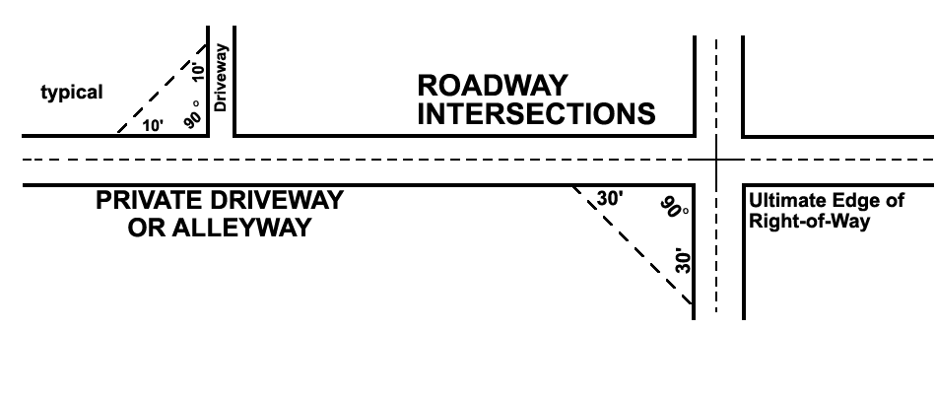

Figure 9.35.060-A Clear Site Triangle

2. On all other lots, and corner lots outside of the Clear Sight Triangle, a maximum six (6) foot high solid wall or fence may be located anywhere except in the required front or street side setback, unless greater height is required to screen an outdoor use in accordance with Section 9.35.080. Within the required front or street side setback solid walls or fences are limited to forty-two (42) inches in height; open fences constructed of wrought iron incorporating decorative features such as pilasters and spires or other embellishments, may be six (6) feet in height.
3. When there is a difference in the ground level between two adjoining lots or between Town right-of-way and an adjoining lot, the height of any retaining wall constructed along the property line or right-of-way shall be determined from the lowest finished grade at the wall.
4. Retaining walls not within the Clear Sight Triangle and not exceeding the maximum permitted height may incorporate a protective guardrail when specifically required by the Uniform Building Code. Guardrails shall not exceed forty-two (42) inches above the top of the retaining wall and shall be constructed of wrought iron with intermediate rails or an ornamental pattern such that a sphere four (4) inches in diameter cannot pass through.

9.35.070 Accessory Structures
The following provisions for accessory structures shall apply to all Commercial and Office districts:
A. Accessory structures shall not be located in the front or street side setback or in front of the primary structure.
B. Accessory structures shall meet all of the setback requirements of the zoning district in which it is located.
C. Accessory structures shall be constructed of or finished with materials, colors, and architectural treatment that are similar to those of the primary building on the site.

9.35.080 Outdoor Storage and Use (Amended Ord. 289, 366)
A. Outdoor Storage. Outdoor storage of materials and equipment is permitted in the C-S, C-V and M-U districts when it is clearly incidental to the permitted use on the site and is in compliance with the provisions of this Chapter. Such storage shall be located in the rear one-half of the site and screened completely from view from any adjoining property or roadway by a solid wall or fence at least six (6) feet in height, but not to exceed ten (10) feet in height. Said fence or wall shall be constructed of or finished with materials that are compatible with those of the primary building on the site. In the M-U district, outdoor storage shall be screened by a solid decorative block or stucco wall. Items that are being stored outdoors shall not be stacked to a height exceeding the height of the required wall or fence.
In the C-S and C-V districts, when on-site barriers are necessary for security, open view fencing shall be used. Open view fencing shall have pilasters of materials that complement the building architecture. Metal rails and pickets shall be sufficiently spaced to restrict trespassing. Spires or spikes or other detailing may be used to impede trespassing. Barbed wire, razor wire, electrification or similar barriers are only permitted for law enforcement agency vehicle impound yards.

Notwithstanding the above, the exterior storage of hay, packaged feed and related bulk feed products shall be permitted as specified in Tables 9.35.030-A ‘Permitted Uses’ and 9.35.040-A ‘Site Development Standards’ of the Town of Apple Valley Development Code.
B. Visible Storage. Except as may be otherwise permitted in this Chapter, there shall be no visible storage of motor vehicles (except display areas for sales or rentals), trailers, airplanes, boats, recreational vehicles, or their composite parts; loose rubbish, garbage, junk, or their receptacles; or building materials on any portion of a lot. No storage shall occur on a vacant parcel.
C. Permitted Storage of Building Materials. Building materials for use on the same parcel or building site may be stored on the parcel or building site during the time that a valid building permit is in effect.
D. Other Outdoor Storage Standards
1. Storage shall not be permitted in the required setback areas.
2. Storage shall not be permitted in required parking spaces or driveways and shall not at any time impede the use of any required parking space or driveway.
3. The limits of the outdoor storage area shall be clearly delineated on the approved site plan.

9.35.090 Trash Enclosures (Amended Ord. 313)
Garbage containers or trash bins shall not be kept, placed or maintained so as to be visible from any public street or alley, except on days designated for trash collection, in accordance with Section 6.20.130 of the Town Municipal Code. In addition, the standards cited below shall apply.
A. Size of Trash Enclosures. Trash receptacles for commercial and office district uses shall be of sufficient size to accommodate the trash generated by the uses being served, consistent with the Town trash enclosure standards (Figures 9.35.090-A and B).
1. One (1) trash bin per each three (3) commercial establishments or units (or fraction thereof) where the units are 5,000 square feet or less.
2. One (1) trash bin per commercial establishment or unit where they are between 5,001 and 15,000 square feet.
3. Two (2) trash bins per commercial establishment or unit where they are greater than 15,000 square feet.
4. In the M-U district, trash bins for commercial development shall be separate from those for residential development. The requirements for residential trash bins shall be consistent with the requirements of Section 9.31.040 of this Code.
B. Screening of Trash Storage Areas. All outdoor storage of trash, garbage, refuse, and other items or material intended for discarding or collection shall be screened from public view on three sides by a six (6) foot high wall of eight (8) inch block construction, or similar permanent construction using materials used in the primary structure. The fourth side shall be an opaque gate six (6) feet in height made of wood or metal painted to match the surrounding wall, kept in functional order and maintained in good repair at all times. Gates of trash enclosures shall remain closed at all times except when the enclosure is being accessed for refuse disposal or pick-up.
A covered storage area at least three (3) feet by six (6) feet in size, or other size enclosure depending on the nature and quantity of recyclable materials generated, and accessible for truck loading, shall be incorporated into each trash enclosure for collection of recyclable materials.
C. Architectural Treatment. All trash enclosures visible from streets or public parking areas shall be constructed and finished to be compatible with the architectural details and decor of the primary structure.
D. Location. Trash enclosures shall not be located in the required front or street side setbacks and shall be located near a driveway that allows access by the trash pick up vehicles.
E. Variations. Any variation from these standards shall be approved by the Director.

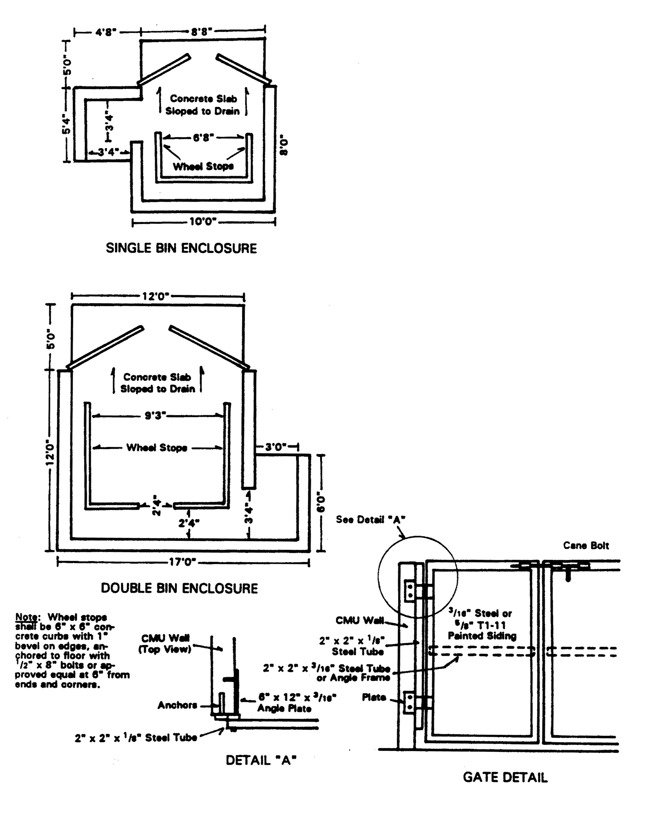
MATERIALS: Six (6) foot high, eight (8) inch block construction per Trash Enclosure Wall Detail (figure 9.28.150-B) with wood or metal opaque gates; set on four (4) inch P.C. pad; pad to be at ground level; all hardware to be corrosive resistant.

FINISH: The decorative block or stucco used shall be finished to be compatible with surrounding architectural features.

NUMBER REQUIRED:

Residential: One (1) - 8' x 14' enclosure per eight (8) dwelling units

Commercial/Industrial:
One (1) trash bin per each three (3) units where the units are 5,000 sq. ft. or less
One (1) trash bin per unit where the units are between 5,001 and 15,000 sq. ft.
Two (2) trash bins per unit where the units are larger than 15,000 sq. ft.

Note: Any variations from these standards shall be approved by the Director. All this is a repeat of above.

Figure 9.35.090-A Trash Enclosure Specification
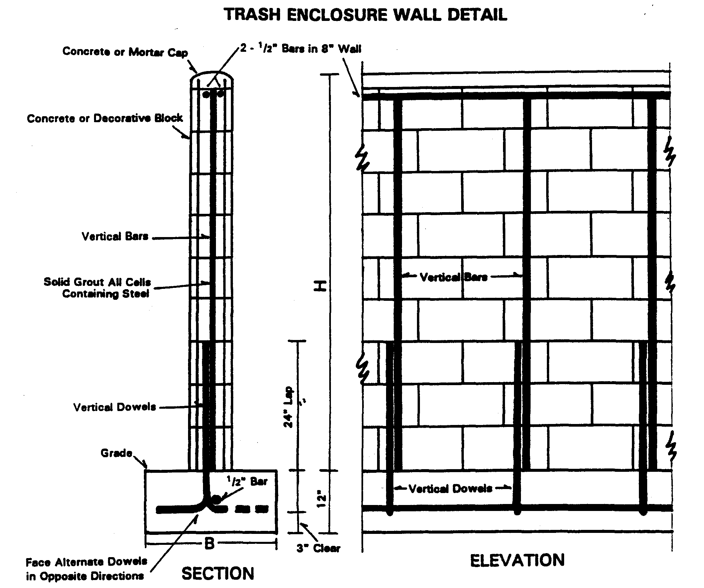
WALL SPECIFICATION:

Height (H)Base (B)Vertical Reinforcing
6'0"24"1/2" @ 32" O.C.
5'0"20"1/2" @ 32" O.C.
4'0"18"3/8" @ 48" O.C.
3'0"12"3/8" @ 48" O.C.

Notes:1. Trash enclosure walls shall be constructed of eight (8) inch concrete or decorative block.
2. All vertical cells containing reinforcing steel shall be filled with grout.
3. Two 1/2 inch diameter vertical bars are required at each side of each opening, foundation dowels of same number, size and spacing required.

Figure 9.35.090-B Trash Enclosure Wall Specifications

9.35.100 Intensity Bonus
A. Purpose. The purpose of this Section is to encourage the addition of enhanced site amenities and increased flexibility in design for new developments in the commercial and office districts through the granting of additional floor space, additional building height, additional lot coverage, reduced setbacks or other variations from the Site Development Standards, Section 9.35.040. Such variations are subject to the approval of a Conditional Use Permit.
B. Types of Amenities
1. Employee trip reduction incentives and/or facilities
2. Shaded public spaces, plazas
3. Public art, sculptures and fountains
4. Enhanced landscaping
5. Other amenities as approved by the Planning Commission.
C. Types of Intensity Bonuses. Variations from the provisions of Section 9.35.040, Site Development Standards, of this Chapter, may be granted by the Planning Commission through the approval of a Conditional Use Permit when enhanced site amenities described in subsection B of this Section are provided. Such variations are limited to:
1. Fifteen (15) foot increase in height, except within 100 feet of a residential use or district; or
2. Ten (10) percent decrease in required landscape coverage, e.g., 10% to 9%, 15% to 13.5%; or
3. Ten (10) percent decrease in required setbacks, except when adjacent to residential uses or districts.

9.35.110 Maintenance of Uses
A. Property Maintenance. All buildings, structures, yards and improvements shall be maintained in a manner which does not detract from the appearance of the neighborhood. The following conditions are prohibited:
1. Dilapidated, deteriorating, unrepaired, or vandalized (such as graffiti) structures including fences, roofs, doors, walls and windows.
2. Accumulation of scrap lumber, junk, trash or debris.
3. Unattended, overgrown or dead landscape materials and damaged or unmaintained landscape features such as benches and sculptures.
B. Vehicle and Equipment Repair and Storage. The following provisions shall apply to any vehicle, motor vehicle, camper, camper trailer, trailer, unmounted camper, trailer coach, motorhome, motorcycle, boat or similar conveyance, for uses within the commercial and office districts.
1. Off-street parking and storage of the above listed conveyances shall be permitted on paved surfaces only.
2. Servicing, repairing, assembling, disassembling, wrecking, modifying, restoring or otherwise working on any of the above listed conveyances is prohibited unless conducted within an enclosed building, except when permitted by this Chapter or by approval of a Conditional Use Permit.
3. Storing, placing or parking of any of the above listed conveyances, or any part thereof, which is disabled, unlicensed, unregistered, inoperative, or from which an essential or legally required operating part is removed, shall be prohibited unless conducted within an enclosed building or otherwise completely screened from public view or views from adjacent properties, except when permitted by this Chapter or by approval of a Conditional Use Permit.

9.35.120 Pre-Fabricated Structures (Amended Ord. 239, 313)
A. Pre-fabricated Structures. The following standards shall apply to the use of pre-fabricated structures:
1. Permitted pre-fabricated structures shall be compatible in scale and design with surrounding structures.
2. Pre-fabricated structures shall conform to all standards, goals and objectives of this Chapter and the General Plan.
3. The design and finish of the pre-fabricated structures shall be compatible with and complementary to existing structures on the site.
4. Adequate screening from adjacent residential uses and public streets shall be provided as indicated in Section 9.37.060, Buffering and Screening, of this Code.
5. A permanent foundation system shall be provided.
6. ADA Requirements shall apply. access and adequate sanitary facilities for the handicapped shall be provided as required by the California Accessibility Standards.
7. Prefabricated structures are prohibited in the Mixed Use district shall also be compatible with, and complementary to surrounding development.
B. Metal Buildings
1. Buildings constructed on site, or structures assembled from modular or similar units on site, or structures assembled off site and moved on site as one unit, may use metal exteriors when the Planning Commission determines, during a project’s Development Permit or Conditional Use Permit review, that the proposed structure shall have an appearance emulating and simulating the color, texture and appearance of other structures within the surrounding area or where it can be clearly demonstrated that the proposed structure shall be an enhancement to the surrounding area. Said metal exterior must provide the same texture depth and other physical characteristics as the exterior of the main structure on the surrounding properties.
2. Metal buildings are prohibited in the Mixed Use district.

9.35.130 Residential Structure Conversion/Relocation
A Conversions of Existing Residential Structures
1. Structures originally designed for residential occupancy (including hotels and motels), or as accessory structures or additions to residences, and located in a non-residential district, shall not be used for any commercial or office use unless the building and site are improved to meet all applicable code requirements for a change in occupancy. This includes, but is not limited to, Building and Safety, Engineering, Fire District, Police, Water District and Planning Division requirements.
2. Conversions of residential structures to commercial or office use is subject to the approval of a Conditional Use Permit.
3. In approving a Conditional Use Permit the Planning Commission shall impose conditions necessary to make the following findings:
a. The conversion will not adversely impact adjacent properties or the reasonable use thereof.
b. Adequate parking and circulation will be provided.
c. The architectural design and materials used will be compatible with the character of the neighborhood.
d. Public improvements that would normally be required for new construction will be provided.
B. Relocation
Structures may be relocated in accordance with the following standards:
1. Upon relocation of a structure, The parcel, and the relocated structure, shall comply with all applicable provisions of this Chapter including all development standards, regulations, and restrictions for the proposed use in the zoning district to which the structure is relocated.
2. Construction on a relocated structure shall commence within thirty (30) days and shall be completed within one (1) year of the date that the structure is moved onto the relocation site.
3. Conditions and requirements of all other applicable regulations and ordinances and the goals and objectives of the General Plan shall be complied with, except as may be otherwise required by State law.

9.35.140 Abandoned or Converted Service Stations
A. Abandoned Service Stations
1. Service stations that remain vacant or cease operations for more than one hundred eighty (180) days shall be required to have all underground storage tanks (unless waived in writing by the Apple Valley Fire District and the San Bernardino County Environmental Health Services Department), all gasoline pumps and pump islands, and free-standing canopies removed.
2. If the service station is to resume operation, the Director shall be notified by the owner in writing prior to the 180th day from the time operations ceased. Such notification shall include verification that a gasoline allocation has been received and that operation will resume within thirty (30) days.
3. If the service station is to resume operation after the 180 days, the approval of a Conditional Use Permit is required to ensure that the facilities will be upgraded and maintained. Such approval could include, but is not limited to, replanting existing landscape areas, installing new landscape areas, painting structures, upgrading trash enclosures, striping parking spaces, removal of nonconforming signs, installation of new signs in conformance with the adopted sign ordinance, resurfacing of driveways and parking areas, and the installation of required street improvements.
B. Converted Service Stations. Service station sites and buildings which are proposed for conversion to another use are subject to the approval of a Conditional Use Permit. Such approval could include, but is not limited to, replanting existing landscape areas, installing new landscape areas, painting structures, upgrading trash enclosures, striping parking spaces, removal of nonconforming signs, installation of new signs in conformance with the adopted sign ordinance, resurfacing of driveways and parking areas, and the installation of required street improvements as necessary to comply with the applicable standards and property maintenance provisions of this Development Code.

1 (1) Access to roofs shall be from the interior of the building or screened from view from any public street or public parking area. If roof access is on the exterior of the building, security shall be provided to prevent unauthorized access.

