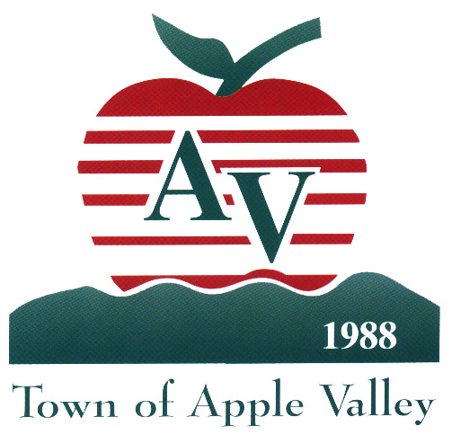


City of Victorville & Town of Apple Valley
In Partnership with
Neighborhood Housing Services
PRESENT


Orientación para los propietarios de viviendas
Un taller para prevenir una ejecución hipotecaria
¡Es Totalmente Gratis!

Steps You Can Take Today to Avoid Foreclosure
Keeping Your Home, and Protecting Your Investment

Saturday, June 19, 2010
Town of Apple Valley, Recreation Center
14955 Dale Evans Pkwy, Apple Valley, CA 92307
Entrance/Parking behind Town Hall – Enter from Wakita off Outer Hwy 18

For more information call: (909) 884-6891 ext. 222

REGISTRATION: 8:30 a.m. to 9:00 a.m.
TWO SEMINAR SESSIONS:
English – 9:00 to 11:00 a.m. / Spanish – 11:30 a.m. to 1:30 p.m.

Topics to include:
- Foreclosure Process
- Loan Modification Scam Alert
- Can my home be saved from foreclosure?
- Who can I trust?
- Short Sale Information
- Property Tax Assessment Information
- Tax Relief for Struggling Homeowners

El Seminario Incluirá:
- El Proceso de ejecución hipotecaria
- Alerta Sobre Ayuda Fraudulenta
- Opciones Disponibles Para Salvar Su Casa
- Orientación Sobre Modificación y “Short Sale”
- Información sobre Evaluación de Impuestos Propietarios
- Alivio de Impuestos para propietarios en apuros

