Agenda Item No. 3

TOWN OF APPLE VALLEY PLANNING DIVISON

Staff Report
AGENDA DATE: July 21, 2010
CASE NUMBER: Development Permit No. 2010-006
APPLICANT: Mr. Tom Regan, TRLS Engineering, representing Mr. David Patterson

PROPOSAL: A request to allow construction of a detached Recreational Vehicle Garage that is nineteen (19)-feet, ten (10) inches in height and is 2,602 square feet in size. The project site is located within the Equestrian Residential (R-EQ) zoning designation.

LOCATION: The project is located at 15211 Chaparral Lane
APN 0479-022-21

ENVIRONMENTAL
DETERMINATION: The Project is Categorically Exempt from further environmental review under Section 15303(e) of the State Guidelines to Implement the California Environmental Quality Act (CEQA).

CASE PLANNER: Mr. Conrad Olmedo, Assistant Planner

RECOMMENDATION: Approval

PROJECT AND SITE DESCRIPTION

- Project Size
The property is 0.78 (34,638 square feet) acres in size.

- Surrounding General Plan Designations and Land Use:
Project Site - Single-Family Residential (R-SF); existing single family residence
North - Single-Family Residential (R-SF); existing single family residence
South - Single-Family Residential (R-SF); vacant
East - Single-Family Residential (R-SF); existing single family residence
West - Single-Family Residential (R-SF); existing single family residence

- Surrounding Zoning and Land Use:
Project Site - Equestrian Residential (R-EQ); existing single family residence
North - Equestrian Residential (R-EQ); existing single family residence
South - Equestrian Residential (R-EQ); vacant
East - Equestrian Residential (R-EQ); existing single family residence
West - Equestrian Residential (R-EQ); existing single family residence

- Building Height:
Permitted Maximum: Sixteen (16) feet
Proposed Maximum: Nineteen (19) feet and ten (10) inches

- Setback Analysis:
Required: Proposed:
Front: 25 feet 148 feet
Rear: 5/12.5* feet 14 feet
South Side: 5 feet 5 feet 4 inches
North Side: 5 feet 164 feet
From Residence: 6 feet 34 feet

*Recorded Public Utility Easement is twelve and one-half (12½) feet.

- Lot Coverage:
Permitted Maximum: 10,391 square feet (30%)
Proposed Maximum: 6,936 square feet (20%)

- Detached Accessory Structure:
Permitted Maximum: 3,326 square feet (75% of principle structure)
Proposed Maximum: 2,602 square feet (58% of principle structure)

Analysis:

- General:

The applicant proposes to construct a detached garage, nineteen (19) feet, ten (10) inches in height and 2,602 square feet in size. According to Section 9.29.020D Planning Commission review and approval is required for an accessory structure that exceeds the maximum of sixteen (16) feet in height for a one-story structure in the Residential Single-Family (R-SF) Zoning designation:

9.29.020 Accessory Uses and Structures
D. Height. The maximum height of an accessory structure shall not exceed the maximum height for the zoning district in which it is located, except that the maximum total height of antennas and their support structures shall be as specified in Chapter 9.77, Wireless Telecommunications Towers and Antennas, of this Code. Accessory structures in the single family residential, equestrian residential, and multi-family residential districts shall not exceed one-hundred percent (100%) of the height of the main structure on site, or sixteen (16) feet, whichever is lesser, if a one story structure, nor seventy-five (75) percent of the height of the main structure, if that main structure is two or more stories in height. A greater height may be approved by the Planning Commission upon review and approval of a Development Permit as provided in Chapter 9.17 “Development Permits.”

- Site Analysis:
The project site has an existing 4,435 square-foot single-family residence with an attached garage, existing landscaping, and is relatively flat. There is an existing shed that served as a barn, built prior to the Town’s incorporation, which will be removed and replaced with the proposed recreational vehicle garage.

- Architecture Analysis:
The Development Code establishes standards for detached garages in order to ensure the single-family residence remains the dominant land use and that a quality, aesthetic presentation of the property is maintained. The Development Code establishes standards for detached garages in order to ensure the single-family residence remains the dominant land use and that a quality, aesthetic presentation of the property is maintained. The design of an accessory building is required to be architecturally compatible with the primary structure through the use of compatible building materials, walls/roof and landscaping (Condition No. P7).

The detached recreational vehicle garage is trapezoidal in shape with the longest sides being sixty-one (61) feet in length and sixty (60) feet in width. The maximum height will be nineteen (19) feet and ten (10) inches (Condition No. P8). There will be three (3) windows approximately two (2) feet by six (6) feet that will be placed about ten (10) feet in height on the west building elevation. Along the west property line, which is held in common with a vacant lot, there is an existing block wall six (6) feet in height. The rear building elevation, that which faces the public utility easement, will be blank; therefore, staff is recommending faux windows or other acceptable architectural enhancements (Condition No. P9). In order to provide consistent architectural features between both the detached recreational vehicle garage and the principal residence, Condition No. P10 requires that all windows have window surrounds similar to the principal residence.

With the implementation of the Conditions of Approval, the proposed garage will be compatible with the main residence and the surrounding structures. The proposed height and size of the garage will not cause a visual obstruction and is in scale with the surrounding residential neighborhood.

- Noticing:
This item was advertised as a public hearing in the Apple Valley News newspaper on June 18, 2010. Property owners within 300 feet of the project site were notified of the July 21, 2010 Planning Commission meeting. No public comment has been received by staff regarding this proposal at the time this staff report was written.

Development Permit Findings:
As required under Section 9.17.080 of the Development Code, prior to approval of a Development Permit, the Planning Commission must make the following Findings:

  - That the location, size, design, density and intensity of the proposed development is consistent with the General Plan, the purpose of this Code, the purpose of the zoning district in which the site is located, and the development policies and standards of the Town;

Comment: The proposed detached recreational vehicle garage is in compliance with the General Plan Land Use and zoning designation. The subject property is designated Equestrian Residential (R-EQ) which allows for detached accessory structures to exceed the height limit of sixteen (16) feet, subject to approval of a Development Permit (Section 9.29.020D).

  - That the location, size and design of the proposed structures and improvements are compatible with the site's natural landforms, surrounding sites, structures and streetscapes;

Comment: The detached recreational vehicle garage is proposed within the Equestrian Residential (R-EQ) zoning designation, is compatible with the surrounding area, and is consistent with previously reviewed and approved detached accessory structures by the Commission. The site and existing improvements can facilitate the proposed project and is permitted subject to approval of a Development Permit.

  - That the proposed development produces compatible transitions in the scale, bulk, coverage, density and character of development between adjacent land uses;

Comment: The proposed detached recreational vehicle garage is compatible with the site and surrounding area and has been designed with adequate landscaping and circulation. The use is not anticipated to generate excessive noise, vibration, traffic or other disturbances.

  - That the building, site and architectural design are accomplished in an energy efficient manner;

Comment: The proposed detached recreational vehicle garage must be constructed in accordance with the Uniform Building Code and the proposed construction must comply with Building and Safety Division and UBC Title 24 requirements.

  - That the materials, textures and details of the proposed construction, to the extent feasible, are compatible with the adjacent and neighboring structures;

Comment: The design, materials and details of the detached recreational vehicle garage, with adherence to recommended Conditions of Approval, will be compatible with properties or improvements in the vicinity. The property is within the Residential Equestrian (R-EQ) zoning designation and detached accessory structures may exceed the height limit of sixteen (16) feet and utilize a design that is architecturally compatible with the primary structure through the use of compatible building materials, walls/roof and/or landscaping as approved under a Development Permit, prior to issuance of a Building Permit.

  - That the development proposal does not unnecessarily block public views from other buildings or from public ways, or visually dominate its surroundings with respect to mass and scale to an extent unnecessary and inappropriate to the use;

Comment: The proposed detached recreational vehicle garage is located to the southeast of the existing primary residence and has the appropriate separation from the main structure and setbacks from property lines. The additional height of three (3) feet, ten (10) inches requested for the proposed detached recreational vehicle garage will not block public views and is a compatible use because the structure is consistent in scale to other residential-related structures in the area.

  - That the amount, location, and design of open space and landscaping conforms to the requirements of this Code, enhances the visual appeal and is compatible with the design and function of the structure(s), site and surrounding area;

Comment: The proposed detached recreational vehicle garage is located on property that contains established landscaping and is compatible with adjacent residential uses within the general area. The location and size of the proposed recreational vehicle garage complies with the Code, subject to a Development Permit. The design of the proposed recreational vehicle garage will be compatible with the existing residence and the garage function is appropriate for the area, which is zoned Equestrian Residential (R-EQ).

  - That quality in architectural design is maintained in order to enhance the visual environment of the Town and to protect the economic value of existing structures;

Comment: The proposed detached recreational vehicle garage is designed to be compatible with the existing residence and surrounding development. The project, with adherence to recommended Conditions of Approval, is permitted subject to approval of a Development Permit.

  - That excessive and unsightly grading of hillsides does not occur, and the character of natural landforms and existing vegetation are preserved where feasible and as required by this Code;

Comment: The primary structure and the natural slope in the area will minimize any potential visual impact. The proposed detached recreational vehicle garage will not block public and private views and is in scale to other residential developments in the area. The project will not impact any natural landforms.

  - That historically significant structures and sites are protected as much as possible in a manner consistent with their historic values;

Comment: The project is proposed on a lot with an existing single-family residential home and there are no known historical structures on the site.

  - That there are public facilities, services and utilities available at the appropriate levels, or that these shall be installed at the appropriate time, to serve the project as they are needed;

Comment: There are existing improvements available to serve the site. In addition, the proposal will be compatible with the surrounding neighborhood.

  - That access to the site and circulation on and off-site is safe and convenient for pedestrians, bicyclists, equestrians and motorists;

Comment: The proposed detached recreational vehicle garage will be located on an existing residential site which fronts Chaparral Lane and must adhere to Conditions of Approval required in the Development Permit. Therefore, the proposal will not adversely impact access, circulation and the physical character of surrounding streets.

  - That the proposed development's generation of traffic will not adversely impact the capacity and physical character of surrounding streets;

Comment: The proposed detached recreational vehicle garage will be located on a residential site, which fronts Chapparal Lane, a roadway designed to accommodate residential traffic. In addition, the proposed project must adhere to the Conditions of Approval required in the Development Permit. Therefore, the proposal will not adversely impact the capacity and physical character of surrounding streets.

  - That traffic improvements and or mitigation measures are provided in a manner adequate to maintain a Level of Service “C” or better on arterial roads and are consistent with the Circulation Element of the Town General Plan;

Comment: Traffic generated from the project will not adversely impact the surrounding area. The proposed detached recreational vehicle garage will be located on, and adjacent to, residentially designated properties, fronting Chapparal Lane which can accommodate traffic generated from the project site.

  - That environmentally unique and fragile areas such as the knolls, areas of dense Joshua trees, and the Mojave River area shall remain adequately protected;

Comment: The proposal is within the Equestrian Residential (R-EQ) zoning designation and not within any significant environmentally unique or fragile areas.

  - That there will not be significant harmful effects upon environmental quality and natural resources;

Comment: Under the State Guidelines to Implement the California Environmental Quality Act (CEQA), the project is not anticipated to have any direct or indirect impact upon the environment and is Categorically Exempt under Section 15303(e).

  - That there are no other relevant negative impacts of the proposed use that cannot be mitigated;

Comment: Under the State Guidelines to Implement the California Environmental Quality Act (CEQA), the project is not anticipated have any direct or indirect impact upon the environment and is Categorically Exempt under Section 15303(e).

  - That the impacts which could result from the proposed development, and the proposed location, size, design and operating characteristics of the proposed development, and the conditions under which it would be operated or maintained, will not be detrimental to the public health, safety and welfare of the community or be materially injurious to properties or improvements in the vicinity, nor be contrary to the adopted General Plan; and

Comment: The proposed detached recreational vehicle garage, by its design and operating characteristics, and with adherence to the conditions under which it will be operated and maintained, will not be detrimental to the public health, safety or welfare, nor be materially injurious to properties or improvements in the vicinity.

  - That the proposed development will comply with each of the applicable provisions of this Code and applicable Town policies, except approved variances.

Comment: The proposed detached recreational vehicle garage can be built in conformance to the Development Code, subject to approval of a Development Permit and adherence to the recommended Conditions of Approval.

RECOMMENDATION
Based upon the information contained within this report, and any input received from the public at the hearing, it is recommended that the Planning Commission move to:

  - Determine that the project is not anticipated to have any direct or indirect impact upon the environment, as it has been determined that the proposed request is Exempt from further environmental review.

  - Find the facts presented in the staff report support the required Findings for approval and adopt the Findings.
  - Approve Development Permit No. 2010-006, subject to the attached Conditions of Approval.
  - Direct staff to file a Notice of Exemption.

Prepared By: Reviewed By:

Conrad Olmedo Lori Lamson
Assistant Planner Assistant Director of Community Development

ATTACHMENTS:

- Recommended Conditions of Approval
- Subject Site, Figure 1
- Site Plan
- Building Elevations
- Site Photo
- Zoning Map
TOWN OF APPLE VALLEY

RECOMMENDED CONDITIONS OF APPROVAL
Development Permit No. 2010-006

Please note: Many of the suggested Conditions of Approval presented herewith are provided for informational purposes and are otherwise required by the Municipal Code. Failure to provide a Condition of Approval herein that reflects a requirement of the Municipal Code does not relieve the applicant and/or property owner from full conformance and adherence to all requirements of the Municipal Code.

Planning Division Conditions of Approval:

- This project shall comply with the provisions of State law and the Town of Apple Valley General Plan and the Development Code. This conditional approval, if not exercised, shall expire two (2) years from the date of action of the reviewing authority, unless otherwise extended pursuant to the provisions of application of State law and local ordinance. The extension application must be filed, and the appropriate fees paid, at least sixty (60) days prior to the expiration date. The Development Permit becomes effective ten (10) days from the date of the decision unless an appeal is filed as stated in the Town’s Development Code.

- The applicant shall agree to defend, at its sole expense (with attorneys approved by the Town), hold harmless and indemnify the Town, its agents, officers and employees, against any action brought against the Town, its agents, officers or employees concerning the approval of this project or the implementation or performance thereof, and from any judgment, court costs and attorney's fees which the Town, its agents, officers or employees may be required to pay as a result of such action. The Town may, at its sole discretion, participate in the defense of any such action, but such participation shall not relieve the applicant of this obligation under this condition.

- The filing of a Notice of Exemption requires the County Clerk of the Board to collect a documentary handling fee of fifty dollars ($50.00). The fee must be paid in a timely manner in accordance with Town procedures. No permits may be issued until such fee is paid.

- The rendering presented to and approved by the Planning Commission at the public hearing shall be the anticipated and expected appearance of the structure upon completion.

- It is the sole responsibility of the applicant on any Permit, or other appropriate discretionary review application for any structure, to submit plans, specifications and/or illustrations with the application that will fully and accurately represent and portray the structures, facilities and appurtenances thereto that are to be installed or erected if approved by the Director. Any such plans, specifications and/or illustrations that are reviewed and approved by the Director shall accurately reflect the structures, facilities and appurtenances expected and required to be installed at the approved location without substantive deviations, modifications, alterations, adjustments or revisions of any nature.

- The Assistant Director of Community Development or his/her designee, shall have the authority for minor architectural changes focusing around items such as window treatments, color combinations, façade treatments, and architectural relief. Questions on the interpretation of this provision or changes not clearly within the scope of this provision shall be submitted to the Planning Commission for consideration under a Revision to the Development Permit.

- The detached recreational vehicle garage shall match existing residence in color and building materials.

- The maximum height of the detached recreational vehicle garage shall be nineteen (19) feet and ten (10) inches.

- Architectural enhancements which can include, one (1) faux window placed on each of the two (2) highest portions of the rear building elevation facing the public utility easement.

- All windows on the detached recreational vehicle garage shall have window surrounds similar to those of the principal residence.

Building and Safety Division Conditions of Approval:

- Submit plans, engineering and obtain permits for all structures, retaining walls, and signs.

- A pre-construction permit and inspection are required prior to any land disturbing activity to verify requirements for erosion control, food hazard, native plant protection, and desert tortoise habitat.

- All utilities shall be placed underground in compliance with Town Ordinance No. 89.

- Page two (2) of the submitted building plans will be the Conditions of Approval.

- Construction must comply with 2007 California Building Codes.

- Best Managements Practices (BMPs) are required for the site during construction.

Apple Valley Fire Protection District Conditions of Approval:

- The above referenced project is protected by the Apple Valley Fire Protection District. Prior to construction occurring on any parcel, the owner shall contact the Fire District for verification of current fire protection development requirements.

- Approved numbers or addresses shall be placed on all new and existing buildings in such a position as to be plainly visible and legible from the street or road fronting the property. Said numbers shall contrast with their background.
Apple Valley Fire Protection District, Ordinance 45

- Prior to issuance of building permit, the developer shall pay all applicable fees as identified in the Apple Valley Fire Protection District Ordinance.

- End of Conditions -
Subject Site – Recreational Vehicle Garage

Development Permit DP 2010-006
15211 Chaparral Lane
APN 0479-022-21

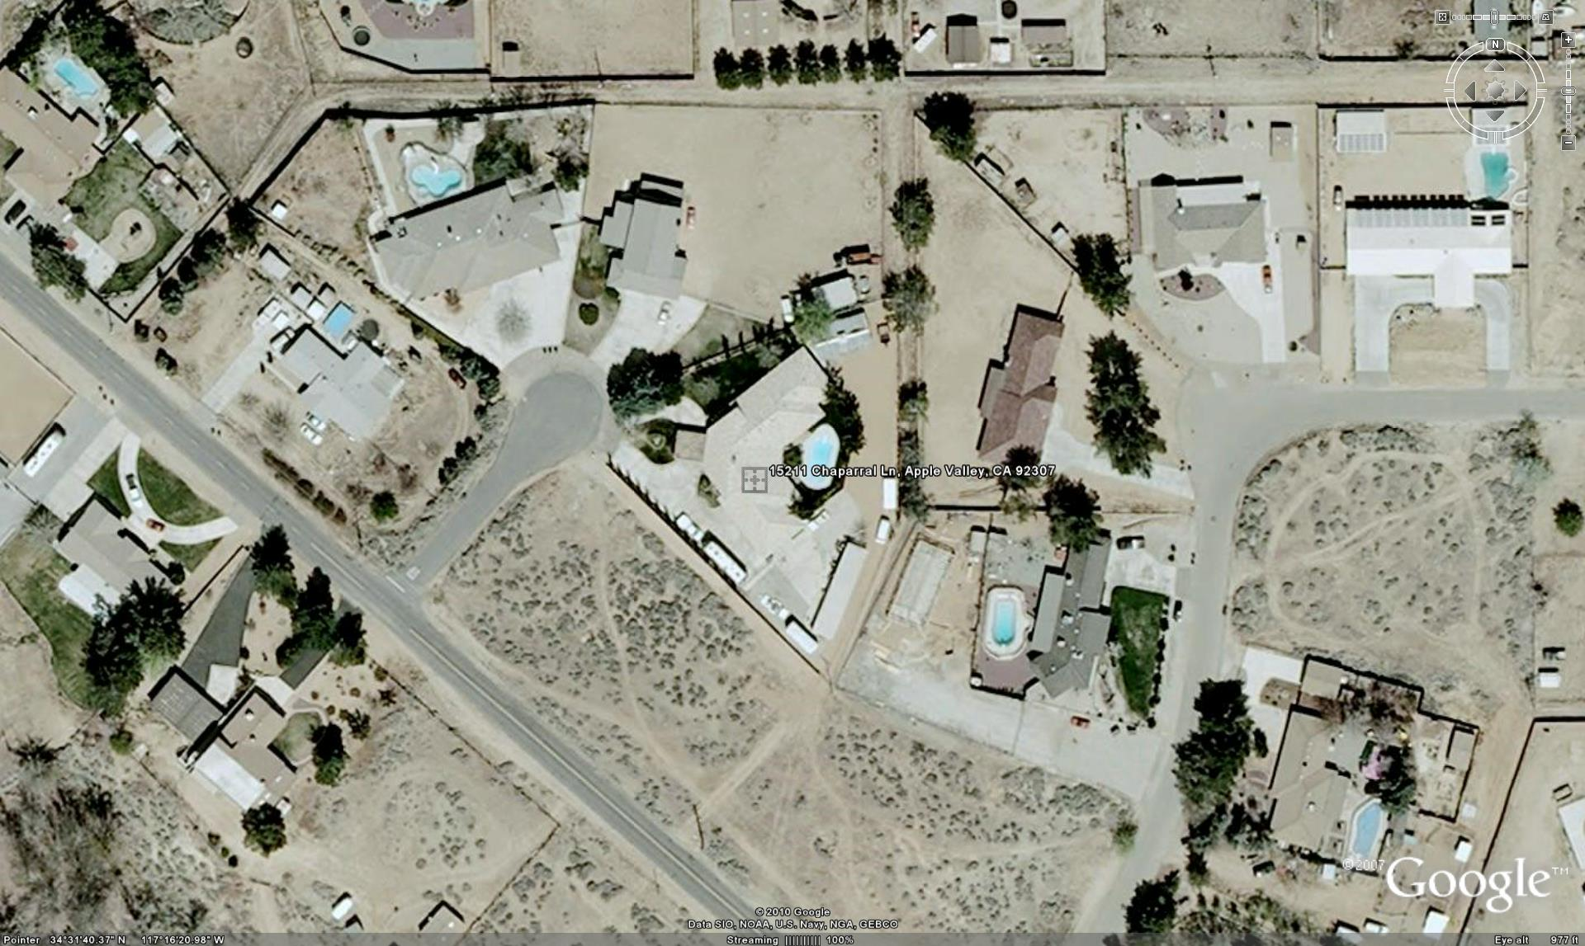

Figure 1

