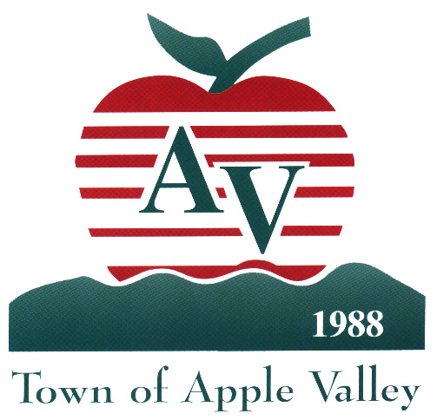
TOWN OF APPLE VALLEY

MEMORANDUM

TO: Planning Commission

FROM: Lori Lamson, Assistant Director of Community Development

SUBJECT: Development Code Interpretation No. 2011-001. Interpretation of ATM island canopy as being similar to a service station canopy for setback requirements.

DATE: April 6, 2011

Staff is requesting the Planning Commission’s interpretation of the Development Code relating to commercial canopy setback requirements. The Development Code requires a minimum ten (10)-foot setback from all property lines for service station pump island canopies but is silent on other similar types of canopies, specifically with respect to setback requirements for a freestanding drive-up bank automotive teller machine (ATM) island canopies. Based on the function similarities between a service station pump island canopy and a drive-up ATM island canopy, staff recommends that the ten (10)-foot setback should also be applied to the ATM canopy. However, since the Code does not specifically address an ATM canopy, staff has brought this forward for an interpretation/ concurrence that these types of structures are similar, and based on this similarity, the setback requirement should be the same for both types of structures.

Development Code Sections:
Section 9.36.190 Service (Gasoline) Stations
C. Minimum Development Standards
3. Canopies shall be at least ten (10) feet from any property line and shall be architecturally integrated with, the main structure.

